Judges Adage
If you want to keep a secret, put it in the Sailing Instructions. If you really want to keep a secret, put it in the Notice of Race.
“Is the start/finish line restricted?” This is the most often asked question at a skipper’s meetings. The answer can always be found either in the Notice of Race or Sailing Instructions, or posted on the Official Notice board. If nothing is specifically stated then the line is not restricted.
In the last Windjammer, I stated that in the new rules an obstruction can be defined in the Notice of Race or Sailing Instructions as an object, area, or line. I also said that the start-finish line being ‘restricted’ is NOT the same as defining it is an ‘obstruction’ and that this will determine whether RRS 19 (Room to Pass an Obstruction) and RRS 20 (Room to Tack at an Obstruction) will apply.
Here are the new rules we are going to talk about:
19 ROOM TO PASS AN OBSTRUCTION
19.1 When Rule 19 Applies
Rule 19 applies between two boats at an obstruction except
(a) when the obstruction is a mark the boats are required to leave on the same side, or
(b) when rule 18 applies between the boats and the obstruction is another boat overlapped with each of them.
However, at a continuing obstruction, rule 19 always applies and rule 18 does not.
19.2 Giving Room at an Obstruction
(a) A right-of-way boat may choose to pass an obstruction on either side.
(b) When boats are overlapped, the outside boat shall give the inside boat room between her and the obstruction, unless she has been unable to do so from the time the overlap began.
(c) While boats are passing a continuing obstruction, if a boat that was clear astern and required to keep clear becomes overlapped between the other boat and the obstruction and, at the moment the overlap begins, there is not room for her to pass between them,
(1) she is not entitled to room under rule 19.2(b), and
(2) while the boats remain overlapped, she shall keep clear and rules 10 and 11 do not apply.
20 ROOM TO TACK AT AN OBSTRUCTION
20.1 Hailing
A boat may hail for room to tack and avoid a boat on the same tack. However, she shall not hail unless
(a) she is approaching an obstruction and will soon need to make a substantial course change to avoid it safely, and
(b) she is sailing close-hauled or above. In addition, she shall not hail if the obstruction is a mark and a boat that is fetching it would be required to change course as a result of the hail.
20.2 Responding
(a) After a boat hails, she shall give a hailed boat time to respond.
(b) A hailed boat shall respond even if the hail breaks rule 20.1.
(c) A hailed boat shall respond either by tacking as soon as possible, or by immediately replying ‘You tack’ and then giving the hailing boat room to tack and avoid her.
(d) When a hailed boat responds, the hailing boat shall tack as soon as possible.
(e) From the time a boat hails until she has tacked and avoided a hailed boat, rule 18.2 does not apply between them.
20.3 Passing On a Hail to an Additional Boat
When a boat has been hailed for room to tack and she intends to respond by tacking, she may hail another boat on the same tack for room to tack and avoid her. She may hail even if her hail does not meet the conditions of rule 20.1. Rule 20.2 applies between her and a boat she hails.
20.4 Additional Requirements for Hails
(a) When conditions are such that a hail may not be heard, the boat shall also make a signal that clearly indicates her need for room to tack or her response.
(b) The notice of race may specify an alternative communication for a boat to indicate her need for room to tack or her response, and require boats to use it.

Let’s take a look at some boats passing a start-finish line and see what all this means on the water, i.e. what are each boat’s options and responsibilities.

To help keep this short some abbreviations will be used:
- ROW => right of way
- KC => keep clear
- L => leeward
- W => windward
- P => port
- S => starboard
The abbreviations may be combined, i.e. PL-ROW = port, leeward, and right of way.

Remember that when both boats are more than 90 degrees from the true wind they can be overlapped even though they are on opposite tacks.

Assume that the Sailing Instructions contain one of the following:
- The start-finish line is restricted except when starting or finishing. Boats shall not cross the start-finish line except when starting or finishing.
- The start-finish line is defined as an obstruction except when starting or finishing. Boats shall not cross the start-finish line except when starting or finishing.

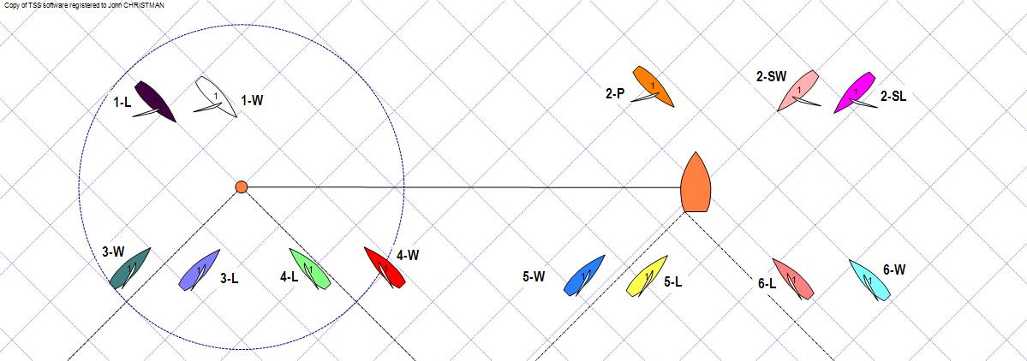

Black (1-L) v White (1-W)
Black is L-ROW, White is W-KC. RRS 20 does not apply as the boats are not on a close-hauled course (RRS 20.1(b)).
- Because they are not approaching an obstruction, RRS 19 does not apply (RRS 19.1). Black does not have to give White room to pass between her and the pin. Black may force White to go around the RC boat by not giving her room at the pin or by going around the RC boat herself.
- Because they are approaching an obstruction, RRS 19 applies (RRS 19.1). As ROW, Black can choose which end of the line she will go around (RRS 19.2(a)). If Black chooses the pin end she, the outside boat, must give White, the inside boat, room to pass between her and the pin (RRS 19.2(b)). If White must gybe to pass the pin, Black must give her room to do so.

Orange (2-P) v Peach (2-SW) v Magenta (2-SL)
Magenta is ROW for both Peach (W-KC) & Orange (P-KC); Peach is S-ROW, Orange is P-KC. RRS 20 does not apply as the boats are not on a close-hauled course (RRS 20.1(b)).
- Because they are not approaching an obstruction, RRS 19 does not apply (RRS 19.1).
Magenta does not have to give Peach or Orange room to pass between her and the RC boat. Magenta may force both Orange and Peach to go around the pin by not giving them room at the RC boat or by going around the pin herself.
If Magenta gives Peach room to go between her and the RC boat, Peach does not have to give Orange room to pass between her and the RC boat. Peach may force Orange to go around the pin by not giving her room at the RC boat or by going around the pin herself.
- Because they are approaching an obstruction, RRS 19 applies (RRS 19.1). As ROW over both Orange and Peach, Magenta can choose which end of the line she will go around (RRS 19.2(a)). If Magenta chooses the RC boat end she, as the outside boat, must give Orange and Peach, as the inside boats, room, including room for Orange to gybe, to pass between her and the RC boat (RRS 19.2(b)).

Dark Green (3-W) v Lavender (3-L)
Lavender is L-ROW, Dark Green is W-KC.
- Because they are not approaching an obstruction, RRS 19 and RRS 20 do not apply (RRS 19.1, RRS 20.1). Dark Green does not have to give Lavender room to pass between her and the pin. Additionally, Lavender may not hail for room to tack as the line is not an obstruction (RRS 20.1(a)). Lavender may be forced to go around the RC boat. Lavender’s best option is to luff head to wind and hold there until Dark Green tacks away and then tack.
- Because they are approaching an obstruction, RRS 19 and RRS 20 apply as the required conditions are met (RRS 19.1, RRS 20.1) although RRS 19 doesn’t really come into play here. Lavender may call for room to tack as allowed by RRS 20 and Dark Green must give her the room to tack.

Green (4-L) v Red (4-W)
Green is L-ROW, Red is W-KC.
- Because they are not approaching an obstruction, RRS 19 and RRS 20 do not apply (RRS 19.1, RRS 20.1). Green does not have to give Red room to pass between her and the pin. Red needs to recognize this early and tack before or at the layline to the RC boat.
- Because they are approaching an obstruction, RRS 19 applies as the required conditions are met (RRS 19.1). RRS 20 does not apply as Green does not “need to make a substantial course change to avoid it safely” (RRS 20.1(a)). Green is required to give Red room to pass between her and the starting pin

Blue (5-W) v Yellow (5-L)
Blue is W-KC, Yellow is L-ROW.
- Because they are not approaching an obstruction, RRS 19 and RRS 20 do not apply (RRS 19.1, RRS 20.1). Yellow does not have to give Blue room to pass between her and the RC boat. Blue needs to recognize this early and tack before or at the layline to the pin.
- Because they are approaching an obstruction, RRS 19 applies as the required conditions are met (RRS 19.1). RRS 20 does not apply as Yellow does not “need to make a substantial course change to avoid it safely” (RRS 20.1(a)). Yellow is required to give Blue room to pass between her and the RC boat

Pink (6-L) v Turquoise (6-W)
Pink is L-ROW, Turquoise is W-KC.
- Because they are not approaching an obstruction, RRS 19 and RRS 20 do not apply (RRS 19.1, RRS 20.1). Turquoise does not have to give Pink room to pass between her and the RC boat. . Additionally, Pink may not hail for room to tack as the line is not an obstruction (RRS 20.1(a)). Pink may be forced to go around the pin. Pink’s best option is to luff head to wind and hold there until Turquoise tacks away and then tack.
- Because they are approaching an obstruction, RRS 19 and RRS 20 apply as the required conditions are met (RRS 19.1, RRS 20.1) although RRS 19 doesn’t really come into play here. Pink may call for room to tack as allowed by RRS 20 and Turquoise must give her the room to tack.

Yellow (5-L) v Turquoise (6-W)
Yellow is P-KC, Turquoise is S-ROW.
- Because they are not approaching an obstruction, RRS 19 and RRS 20 do not apply (RRS 19.1, RRS 20.1). This is a simple port/starboard situation and Yellow must keep clear of Turquoise.
- RRS 19 does not apply as the boats are not overlapped as required by RRS 19.2(b). RRS 20 does not apply as neither boat will need to tack to pass the obstruction. This is a simple port/starboard situation and Yellow must keep clear of Turquoise.

Other notes of interest
- There is no ‘zone’ around an obstruction for applying RRS 19 or RRS 20. An outside ROW boat may sail any course she chooses to get to the mark as long as she gives the inside KC boat room to pass the obstruction.
- The starting line may change between and obstruction and a continuing obstruction. If the boats are sailing along the line then it may be considered a continuing obstruction rather than an obstruction and RRS 19.2(c) may apply.
- As long as the ROW boat can make a reasonable case regarding proper course RRS 17 does not come into play, i.e. W-KC cannot claim L-ROW is sailing above her proper course.

I hope this helps you set your tactics when passing the start-finish line based on how it is defined.

