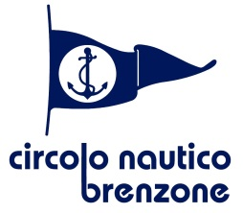

52^ KIELZUGVOGEL INTERNATIONAL REGATTA
Dinner at the Sailing Club 5.10.2022 at 19.30

Benvenuto della cucina
(Vorspeise)
***
Risotto al tastasal
(Risotto mit würst)
***

Saltimbocca alla romana con patate al forno
(Saltimbocca alla romana mit Kartoffeln)
***

Dolce della casa
(Nachspeise des Hauses)
***

Caffè, acqua e degustazione vini
(Kaffee-, Wasser- und Weinverkostung)

Free for competitors – Extra guests : € 25.00
(Remember to bring the tickets with you!
For extra guests please make your reservation at the restaurant of the
sailing club. thank you)

