39th Offshore Sailing Race
«POROS 2023»
In Memory of ¨Makis Gritzalis¨
ENTRY FORM
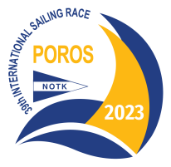

To Ν.Ο.Τ.Κ. Secretariat:
PARTICIPATION DATA
Boat : | CLUB:
Request for Participation to «POROS 2023» Race to one of the Following Classes (Note with √ ) :
PERFORMANCE: SPORT: NON SPINNAKER: DOUBLE HANDED:

CHARACTERISTICS OF BOATs NATIONALITY
FLAG: | PORT of REGISTRATION:
NATIONALITY LETTERS & SAILS No:

BOAT AND RIG DATA
MODEL: | MANUF. YEAR:
BOAT COLOUR: | DECK COLOUR:
HULL COLOUR: | RIG TYPE:

DETAILS OF THE ATTACHED RACING CERTIFICATE
ΝUMBER: | ISSUE DATE : | ISSUING AUTHORITY :
All Purpose Handicap (APH): |  | Class:

VHF
VHF Call Sign : | Existing Channels:

Person’s in Charge Legal Statement
1. I hereby declare that I accept the regulations and conditions specified in the notice of race and sail instructions, I will participate in the race with my own and sole responsibility, and I accept that the organizing club and any committee involved with the race has no responsibility for any accident or damages that might occur to the boat, to persons or things, in the sea or in the land during the race. In addition I accept full responsibility for any accident that might occur to other no- athlete’s people on board, and to health related incidents to the other non-athletes people on board due to the possible absence of preventive medical check by them.
2. In addition I declare that the above mentioned boat is equipped in accordance with the requirements of the current ISAF Offshore Special Regulations for races of category 4, and that she displays or does not display advertisements during the race for which I attach a copy from the National Authority relevant permission.

3. I certify that the copies of the certificate and the inventory pages attached are valid, and have not been modified for withdrawn until today for any reason.
4. I declare that I will comply with the relevant provisions of the Hellenic General Port Regulations No 20 and No 23 as amended and in force, that the described shipping documents and supplies are in force , updated and on board, and that I will comply to the International Maritime Safety Regulations.
5. I declare that my boat has an insurance policy that includes third party liability coverage during the participation in official sailing races, as required by the relevant directive of the Hellenic Sailing Federation/Offshore Committee

Person’s in Charge Name : | Signature :
CLUB:
ADDRESS :
MOBILE :
E-MAIL : | Date:

CREW LIST
39th Offshore Sailing Race
«POROS 2023»
In Memory of ¨ΜΑΚIS GRITZALIS¨

CREW LIST
39th Offshore Sailing Race
«POROS 2023»
In Memory of ¨ΜΑΚIS GRITZALIS¨
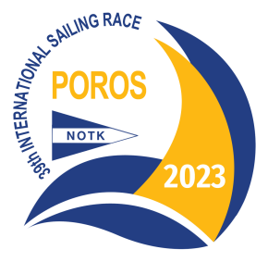

EVENT:

BOAT NAME: | SAIL NUMBER :

SKIPPER: | Athletic Card No: | CLUB:

DESIGNATED REPRESENTATIVE:

CREW MEMBER FAMILIAR WITH FIRST AID:

CREW

 | NAME | Athletic Card No: | CLUB
1.
2.
3.
4.
5.
6.
7.
8.
9.
10.
11.
12.
13.
14.

DATE :

SIGNATURE :

