*Frostbite Open Series*



Royal Saint-Lawrence Yacht Club

***October 2nd, 9th, 16th & 23rd, 2022***

Montreal, Quebec, Canada

AMENDMENT No. 4 toSAILING INSTRUCTIONS (SIs)

September 26th, 2022

Section 6. CLASS FLAGS replaced as follow:

6. CLASS FLAGS

6.1 The class flags are:

|  |  |
| --- | --- |
| DIVISION | DIVISION FLAG |
| 1 | Numeral Pennant 1 1flag.gif (295 bytes) |
| 2 | Numeral Pennant 2 2flag.gif (285 bytes) |
| 3 | Numeral Pennant 3 3flag.gif (320 bytes) |

6.2 **NO** Division 4

6.3. When Numeral Pennant 7 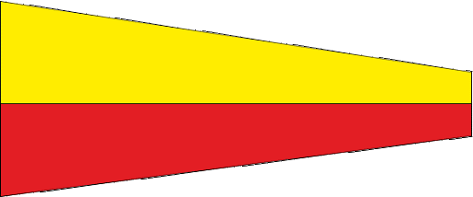 is displayed as the warning signal, all classes will start together.

Section 7. COURSES replaced as follow:

7. COURSE

7.1 One course for all divisions. See below:

# **Course**

Start – 1 – 2 -1 – Finish

1

RC

2