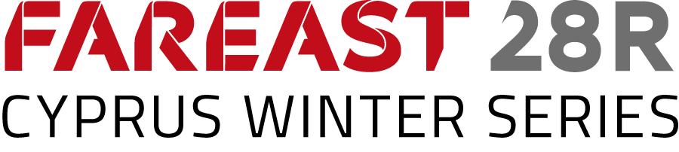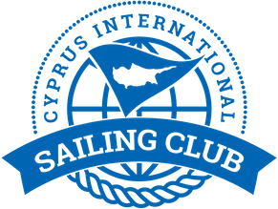

Yacht and Team for Cyprus Fareast 28R Winter Series, Stage 3

Yacht name | Yacht Sail | Yacht Number
Alfa | CYP 1 | 1
Bravo | CYP 2 | 2
Charlie | CYP 3 | 3
Delta | CYP 4 | 4
Echo | CYP 5 | 5
Foxtrot | CYP 6 | 6

Teams, skippers, yachts

Team name | Skippers’ name | Contact email | Yacht number
Leto Team | Andrii Sydorenko | Sidor_82@ukr.net
WhyNot! | Yury Troshin | y.troshin@mail.ru
Masha & Medvedi | Maria Pakhtusova | Bona-fides@bk.ru
Iron FX | Nicolas Epiphaniou | nepiphan@interyachting.com.cy
MIR | Ihor Matviienko | imsailinginfo@gmail.com
Fortunato team | Maksim Grishchev | maksimgrischev@gmail.com

