KFC- 26th Merdeka Regatta 2019
16TH -18TH August 2019
Kinabalu Yacht Club, Kota Kinabalu, Malaysia
The Organising Authority (OA) is the Kinabalu Yacht Club and the Sabah Sailing Association
SAILING INSTRUCTIONS
1 RULES
1.1 The event will be governed by the rules as defined in The Racing Rules of Sailing (RRS).
1.2 Sabah registered sailors are governed by the prescriptions of registration by the Sabah Sailing Association for State ranking and all Malaysian sailors are governed by the prescriptions of the Malaysian Sailing Association . This is a Malaysian Ranking Regatta and non discardable.
1.3 In all rules governing this event, the notations;
1.3.1 [DP] denotes a rule for which the penalty is at the discretion of the jury and may be less than a disqualification. See RRS Introduction- Notation.
1.3.2 [SP] denotes a rule for which a standard penalty may be applied by the race committee without a hearing. This changes RRS 63.1, A4 and A5.
1.3.3 [NP] denotes a rule that shall not be grounds for protests by a boat. This changes RRS 60.1(a).
1.4 The Equipment Rules of Sailing (ERS) will apply. The Jury has full discretion to approve any change to the ERS. The Race Committee shall act as the Technical Committee.
1.5 Charter Boats – In accordance with RRS Appendix G3, boats chartered through the organisers may carry national letters or sail numbers in contravention of her class rules.
1.6 Failure of supplied equipment by the organisers is not grounds for redress. This changes RRS 62.1(a).
1.7 If there is a conflict between a rule in the Notice of Race (NOR) and one in the Sailing Instructions, the rule in the Sailing Instructions shall take precedence. This changes RRS 63.7.
1.8 Optimist Novice, if included under the Notice of Race, are restricted to Sabah Sailors whose eligibility shall be determined by the Sabah Sailing Association.

2 NOTICES TO COMPETITORS
2.1 Notices to competitors will be posted on the Official Notice Board (ONB) located at the south side of the Kinabalu Yacht Club building.
3 CHANGES TO SAILING INSTRUCTIONS
Any change to the Sailing Instructions will be posted no later than two hours before the scheduled time of the first race affected, except that any change to the format or schedule of races will be posted by 2000h on the day before it will take effect.

4 SIGNALS MADE ASHORE
4.1 Signals made ashore will be displayed at flagstaff near the Kinabalu Yacht Club boat park entrance.
4.2 When flag AP is displayed ashore, “1 minute” is replaced with “not less than 15 minutes” in the race signal AP.

5 FORMAT
The event will consist of a single series of fleet races with a minimum of one race to constitute a series.
6 SCHEDULE OF RACES
6.1 Dates of racing:

15th Aug 2019 Thursday | Registration/Boat allocation | 0900hrs
16th Aug 2019 Friday | Registration/Boat allocation  Start of fleet racing | 0800hrs  1330hrs
17th Aug 2019 Saturday | Fleet racing | 1000hrs
18th Aug 2019 Sunday | Fleet racing  Last possible start  Prize giving  High Tea | 1000hrs  1400hrs  1700hrs  1800hrs

6.2 A maximum of 9 races are scheduled and no more than 4 races per day will be sailed.
6.3 To alert boats that a race or sequence of races will begin soon, the orange starting line flag (the orange flag) will be displayed with one sound at least five minutes before a warning signal is made.
6.4 On the last scheduled day of racing, no warning signal will be made after 1400hrs
7 CLASS FLAGS
The class flags will be as follows:
Fleet | Class Insignia | Background Colour
Optimist | Optimist logo (Black) | White
Optimist Novice | Optimist logo (Black) | Yellow
Laser 4.7 | 4.7 | White
Laser Radial/Standard | Laser (Red) | White
470/420 | 470 | White
Bic Techno | ICF "W"
8 RACING AREAS
The racing area will be in the waters outside of the Kinabalu Yacht Club.
SI Addendum A shows the location of the racing areas.
9 THE COURSES
9.1 The diagrams in SI Addendum B show the courses, including the approximate angles between legs, the order in which marks are to be passed, and the side on which each mark is to be left.
9.2 The Optimist Novice course will be given during a daily briefing.

10 MARKS
10.1 Marks DM1, DM2, DM3, will be yellow cylindrical buoys.
Marks OM1, OM2, OM3P, OM3S, OM4 will be red spherical buoys.
10.2 New marks, as provided in SI 12.1, will be Black spherical buoy.
10.3 The starting marks will be race committee vessels.
10.4 A race committee vessel signalling a change of a leg of the course is a mark as provided in SI 12.2.
11 THE START
11.1 The starting line will be between staffs displaying orange flags on the starting boat and a pin end boat displaying orange flag.
11.2 [DP][NP] Boats whose warning signal has not been made shall avoid the starting area during the starting sequence for other races and provide classes that are starting enough manoeuvring space to prepare for the start.
11.3 A boat that does not start within 4 minutes after her starting signal will be scored Did Not Start (DNS) without a hearing. This changes RRS A4 and A5.
12 CHANGE OF THE NEXT LEG OF THE COURSE
12.1 To change the next leg of the course, the race committee will (a) lay a new mark and remove the original mark as soon as practicable, or (b) move the finishing line to a new position, or (c) move the leeward gate marks. When in a subsequent change a new mark is replaced, it will be replaced by an original mark.
12.2 Except at a gate, boats shall pass between the race committee vessel signalling the change of the next leg and the nearby mark, leaving the mark to port and the race committee vessel to starboard. This changes RRS 28.
13 THE FINISH
13.1 Optimist and Laser 4.7 finish line : Between a Race committee vessel staff carrying an orange flag and a buoy carrying a blue flag
470/420 Laser Standard, Laser radial and Windsurfing finish line : Race Committee vessel staff carrying an orange flag and a blue round buoy .

13.2 [DP] When boats are finishing, boats who have finished shall avoid the finishing area, keeping well clear of all boats racing, and shall not act to interfere with a boat that has not finished.
14 PENALTY SYSTEM
14.1 RRS Appendix P will apply as changed by SI 14.2.
14.2 RRS P2.3 will not apply and RRS P2.2 is changed so that it will apply to any penalty after the first one.
15 TIME LIMITS AND TARGET TIMES
15.1 The time limits and target times in minutes are as follows:
Event | Time limit | Mark 1 time limit | Finishing window | Target time
All classes | 70 | 20 | 15 | 50

If no boat has passed Mark 1 within the Mark 1 time limit the race will be abandoned. Failure to meet the target time will not be grounds for redress. This changes RRS 62.1(a).
15.2 Boats failing to finish within the time stated in the finishing window after the first boat sails the course and finishes will be scored Did Not Finish (DNF) without a hearing. This changes RRS 35, A4 and A5.
16 PROTESTS, PENALTIES AND REQUESTS FOR REDRESS
16.1 Protest forms are available from the Race Office. Protests and requests for redress or reopening shall be delivered there within the appropriate time limit.
16.2 For each course area, the protest time limit is 60 minutes after the last boat has finished the last race of the day, or the race committee signals no more racing today, whichever is later.
16.3 Notices will be posted no later than 30 minutes after the protest time limit to inform competitors of hearings in which they are parties or named as witnesses. Hearings may be scheduled to begin up to 30 minutes before the end of protest time limit. Hearings will be held in the jury room located at Meeting Room upstairs of Kinabalu Yacht Club beginning at the time posted.
16.4 Notices of protests by the race committee, technical committee or protest committee will be posted to inform boats under RRS 61.1(b).
16.5 A list of boats that, under SI 14.1, have been penalised for breaking RRS 42, and under SI 16.7 will be posted.
16.6 [NP] For breaches of the SIs marked “[SP]”, the race committee may apply a standard penalty without a hearing. A boat that has been penalised with a standard penalty can neither be protested for the same incident by another boat nor can another boat request redress for this race committee action. The penalty will be a 5% scoring penalty (SCP) of the score for Did Not Finish (DNF), rounded to the nearest whole number (0.5 rounded upwards), applied to all races of the day. The scores of other boats shall not be changed; therefore, two boats may receive the same score. However, the penalty shall not cause the boat’s score to be worse than the score for Did Not Finish (DNF). The race committee may protest a boat when they consider the standard penalty to be inappropriate. This changes Appendix A5. When a penalty is given under SI 16.7 before a race is started, the penalty will remain if that race is restarted or re-sailed. This changes RRS 36.
16.7 On the last scheduled day of racing a request for redress based on a protest committee decision shall be delivered no later than 30 minutes after the decision was posted. This changes RRS 62.2.
16.8 Decisions of the International Jury will be final as provided in RRS 70.5.
17 SCORING
17.1 RRS B8 is deleted.
17.2 1 race is required to be completed to constitute the event.
17.3 (a) When 5 or less races have been completed, a boat’s series
score will be the total of her race scores.
(b) When from 6 to 9 races have been completed, a boat’s series score will be the total of her race scores excluding her worst score.
17.4 To request correction of an alleged error in posted race or series results, a boat may complete a scoring enquiry form available from the Race Office.
18 [NP] SAFETY REGULATIONS
18.1 [DP] All competitors shall wear a personal floatation device at all times whilst afloat, except briefly while changing or adjusting clothing, or personal equipment. Wet suits, dry suits and trapeze harnesses are not personal floatation devices. This changes RRS 40.
18.2 Personal floatation devices shall comply with appropriate international standards. The organising authority reserves the right to reject any personal floatation devices which it considers unsuitable.
18.3 [SP] Check-Out and Check-In Procedures:
18.3.1 Before launching on each scheduled racing day, a competitor from each boat shall personally Check-Out, by signing on the forms provided at the desk located near the Race Secretariat.
18.3.2 After returning ashore, a competitor from each boat shall personally Check-In, by signing on the forms provided at the Race Office, within the protest time limit.
18.4 [DP] A boat that retires from a race shall notify the race committee as soon as possible before leaving the course area, or if that is not possible, shall complete a retirement declaration form at the Race Office as soon as possible after returning ashore but no later than the protest time limit.
18.5 When the race committee displays flag V with repetitive sounds, all official and support vessels shall monitor the race committee radio channel for that course area for search and rescue instructions. This may be to collaborate with rescue tasks and shall stay in the course area until flag V is lowered, or the “All-Clear” has been confirmed by the Principal Race Officer (PRO).
18.6 Support vessels are encouraged for safety reasons to bring their own VHF radio and monitor channel 69 The emergency rescue channel for the race committee is also 69
19 [DP][NP] REPLACEMENT OF CREW OR EQUIPMENT
19.1 Substitution of competitors will not be allowed.
19.2 Substitution of damaged or lost equipment will not be allowed unless approved in writing by the technical committee. Requests for substitution shall be made to the technical committee at the first reasonable opportunity by filling in a relevant form at the Race Office. The substitution may only be permitted after the technical committee has checked and scrutinised both the damaged and the substituting equipment.
19.3 If the substitution was made on the water before or between races, both the damaged and the substituting equipment shall be presented to the Technical committee after the end of the day’s racing. Repairs or replacements required afloat may be approved after the race provided that either the race committee or the technical committee afloat are notified before the next race.
20 [DP][NP] EQUIPMENT AND MEASUREMENT CHECKS
20.1 On the water, a boat can be instructed by a member of the technical committee to proceed immediately to a designated area for inspection. Ashore, equipment may be inspected or measured at any time.
20.2 Once a boat has completed measurements, the hull may not be removed from the boat park without the permission of the race committee.
21 EVENT ADVERTISING
21.1 Competitor advertising will be restricted to World Sailing Regulation 20, Advertising Code.
21.2 [DP] Boats may be required to display advertising chosen and supplied by the organising authority. If this rule is broken, World Sailing Regulation 20.9.2 applies.
22 OFFICIAL VESSELS
Official vessels will be marked as follows:
RC Start and Finish Vessels only
(Orange Kinabalu Yacht Club Burgee or
Orange flag)
Other RC vessels | RC
Jury (J or Jury) | J
Technical Committee | M
Rescue/Safety | SAFETY
Press/Media | MEDIA
Spectators | SPECTATOR
Principal Race Officer | PRO

23 [DP][NP] SUPPORT VESSELS
23.1 Support persons shall stay outside areas where boats are racing from the time of the warning signal for the first fleet to start until all boats have finished or retired or the race committee signals a postponement, general recall or abandonment.
23.2 Support vessels shall display white flags bearing the three letter MNA code of the boats they are supporting or their State Flag. No other flags or identification shall be displayed by support boats unless approved by the race committee.
23.3 Support vessels shall comply with any rules that may be established by the race committee or organising authority.
24 TRASH DISPOSAL
Trash may be placed aboard support or official vessels.
25 [DP][NP] RADIO COMMUNICATION
Except in an emergency, a boat that is racing shall not make voice or data transmissions and shall not receive voice or data communication that is not available to all boats.
26 PRIZES
26.1 Medals will be awarded as per Notice of Race.
27 DISCLAIMER OF LIABILITY
Competitors participate in the event entirely at their own risk. See RRS 4, Decision to Race. The organising authority, or any other race officials and volunteers, will not accept any liability for material damage or personal injury or death sustained in conjunction with or prior to, during, or after the event.
28 [DP][NP] MEDIA RIGHTS, CAMERAS AND ELECTRONIC EQUIPMENT
28.1 By participating in this event, competitors and their support team automatically grant to the organising authority and any event sponsors, the right in perpetuity to make, use, and show at their discretion, any photographs, audio and video recordings, and other reproductions of them made at the venue, or on the water from the time of their arrival at the venue, until their final departure, without compensation.
28.2 Boats may be required to carry cameras, sound equipment or positioning equipment as specified by the organising authority. Information from such equipment shall not be used by a boat as evidence in a hearing. This changes RRS 63.6.
28.3 The equipment provided, once placed on the boat as instructed by the organising authority, shall not be manipulated by the competitor or the support person in any way, except when so required by the organising authority.
28.4 Competitors may be required for media interviews during the period of the event.

ADDENDUM A – Racing Areas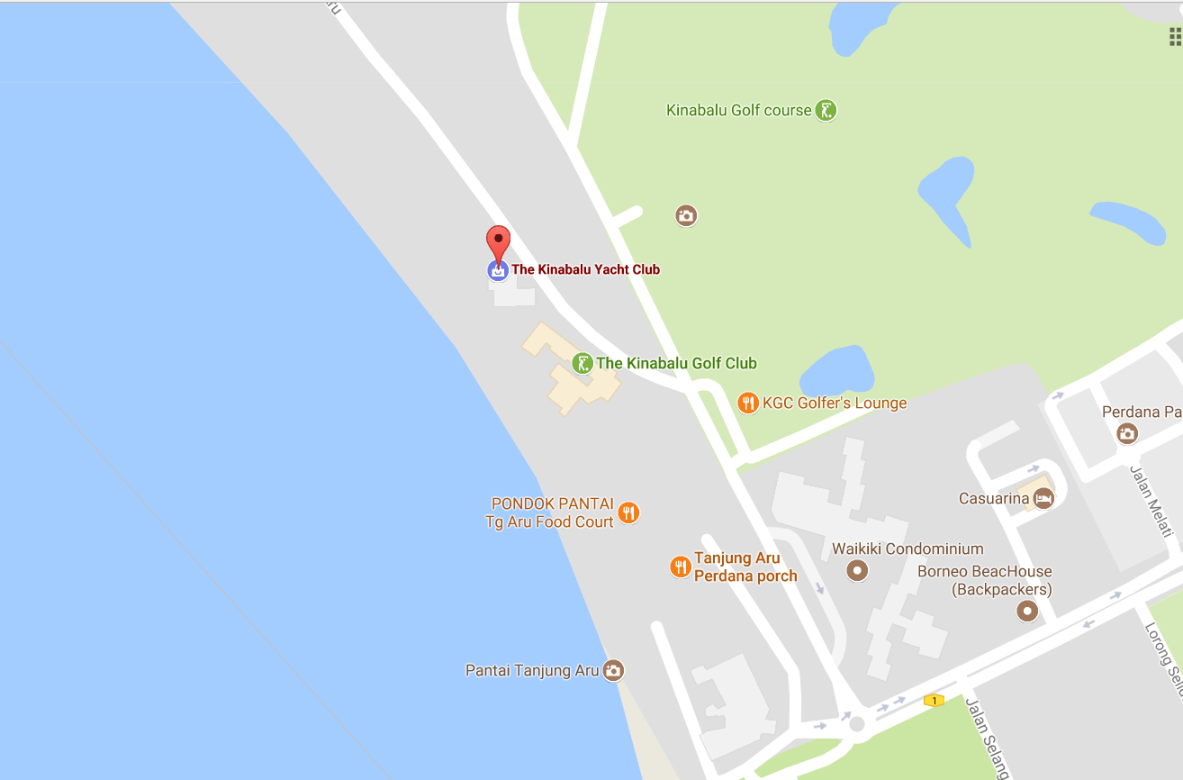
Main
Racing Area
Novice
Race Area

OPTIMISTS: START, OM1, OM2, OM3/P or OM3/S FINISH

LASER 4.7: START, OM1, OM4, OM1, OM2, OM3P OR OM3S, FINISH

WINDSURFERS,START,DM1,DM2,DM3&FINISH

LASER STD, LASER RADIAL, 470 & 420 : START, DM1, DM2, DM3, DM2, DM3 & FINISH.

WINDSURFERS, LASER,
470 & 420
FINISH VESSEL

DM2
DM3
DM1
OM2
OM1
OPTIMIST/ LASER 4.7 FINISH VESSEL

PORT END VESSEL
WIND
OM3S
ADDENDUM B

KFC - 26th MERDEKA REGATTA 2019
RACE COURSE
16th -18th AUGUST 2019 (NOT TO SCALE)

OM3P
START VESSEL
OM4

