Inaugural BDYA Sailing Championship 2019

SAILING INSTRUCTIONS FINAL ver 1
1 RULES
1.1The regatta will be governed by the rules as defined in The Racing Rules of Sailing.
1.2 No national prescriptions will apply.
1.3 In all rules governing this event, the notations;
1.3.1 [DP] denotes a rule for which the penalty is at the discretion of the jury and may be less than a disqualification. See RRS Introduction- Notation.
1.3.2 [SP] denotes a rule for which a standard penalty may be applied by the race committee without a hearing. This changes RRS 63.1, A4 and A5.
1.3.3 [NP] denotes a rule that shall not be grounds for protests by a boat. This changes RRS 60.1(a).
1.4 An on line notice board is available on www.racingrulesofsailing.org/events/706 or event titled “Inaugural BDYA Sailing Championship 2019” inside www.racingrulesofsailing.org . Competitors are encouraged to load the App racingrulesofsailing.org on their smartphones and register themselves to take advantage of the online access to the event on-line notices and forms.
1.5 Boats that are chartered to competitors by the Organising Authority shall not modify them or cause them to be modified in any way [DP] [NP] except that:
- a compass may be tied or taped to the hull or spars;
- wind indicators, including yarn or thread, may be tied or taped anywhere on the boat;
- hulls, center boards and rudders may be cleaned, but only with water;
- adhesive tape may be used anywhere above the water line; and
- all fittings or equipment designed to be adjusted may be adjusted, provided that the class rules are complied with.
1.6 All equipment provided with the boat as in SI1.5 for sailing purposes shall be in the boat while afloat. [DP] [NP]
1.7 The penalty for not complying with SI 1.5 and 1.6 may be less than or a disqualification from all races sailed in which the instruction was broken. [DP} [NP]
1.8 Competitors using chartered boats from the Organising Authority shall report any damage or loss of equipment, however slight, to the organizing authority’s representative immediately after securing the boat ashore. The penalty for breaking this instruction, unless the protest committee is satisfied that the competitor made a determined effort to comply, may be less than or a disqualification from the race most recently sailed. [DP] [NP]
1.9 Class rules requiring competitors to be members of the class association will not apply.

2 NOTICES TO COMPETITORS
Notices to competitors will be posted on the official notice board(s) located at the BDYA Sailing Center. An on-line notice board is available through www.racingrulesofsailing.org . See SI1.4.

3 CHANGES TO SAILING INSTRUCTIONS
Any change to the sailing instructions will be posted before 0900 on the day it will take effect, except that any change to the schedule of races will be posted by 2000 on the day before it will take effect. See SI 2 and SI1.4.

4 SIGNALS MADE ASHORE
4.1 Signals made ashore will be displayed at the flag post in front of the BDYA Sailing Center.
4.2 When flag AP is displayed ashore, ‘1 minute’ is replaced with ‘not less than 20 minutes’ in the race signal AP.
4.2 Flag D with one sound means ‘The warning signal will be made not less than 20 minutes after flag D is displayed. Boats shall not leave the berthing area until this signal is made. [DP]’

5 SCHEDULE OF RACES
5.1 | Date | Time | Event
 | 19th September Thursday | 0800 | Registration
 | 20th September Friday | 1400 | Marathon Race/ Series Races
 | 21st September Saturday | 1030 | Series Races
 | 22nd September Sunday | 1030 | Series Races
 |  | 1700 | Prize Giving after beach clean-up.

5.2The scheduled time of the warning signal for the first race each day is 1030 except on the 20th September when the first warning signal shall be 1400.
5.3 To alert boats that a race or sequence of races will begin soon, the orange starting line flag will be displayed with one sound at least five minutes before a warning signal is made.
On the last scheduled day of racing no warning signal will be made after 1500.
5.4 The RC will endeavor to start the Windsurfing Class first followed by the Laser Standard and Radial Classes, the Laser 4.7 Class and finally the Optimist Class. This sequence may be changed by the RC for practical reasons.

6 CLASS FLAGS
Class flags:
START SEQUENCE | CLASS | CLASS FLAG
1 | Windsurfing
2 | Laser Standard / Radial
3 | Laser 4.7 | 4.7
4 | Optimist

7 RACING AREAS
Addendum A shows the location of racing areas.

8 THE COURSES.
8.1The diagrams in Addendum B show the courses, including the approximate angles between legs, the order in which marks are to be passed, and the side on which each mark is to be left.
8.3 Courses may be shortened.
8.4 Legs of the course will not be changed after the preparatory signal. This changes RRS 33.

9 MARKS.
9.1 Marks DM1, DM2, DM3, OM4 will be Orange triangular buoys. Marks OM1 and OM2 will be Orange/Black cylinders.
9.2 The Starting and Finish port end marks will be black round buoys.
.
10 AREAS THAT ARE OBSTRUCTIONS
Areas that are designated as obstructions will be posted on the Official Notice Board.

11 THE START
11.1 Races will be started by using RRS 26 with the warning signal made 5 minutes before the starting signal.
11.2 The starting line will be between a staff displaying an orange flag on the starting vessel at the starboard end and the course side of the port-end starting mark.
11.3 Boats whose warning signal has not been made shall avoid the starting area during the starting sequence for other races. [DP] [NP]
11.4 A boat that does not start within 4 minutes after her starting signal will be scored Did Not Start without a hearing. This changes RRS A4 and A5.

12 CHANGE OF THE NEXT LEG OF THE COURSE
12.1 To change the next leg of the course, the race committee will move the original mark to a new position.

13 THE FINISH
13.1 The finishing line will be between a staff displaying blue flag on the finishing vessel at the starboard end and the course side of the port-end finishing mark. The Marathon Race Finish is the Start Line.

14 PENALTY SYSTEM
14.1 Appendix P will apply as changed by SI 14.2
14.2 RRS P2.3 will not apply and RRS P2.2 is changed so that it will apply to any penalty after the first one.

15 TIME LIMITS AND TARGET TIMES
15.1
TRAPEZOID COURSE RACES |  |  |  | MARATHON RACE See Addendum C
Class | Mark 1 | Finish | Time Limit after 1st boat | FINISH | Time Limit after 1st boat
Optimist | 15mins | 60mins | 15 mins | 2 Hrs | 30 mins
Laser 4.7 | 15mins | 60mins | 15 mins | 2 Hrs | 30 mins
Laser Std and Radial | 15mins | 60mins | 15 mins | 2 Hrs | 30 mins
Windsurfing | 10mins | 40mins | 10mins | 2 Hrs | 30 mins

If no boat has passed Mark 1 within the Mark 1 time limit the race will be abandoned. Failure to meet the target time will not be grounds for redress. This changes RRS 62.1(a). See Addendum C for Marathon special time limits.
15.2 Boats failing to finish within the time limit in SI15.1 after the first boat sails the course and finishes will be scored Did Not Finish without a hearing. This changes RRS 35, A4 and A5.

16 PROTESTS AND REQUESTS FOR REDRESS
16.1 Protest forms are available at the race office[, located at the BDYA Race secretariat or may be lodged via the on line site www.racingrulesofsailing.org or by scanning the QR Codes in Addendum D. Protests and requests for redress or reopening shall be delivered there within the appropriate time limit. See SI1.4.
16.2 For each class, the protest time limit is 60 minutes after the last boat has finished the last race of the day or the race committee signals no more racing today, whichever is later.
16.3 Notices will be posted no later than 30 minutes after the protest time limit to inform competitors of hearings in which they are parties or named as witnesses. Hearings will be held in the protest room, located at the BDYA Sailing Center Jury Room, beginning at the time posted.
16.4 Notices of protests by the race committee, technical committee or protest committee will be posted to inform boats under RRS 61.1(b).
16.5 A list of boats that, under SI 14.1, have been penalized for breaking RRS 42 will be posted both on the official notice board and the event on line notice board on www.racingrulesofsailing.org.
16.6 On the last scheduled day of racing a request for redress based on a protest committee decision shall be delivered no later than 30 minutes after the decision was posted. This changes RRS 62.2.
16.7 Decisions of the protest committee will be final as provided in RRS 70.5.

17 SCORING
17.1 The Appendix A low point scoring system shall apply with the following:
17.2 One race is required to be completed to constitute a series. There is no maximum number of races.
17.3
- When fewer than 4 races have been completed, a boat’s series score will be the total of her race scores.
- When 4 or more races have been completed, a boat’s series score will be the total of her race scores excluding her worst score.
17.4 The Marathon race (Addendum C) shall also constitute as one of the Series Race and shall not be discardable.
17.5 The Laser Standard and Laser Radial shall race together and their finishing times taken to obtain a separate Laser Overall score for Men and Women using the PY handicap as described in SI26(d)&(e) respectively. The Laser 4.7 is not included in this Laser Overall category.
17.6 The Bic Techno and Raceboards shall race together and have separate scores for each class. The top three men and women crossing the finish line from any class shall win the Men’s and Women’s Windsurfing Overall prizes described in SI26(k)&(l) respectively.

18 SAFETY REGULATIONS
18.1 All boats must sign out to race and after racing, sign in back to shore within the Protest Time Limit. The penalty for not signing in or signing out will be applied to the race nearest to the infringement. [SP] [NP]
18.2 A boat that retires from a race shall notify the race committee as soon as possible. [DP] [NP]
18.3 All competitors and support persons shall wear a personal buoyancy vest while afloat [DP][NP]

19 REPLACEMENT OF CREW OR EQUIPMENT
19.1 Substitution of competitors will not be allowed without prior written approval of the [race committee] [protest committee]. [DP] [NP]
19.2 Substitution of damaged or lost equipment will not be allowed unless authorized by the [race committee] [protest committee]. Requests for substitution shall be made to the committee at the first reasonable opportunity. [DP]

20 EQUIPMENT AND MEASUREMENT CHECKS
On the water, a boat can be instructed by a member of the race committee or the technical committee to proceed immediately to a designated area for inspection.

21 EVENT ADVERTISING
Boats are not required to display any advertisement by the Organising Authority. [DP] [NP]

22 OFFICIAL VESSELS
Official boats will be marked as follows:
RC flag for Race Committee Vessels.
SAFETY Flag for Safety Vessel.
JURY or J Flag for Jury Vessel.

23 SUPPORT VESSELS
23.1 Team leaders, coaches and other support persons shall stay outside areas where boats are racing from the time of the preparatory signal for the first class to start until all boats have finished or retired or the race committee signals a postponement, general recall or abandonment. [DP]
23.2 Support vessels shall be marked with Club/State sticker on the engine or Club/State flag. [DP] [NP]

24 TRASH DISPOSAL
Trash may be placed aboard support or official boats. [NP]

25 RADIO COMMUNICATION
Except in an emergency, a boat that is racing shall not make voice or data transmissions and shall not receive voice or data communication that is not available to all boats. [DP] [NP]

26 PRIZES
PRIZES/MEDALS
a) Laser Standard – Medals for 1st, 2nd and 3rd
b) Laser Radial – Medals for 1st, 2nd and 3rd
c) Laser 4.7 – Medals for 1st, 2nd and 3rd
d) Laser Men’s Overall – Medals for 1st, 2nd, 3rd and Champion’s Shield
e) Laser Women’s Overall – Medals for 1st, 2nd, 3rd and Champion’s Shield
f) Optimist – Medals for 1st, 2nd and 3rd
g) Optimist Boy’s Overall – Medals for 1st, 2nd, 3rd and Champion’s Shield
h) Optimist Girl’s Overall – Medals for 1st, 2nd, 3rd and Champion’s Shield
i) Windsurfing Bic Techno – Medals for 1st, 2nd and 3rd
j) Windsurfing Raceboard – Medals for 1st, 2nd and 3rd
k) Windsurfing Men’s Overall – Medals for 1st, 2nd, 3rd and Champion’s Shield
l) Windsurfing Women’s Overall – Medals for 1st, 2nd, 3rd and Champion’s Shield
m) Brunei closed (Male) -Medals for 1st, 2nd and 3rd and Best Male Local Sailor – Winner’s Shield
n) Brunei closed (Female) -Medals for 1st, 2nd and 3rd and Best Female Local Sailor – Winner’s Shield

27 DISCLAIMER OF LIABILITY
Competitors participate in the regatta entirely at their own risk. See RRS 4, Decision to Race. The organizing authority will not accept any liability for material damage or personal injury or death sustained in conjunction with or prior to, during, or after the regatta.

28 INSURANCE
Each participating boat shall be insured with valid third-party liability insurance. [NP] [DP]

- ADDENDUM A

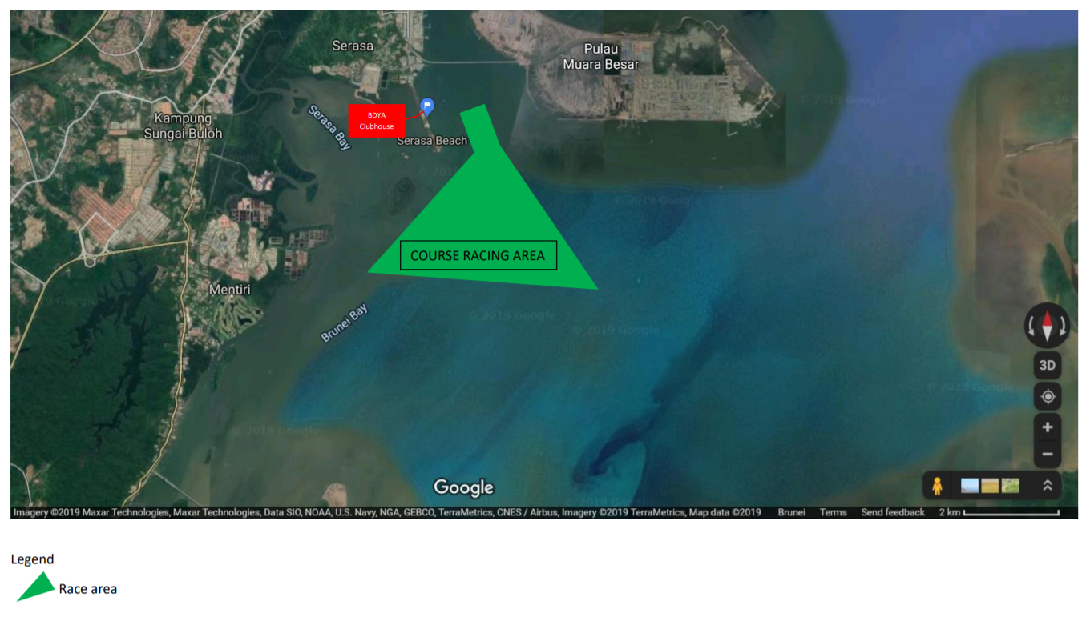
Figure 1 Course Racing Area.
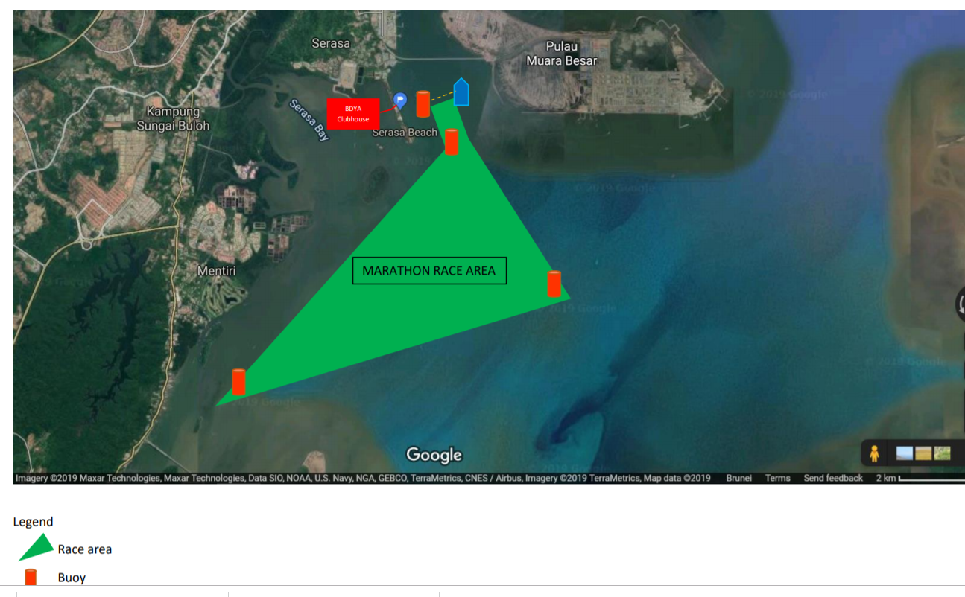
Figure 2 Marathon Racing Area
- ADDENDUM B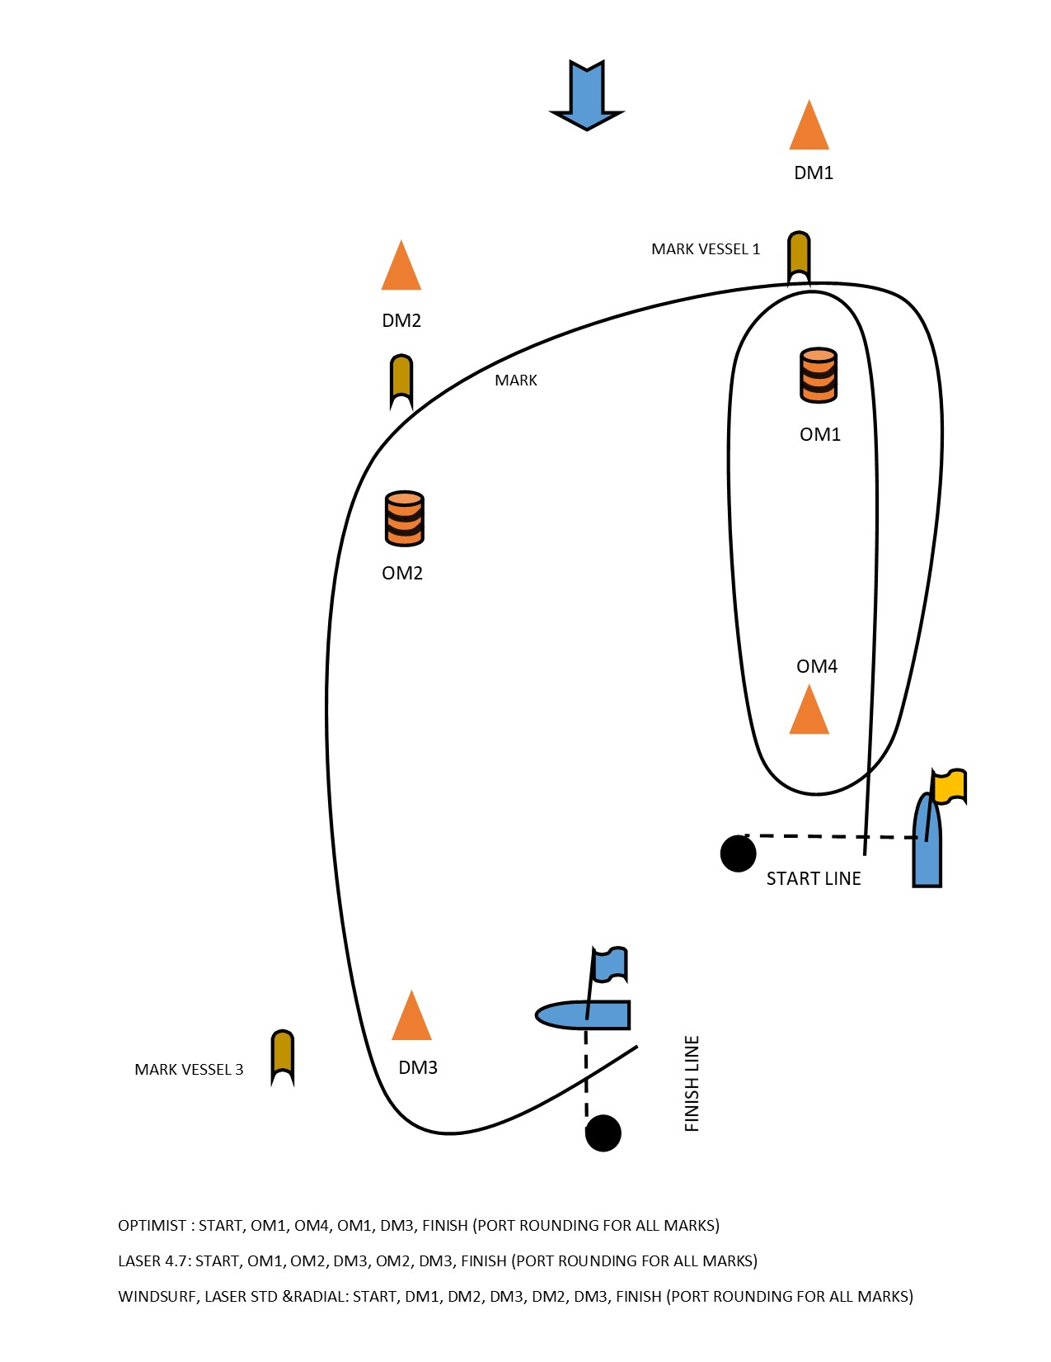Figure 3 Optimist Course
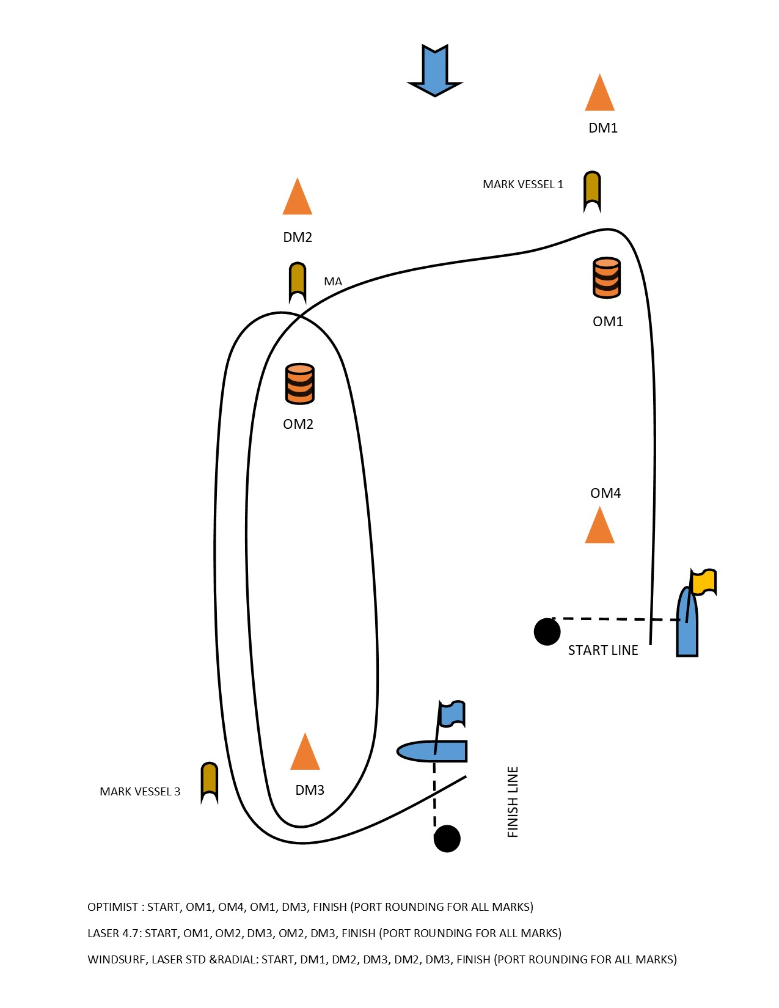
Figure 4 Laser 4.7 Course
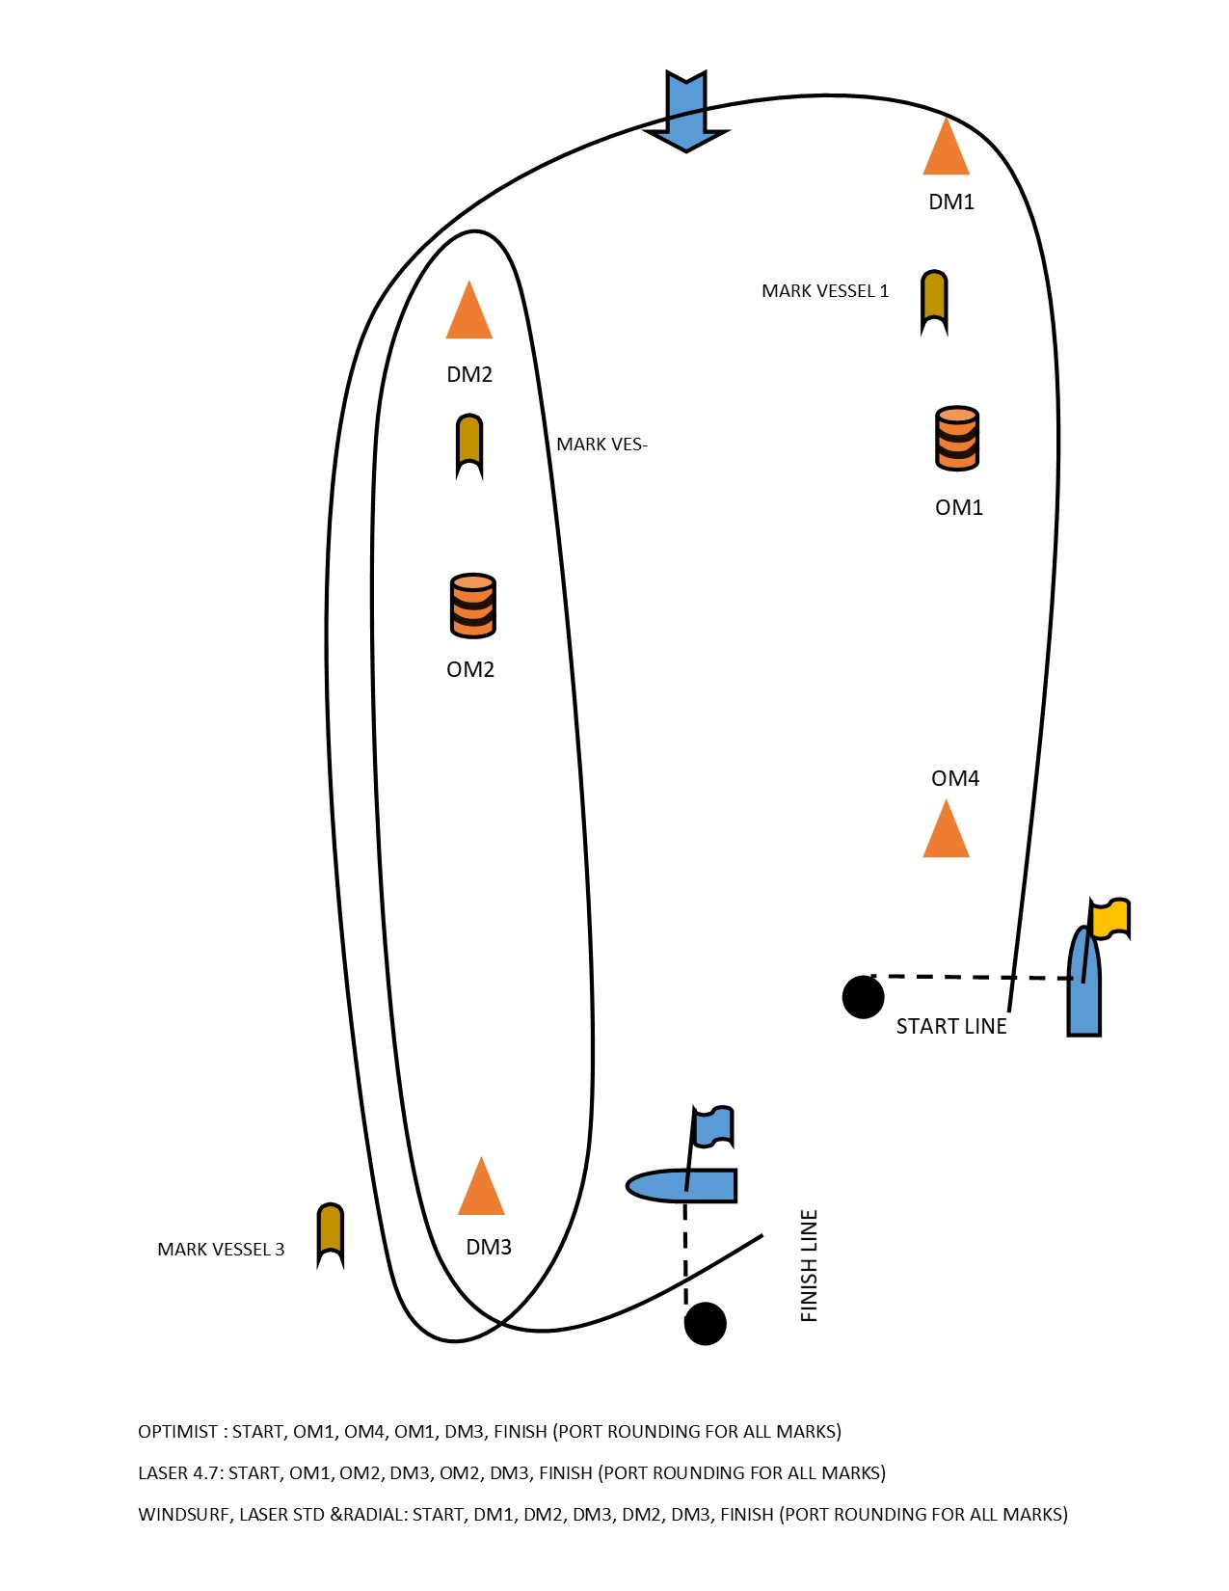Figure 5 Laser Standard, Laser Radial and Windsurfing course
3.ADDENDUM C
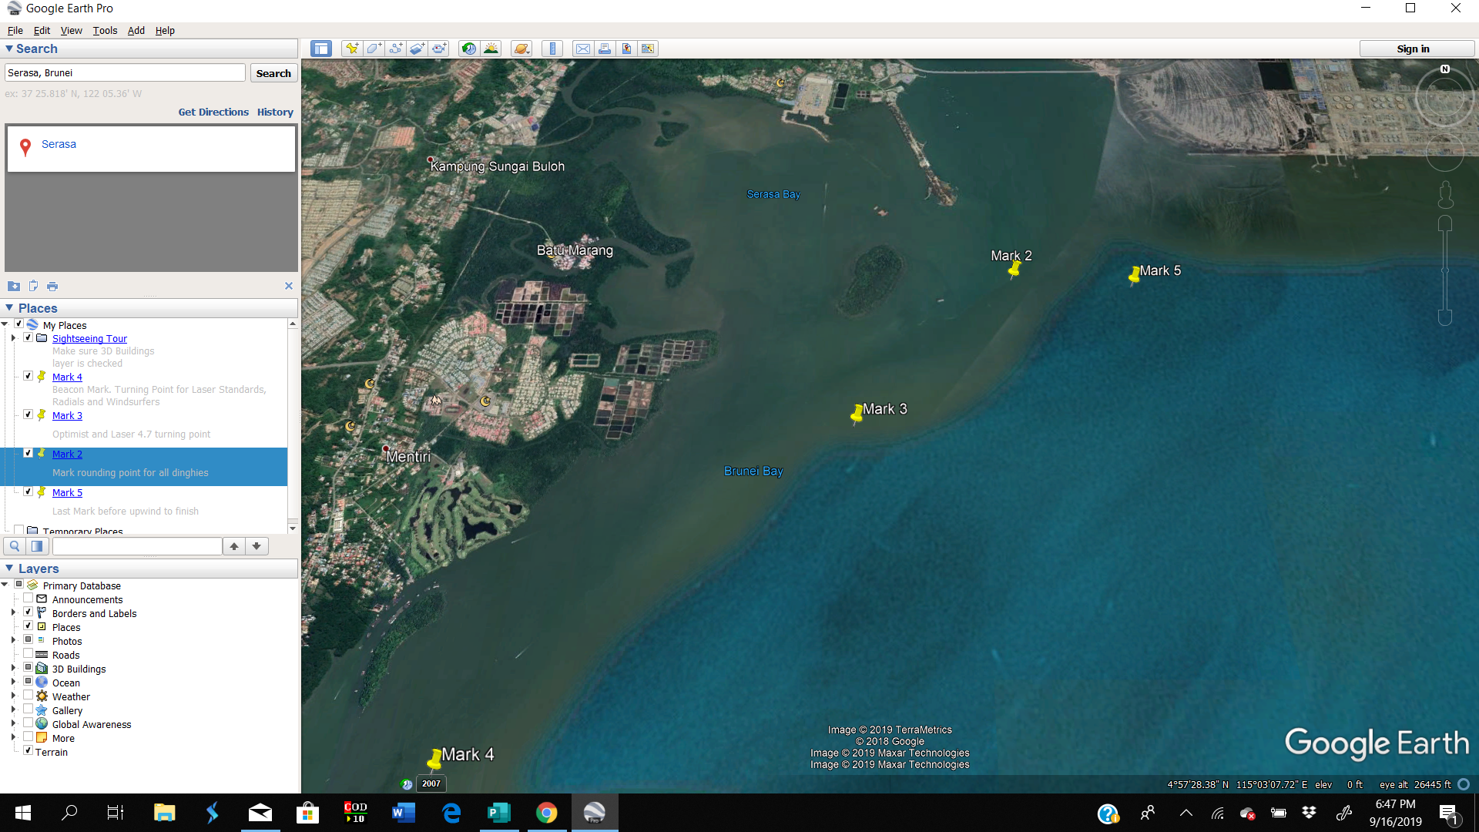
C1 . The Marathon Race course is shown in the diagram below.
Mark 4 GATE Laser Standard/Radial/ Boards
Mark 4 to port

Mark 3 GATE
Laser4.7/
Optimists
Mark 3 to port

Mark 3 & Mark 4
Start &
Finish
SHALLOW
Mark 1

Figure 6 Marathon Race Course. Yellow course for Laser Standard/Radial/Boards. Red Course for Optimists/Laser 4.7

C2. Laser Standard/ Radial/ Boards: Start, Mark1, Mark 2, Pass through Mark 3 Gate, Pass through Mark 4 Gate , Mark5,
Finish. All marks to be left on Port except Mark2 to be left on starboard.
C3. Laser 4.7/ Optimists: Start, Mark1, Mark2, Pass through Mark3 Gate, Mark 5, Finish. All marks to be left on Port except Mark2 to be left on starboard.
C4. If no Laser 4.7/Optimists finish within the time limit of 2 Hours, their finishing positions shall be taken from their respective positions when they crossed Mark 3 Gate.
C5. If no Laser Standards/Radials/Boards finish within the time limit of 2 Hours, their finishing positions shall be taken from their respective positions when they crossed Mark 4 Gate. If no Laser Standards/Radials/Boards cross the Mark 4 Gate within the time limit of 2 Hours, their finishing positions shall be taken from their respective positions when they crossed Mark 3 Gate.
C6. Between Mark 1 and Mark 2, in front of the spit, is a shallow area. Boats may be marshalled by Safety Vessels to stay clear for safety reasons and shall comply. [NP] [DP].
C7. Marks 1 and 2 are Orange Triangle Buoys. Mark 5 is an Orange and Black Cylindrical Buoy. Marks 3 and 4 are Channel Markers. The Start/Finish will be the same line between a staff of an Orange Flag on the RC vessel and a port end pink buoy.
C8. The order of starts will be Laser Standards/Radials/4.7 and Boards together followed by Optimists 5 minutes later.

4.ADDENDUM D

The Inaugural BDYA Sailing Championships 2019
Links to Public Information

Regatta officials are using a web-based program to assist with the management of this regatta. It provides electronic forms for such actions as scoring inquiries, protests, equipment substitutions, etc. And it provides for electronic communication with competitors if competitors have provided an email and/or telephone number accepting SMS. Competitors will be notified electronically of protest time limits, confirmation of a protest filing, scheduled hearing times, etc. This electronic system allows competitors to move freely about the event and remain in contact with relevant officials. And all competitors have electronic access to the scoring inquiries, jury decisions, etc.*

Notice: The Official Notice Board (ONB) is still the only official source of information for this regatta.
Protest Form Crew Substitution Request

Equipment Substitution Request Submit Question for Jury

Submit Scoring Inquiry Submit Penalty Report

NOTICE: When submitting a protest, request or report, the procedure (as set forth in the Racing Rules of Sailing and the Sailing Instructions) remains unchanged.

Online Notice Board Hearing Schedule

Questions for the Jury Protest Decisions

On the Water Penalties Crew Substitutions

Equipment Substitutions Scoring Inquiries

Penalty Reports

The jury and parties reserve the right to limit public access to certain decisions.*

