INTER CLUB TEAM RACING & INDIVIDUAL OPTIMIST SAILING CHAMPIONSHIP 2019
27th DECEMBER 2019 TO 2nd JANUARY 2020

Sailing Instructions
Optimist Team Race

Organising authority: Doha Marine Sports Club

1. Rules
1.1 The regatta will be governed by the rules as defined in The Racing Rules of Sailing (RRS), the Notice of Race and by these Sailing Instructions.
1.2 No national authority prescriptions will apply.
1.3. In all rules governing this Regatta:
1.3.1 [NP] denotes a rule that shall not be grounds for protests by a boat. This changes RRS 60.1(a).
1.3.2 [SP] denotes a rule which a standard penalty may be applied by the Race Committee without a hearing, or a discretionary penalty applied by the International Jury with a hearing. This changes RRS 63.1 and A5.
1.4 Rule 40 and the preamble to Part 4 are changed as follows:
1.4.1 The first sentence of rule 40 is deleted and replaced by: "Each competitor shall wear a personal flotation device (PFD) according to class rule 4.2 (a), properly secured at all times while on the water except when temporarily adding or removing clothing."
1.4.2 Add to the preamble of Part 4, after the word 'racing': " except rule 40 as amended by instruction 1.4.1"
1.5 The Class Rules of the Optimist Class will apply.
1.6.1. Appendix D will apply, including D2.2 (single flag procedure) but deleting D1.1 (d).
1.6.2. The first sentence of D3.1(d)(3) is deleted and replaced by: "when the boat has broken rule 1 or 2, rule 14 when she has caused damage or injury, or a rule when not racing, either the boat's score may be increased or half or more race wins may be deducted from her team, or no penalty may be imposed.".
1.7 [NP][DP]Boats shall be handled according to Attachment C.
1.8 Add rule 64.4 (b) to the list of rules in 63.1.
1.9 When a boat starts and finishes and breaks rule 28.1 by failing to sail the course described in the Sailing Instructions,6 points shall be added to her score without a hearing. This changes rule A5.
1.10 The language of the regatta will be English. If there is a conflict between languages the English text will take precedence.

2. [DP][NP] Advertising, Identification, Cameras and Electronic Equipment
2.1 Boats shall display event sponsor advertising, if required by the organising authority. The organizing authority will supply the advertising and instructions for their use.
2.2 Boats may be required to carry cameras, sound equipment or positioning equipment as specified by the organizing authority.
2.3 The use of other cameras, sound equipment or positioning equipment will not be allowed.
2.4 Boats shall display a coloured ribbon corresponding to the colour of her team, permanently fixed during the day’s races and free to fly from the top of the sprit. The ribbons will be supplied by the organising authority.
2.5 Competitor’s advertising is permitted on the Hull as per World Sailing Regulations 20.3.2 but as restricted by Class Rules 2.8.

3. [DP] Code of conduct
3.1 Competitors and support persons shall comply with any reasonable requests from a regatta official.
3.2 Competitors shall handle any boats or equipment provided by the organizing authority with proper care and seamanship, and in compliance with any written instructions.
3.3 [SP] Boats not racing shall avoid the area where boats are racing and any official boats.
3.4 [SP] Boats that are on a Course Area to which they are not assigned shall avoid the area where boats are racing and any official boat.
3.5 The organizing authority may reduce or remove a prize in the case of misconduct or refusal to comply with any reasonable request, including attendance at official functions.

4. Notices to Competitors
Notices to competitors will be posted on the official notice board (ONB) located on the windows of the Race Office.

5. Changes to the Sailing Instructions
5.1 Any written changes to the Sailing Instructions or the schedule will be posted on the Official Notice Board at least 30 minutes before the warning signal of the race in which it will take effect.
5.2 Sailing Instructions may be changed orally by the Race Committee and/or the Umpires before the warning signal when flag L is displayed. It is the responsibility of each team to obtain any oral instructions given. These changes will also be communicated to the teams and coaches at the coaches' station and posted on the Official Notice Board at the end of that day's racing.
5.3 Changes to the format of racing, the allocation of boats and the publication of the schedule of subsequent races made on the water will be announced as described in SI 5.2.

6. Signals Made Ashore
6.1 Signals made ashore will be displayed on the flag pole located next to the launching ramp.
6.2 When flag AP is displayed ashore, ‘1 minute’ is replaced with ‘not less than 45 minutes' in race signal AP.
6.3[SP] [DP] Flag D with a sound signal means: ‘The warning signals will be made not less than 30 minutes after flag D is displayed or not before the scheduled time, whichever is later. Boats shall not leave their allocated berths until this signal is made.

7. Format of racing
7.1 The intention is to provide as much racing as possible for all teams in the period available.
7.2 The format consists of single round robin for the teams. Each win scores 1 point.
7.3 The regatta format and race schedule may be modified by the Race Committee, and notwithstanding SI 7.2, is subject to change at any time. Details, and any changes, will be posted on the Official Notice Board at least 30 minutes before the warning signal of any race concerned.
7.3 The regatta format and race schedule may be modified by the Race Committee as per SI 5.2.
7.4 The Race Committee may terminate any stage, or the event, when in its opinion it is impractical to attempt to hold the remainder of the races under the existing conditions or in the remaining time scheduled.

8. Schedule
8.1 Daily schedule:
Friday, 27th December 2019 - Official arrival day
09:00 – 17:00 | Registration (Team & Fleet Racing)
Saturday, 28th December 2019 – Team Racing
09:30 | Team Leaders Meeting, Sailors Briefing and draw of teams
11:00 | Team Racing Optimist Class
Wednesday, 1st January 2020
TBD | Closing Ceremony

9. Reserved

10. Racing Areas
Attachment A shows the location of racing areas.

11. The Courses
11.1 The diagrams in Attachment B show the course, the order in which marks are to be passed, and the side on which each mark is to be left.
11.2 The Race Committee will set a course to be sailed in approximately 6 - 8 minutes. An actual shorter or longer racing time shall not be grounds for redress.
11.3 Courses will not be shortened. This changes RRS 32.

12. Marks
12.1 Marks 1, 2, 3 and 4 will be Red inflatable cylindrical buoys.
12.2 The starting marks will be the race committee starting boat at the starboard end and a boat displaying an orange flag (or buoy with staff displaying an orange flag) at the port end.
12.3 The finishing marks will be the race committee finishing boat at the starboard end and a boat displaying an orange flag (or buoy with staff displaying an orange flag) at the port end.
12.4 Marks may be moved at any time. This changes RRS 27.2 and RRS 33 will not apply.

13. The Start
13.1 The starting line will be between staffs displaying orange flags on the starting marks.
13.2 RRS 26 and RRS 27.1 are changed. The races will be started as follows:
Signal | Min. before  starting signal | Sound Signal | Visual Signal
Warning | 3 | One | Class flag displayed
Preparatory | 2 | One | Code flag P displayed
One-minute | 1 | One | Code flag P removed
Starting | 0 | One | Class flag removed
13.3 Times shall be taken from the visual signals; the failure of a sound signal shall be disregarded.
13.4 When the warning signal for the first fleet has been made, boats from other fleets shall be in the pre-start area, well clear of the starting area.
13.5 The race number and the teams to start will be displayed on the stern of the Race Committee boat before the warning signal. When the race number is displayed in this way, it overrides all prior communications, schedules or instructions. The Race Committee may at any time remove a particular race from the published sequence of races and run it later.
13.6 [DP][NP] Boats not racing shall sail to the Waiting Area to leeward of the starting line keeping well clear of boats racing and of all boats whose warning signal has been made. Two round orange fender buoys may indicate the windward boundary of this area.
13.7 [DP][NP] Immediately after finishing, boats being changed for the next set of races shall return directly to the Coaches' Station (Boat) keeping well clear of all boats racing and of all boats whose warning signal has been made.

14. The Finish
The finishing line will be between orange flags on the finishing marks.

15. Time limits and abandonment
15.1 The Race Committee may abandon a race for any reason. This changes RRS 32.

15.2 The Race Committee and/or the umpires may signal abandonment orally. Abandoned races may be re-sailed, and if so, a new warning signal will be made as soon as practical. This changes RRS 32 and Race Signals.

16. Umpiring and Flags
16.1 The event will be umpired in accordance with Appendix D as modified by these Sailing Instructions. Some races may have more Umpires than others as determined by the Chief Umpire.
16.2 The required red protest flag shall be attached to the competitor, clothing or PFD and shall be capable of being displayed at arm's length. To signal a protest, the flag shall be displayed from a concealed position to a position where it is easily visible to the protested boat and Umpires.

17. Protests and requests for redress
17.1 For protests and requests for redress other than protests under a rule listed in RRS D2.2, competitors shall inform an Umpire or the Race Committee at the first reasonable opportunity upon finishing. The Umpires will, when appropriate, hear protests and requests for redress while afloat.
17.2 The protest time limit for competitors is two minutes after finishing and for the Race Committee or Jury it is 60 minutes after the last boat finishes the last race of the day.
17.3 A hearing may be declined if it is not relevant to progress to the next round. This changes rule 63.1.
17.4 When a hearing ashore is necessary, the schedule will be published no later than 30 minutes after the end of the protest time limit.
17.5 Decisions of the Jury will be final as provided in rule 70.5.

18. [DP][NP] Safety Regulations
18.1 Check-out and check-in procedure will be established. All competitors, coaches or team leaders must sign:
a) before leaving to race on each scheduled day after flag D is displayed ashore.
b) within the protest time limit after returning ashore.
The check-out and check-in point will be located in front of the Race Office.
18.2 Boats not leaving the harbour for the day's races shall notify the regatta office as soon as possible.
18.3 A boat that retires from racing shall notify the race committee before leaving the racing area, or if that is not possible, shall notify the regatta office as soon as possible after returning ashore.
18.4 Competitors who require assistance shall blow a whistle or wave the paddle or one arm. The Race Committee reserves the right to assist competitors who in their opinion require assistance, regardless of the wishes of the competitor. This will not be grounds for redress. This changes rule 62.1(a).
18.5 When the race committee displays flag V with repetitive sounds all registered support boats shall comply with any instruction given by the race committee or the Organizing Authority as assistance / rescue boats.

19. Official Boats
Official boats will be marked as follows:

Official Boat | Flag
Race Committee | Flag " RC"
PRO | Flag “PRO”
Jury | Flag “JURY”
VIP | Flag “VIP”
Press/Media boats | Flag “MEDIA”
Rescue Boat | Flag “RESCUE”
Medical | Flag " + "

20. Coaches Station
20.1 There will be a special Coaches' Station (BOAT) close to the start to be used by the coaches and the spare team members.
20.2 [NP][DP] Communication between team members and coaches is only allowed at the Coaches Station.
20.3 Coaches are required to carry a working VHF radio
20.4 The Race Committee will communicate at

- Race Area 1 - VHF channel 5
- Race Area 2 - VHF channel 6

21. [DP][NP] Trash disposal
In addition to RRS 55 trash may be placed aboard support and race committee boats.

22. [DP][NP] Radio Communication
A boat shall neither make radio transmissions while racing nor receive radio communications not available to all boats, except in an emergency or when using equipment provided by the race committee. This restriction also applies to mobile telephones.

23. Prizes and title
Prizes will be awarded as defined in the Notice of Race.

24. Disclaimer of Liability and Risk Statement
24.1 Competitors and support team participate in the regatta entirely at their own risk and they are reminded of the provisions of RRS 4, Decision to Race. Sailing is by its nature an unpredictable sport and therefore involves an element of risk. By taking part in the event, each competitor agrees and acknowledges that:

1. They are aware of the inherent element of risk involved in the sport and accept responsibility for the exposure of themselves, their crew and their boat to such inherent risk whilst taking part in the event;
2. They are responsible for the safety of themselves, their crew, their boat and their other property whether afloat or ashore;
3. They accept responsibility for any injury, damage or loss to the extent caused by their own actions or omissions;
4. By participating in any race, they are satisfied that their boat is in good order, equipped to sail in the event and they are fit to participate;
5. The provision of a race management team, patrol boats, umpires and other officials and volunteers by the organiser does not relieve them of their own responsibilities;
6. The provision of patrol boat cover is limited to such assistance, particularly in extreme weather conditions, as can be practically provided in the circumstances.
24.2 The Organising Authority and all parties involved in the regatta organisation will not accept any liability for material damage or personal injury or death sustained in conjunction with or prior to, during, or after the regatta.

25. Rights to use name and likeness
By participating in this regatta competitors automatically grant to the Organizing Authority and their sponsors the right in perpetuity to make, use and show, from time to time at their discretion any motion pictures, still pictures and live, taped or filmed television and other reproductions of the athlete during the regatta, and of all of his or her material related to the regatta, without compensation.

26. Insurance
26.1 Each participating boat shall be insured with valid third party liability insurance with coverage taking into account the value of the boats.
26.2 The Organizing Authority is not responsible for verifying the status or validity of certificates.
Attachment A – Race Area

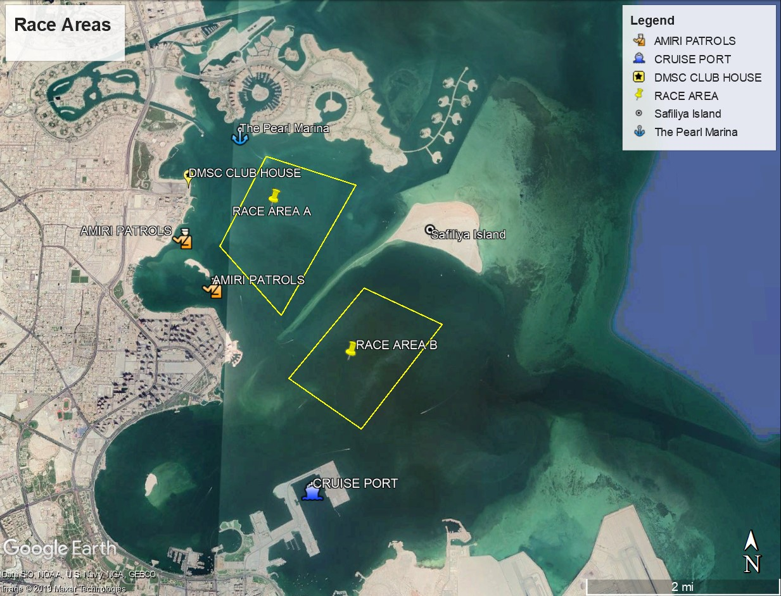

Attachment B – Course

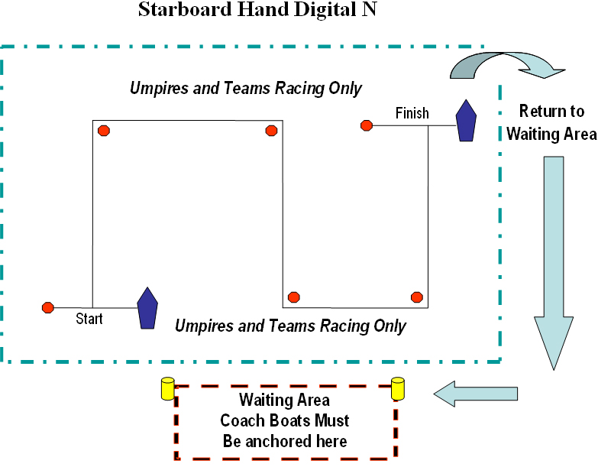
Attachment C – Handling the Boats

- GENERAL
  - While all reasonable care is taken to equalize the boats, variations will not be grounds for redress. This changes rule 62.
  - Competitors shall report to the Race Committee at the first reasonable opportunity after returning to shore any equipment damage or malfunction.
- PROHIBITED ITEMS AND ACTIONS
  - Except in an emergency or in order to prevent damage or injury, or when directed by an umpire otherwise, the following is prohibited:
- Any additions, omissions or alterations to the equipment supplied.
- The use of any equipment for a purpose other than that intended or specifically permitted.
- The replacement of any equipment without the permission of the Race Committee.
- Sailing the boat in a manner that it is reasonable to predict that significant further damage would result.
- Moving equipment from its normal stowage position except when being used.
- Boarding a boat without prior permission.
- Marking directly on the hull or deck with permanent ink.
- ADDITIONAL RULES THAT APPLY
  - When boats change hands from one team to the next, sailors coming out of the boats must make sure the boats are handed over in conformity with the Class Rules.
  - While afloat, rigs shall not be lowered, and sail ties shall not be adjusted, except with prior permission of the Race Committee or an umpire.
- MANDATORY ITEMS AND ACTIONS
  - The following is mandatory:
- The completion of a written damage report before leaving a boat and submitting it to the RC, even if no damage or loss is recorded. Reports shall include any evidence of matters that could cause damage or disadvantage to the boat in future matches.
- At the end of each sailing day:
- folding, bagging and placement of the sails as directed
- leaving the boat in the same state of cleanliness as when first boarded that day
  - At the end of the final day for a particular boat, cleaning the boat, removing all trash and removing all tape and marks.
  - Any request to alter, in any way, the equipment on a boat shall be in writing and worded to permit a yes/no answer.

