INTER CLUB TEAM RACING & INDIVIDUAL OPTIMIST SAILING CHAMPIONSHIP 2019
27th DECEMBER 2019 TO 2nd JANUARY 2020

Sailing Instructions
Optimist Class

Organising authority: Doha Marine Sports Club

1. Rules
1.1 The regatta will be governed by the rules as defined in The Racing Rules of Sailing (RRS), the Notice of Race and by these Sailing Instructions.
1.2 No national authority prescriptions will apply.
1.3. In all rules governing this Regatta:
1.3.1 [NP] denotes a rule that shall not be grounds for protests by a boat. This changes RRS 60.1(a).
1.3.2 [SP] denotes a rule which a standard penalty may be applied by the Race Committee without a hearing, or a discretionary penalty applied by the International Jury with a hearing. This changes RRS 63.1 and A5.
1.4 Rule 61.1 "Informing the Protestee" is changed as follows:
Add to rule 61.1(a) "The protesting boat shall inform the Race Committee of the boat/s being protested at the finishing line immediately after finishing."
1.5 Rule 40 and the preamble to Part 4 are changed as follows:
1.5.1 The first sentence of rule 40 is deleted and replaced by: "Each competitor shall wear a personal flotation device (PFD) according to class rule 4.2 (a), properly secured at all times while on the water except when temporarily adding or removing clothing."
1.5.2 Add to the preamble of Part 4, after the word 'racing': " except rule 40 as amended by instruction 1.5.1"
1.6 The Class Rules of the Optimist Class will apply.
1.7 [DP] Chartered boats shall be handled according to Attachment D.
1.8 The language of the regatta will be English. If there is a conflict between languages the English text will take precedence.

2. [DP][NP] Advertising, Identification, Cameras and Electronic Equipment
2.1 Boats shall display event sponsor advertising, if required by the organising authority. The organizing authority will supply the advertising and instructions for their use.
2.2 Boats may be required to carry cameras, sound equipment or positioning equipment as specified by the organizing authority.
2.3 The use of other cameras, sound equipment or positioning equipment will not be allowed.
2.4 Competitor’s advertising is permitted on the Hull as per World Sailing Regulations 20.3.2 but as restricted by Class Rules 2.8.

3. [DP] Code of conduct
3.1 Competitors and support persons shall comply with any reasonable requests from a regatta official.
3.2 Competitors shall handle any boats or equipment provided by the organizing authority with proper care and seamanship, and in compliance with any written instructions.
3.3 [SP] Boats not racing shall avoid the area where boats are racing and any official boats.
3.4 [SP] Boats that are on a Course Area to which they are not assigned shall avoid the area where boats are racing and any official boat.
3.5 The organizing authority may reduce or remove a prize in the case of misconduct or refusal to comply with any reasonable request, including attendance at official functions.

4. Notices to Competitors
Notices to competitors will be posted on the official notice board (ONB) located on the windows of the Race Office.

5. Changes to the Sailing Instructions
5.1 Any change to the sailing instructions will be posted before 09:00 hrs on the day it will take effect, except that any change to the schedule of the first races of a day will be posted by 20:00 hrs on the day before the day it will take effect.
5.2 Any re-assignment of course areas can be done 30 minutes before flag D is displayed ashore or 30 minutes before flag AP is removed ashore.

6. Signals Made Ashore
6.1 Signals made ashore will be displayed on the flag pole located next to the launching ramp.
6.2 When flag AP is displayed ashore, ‘1 minute’ is replaced with ‘not less than 45 minutes' in race signal AP.
6.3[SP] [DP] Flag D with a sound signal means: ‘The warning signals will be made not less than 45 minutes after flag D is displayed or not before the scheduled time, whichever is later. Boats shall not leave their allocated berths until this signal is made.

7. Regatta format
7.1 The regatta will be sailed in single series.
7.2 There are fewer than 80 entries all boats will sail in one fleet.
7.5 Assignments will be based on the ranking available at 20:00 that day regardless of protests or requests for redress not yet decided.

8. Schedule
8.1 Daily schedule:
Friday, 27th December 2019 - Official arrival day
09:00 – 17:00 | Registration (Team & Fleet Racing)
Saturday, 28th December 2019 – Team Racing
09:30 | Team Leaders Meeting, Sailors Briefing and draw of teams
11:00 | Team Racing Optimist Class
Sunday, 29th December 2019 – Fleet Racing
09:30 | Team Leaders Meeting
11:00 | Racing
Monday, 30th December 2019 – Fleet Racing
09:30 | Team Leaders Meeting
11:00 | Racing
Tuesday, 31st December 2019 – Fleet Racing
09:30 | Team Leaders Meeting
11:00 | Racing
Wednesday, 1st January 2020 – Fleet Racing
09:30 | Team Leaders Meeting
11:00 | Racing
TBD | Closing Ceremony
8.2 No more than 3 races shall be sailed each day.
8.3 Races not sailed on the scheduled day may be sailed on a following day at the discretion of the race committee.
8.4 The warning signal for each succeeding race will be made as soon as practicable.
8.5 No warning signal will be made after 15:30 on the last day.

9. Class Flags
9.1 For the single series class flag will be: Optimist class insignia on white backgroud

10. Racing Areas
Attachment A shows the location of racing areas.

11. The Courses
11.1 The diagrams in Attachment B show the courses, the course designations, the approximate angles between legs, the order in which marks are to be passed, and the side on which each mark is to be left.

12. Marks
12.1 Marks 1, 2 and 3 (3s/3p) will be Red inflatable cylindrical buoys.
12.2 The starting marks will be the race committee starting boat at the starboard end and a boat displaying an orange flag (or buoy with staff displaying an orange flag) at the port end.
12.3 The finishing marks will be the race committee finishing boat at the starboard end and a boat displaying an orange flag (or buoy with staff displaying an orange flag) at the port end.
12.4 New marks as provided in instruction 14.1 will be Yellow inflatable cylindrical buoys.
12.5 A race committee boat signalling a change of course is a mark as provided in S.I. 14.2.
13. The Start
13.1 The starting line will be between staffs displaying orange flags on the starting marks.
13.2 To alert boats that a race or sequence of races will begin soon, the orange starting line flag will be displayed with one sound for at least five minutes before a warning signal is displayed.
13.3 [DP][NP] Boats that have finished shall return directly to the starting area or ashore, keeping well clear of all boats racing and of all boats whose warning signal has been made.
13.4 A boat starting later than four minutes after her starting signal will be scored DNS. This changes RRS A4 and A5.

14. Change of the Position of the Next Mark
14.1 To change the next leg of the course, the race committee will:
(a) lay a new mark;
(b) move the finish line; or
(c) move the leeward mark/gate.
When a new mark is laid, the original mark will be removed as soon as practicable. When in a subsequent change a new mark is replaced, it will be replaced by an original mark.
14.2 Except at a gate, boats shall pass between the race committee boat signalling the change of course and the nearby mark, leaving the mark to port and the race committee boat to starboard. This changes RRS 28.1.
14.3 In case of a missing mark at a gate the remaining mark should be rounded, leaving the mark to port. This changes RRS 28.1.

15. The Finish
The finishing line will be between orange flags on the finishing marks.

16. Penalty System
16.1 Appendix P, Special Procedures for RRS 42, will apply.
16.2 RRS P2.3 will not apply and RRS P2.2 is changed so that it will apply to any penalty after the first one.

17. Time Limits
17.1 Time limits are as follows:
Time Limit | Mark 1 time limit | Finish window | Race Target time
75 min. | 25 min. | 15 min. | 40 min.
17.2 If no boat has passed Mark 1 within the Mark 1 time limit the race will be abandoned.
17.3 Boats failing to finish within the time stated in the Finish Window after the first boat sails the course and finishes will be scored Did Not Finish. This changes RRS 35, A4 and A5.
17.4 Failure to meet the target time will not be grounds for redress. This changes RRS 62.1(a).

18. Protests
18.1 In addition to conformance to RRS 61, the protesting boat shall approach the Race Committee boat stationed at the starboard end of the finishing line immediately after finishing and inform her of the boat/s being protested by hailing the protested boat’s sail number/s. Acknowledgement of the intention to protest should be obtained from the Race Committee on the finish boat.
18.2 Protest forms are available at the Regatta Office. Protests and requests for redress or reopening shall be delivered there within the appropriate time limit.
18.3 The protest time limit is 60 minutes after the last boat has finished the last race of the day or racing has been postponed or abandoned for the day.
18.4 Notices will be posted within 30 minutes of the protest time limit to inform competitors of hearings in which they are parties or named as witnesses. Hearings will be held in the protest room beginning at the time posted. Hearings may be scheduled to begin up to 30 minutes before the end of the protest time. No protest hearing will start after 21:00 hours.
18.5 Notices of protests by the race committee or jury will be posted to inform boats under RRS 61.1(b).
18.6 A list of boats that have been penalized under Appendix P for breaking RRS 42 will be posted.
18.7 Breaches of rules in the sailing instructions marked [NP] will not be grounds for a protest by a boat. This changes RRS 60.1(a).
18.8 Penalties for breaches of the RRS, Class Rules, RRS 55 or rules in the NoR and SIs marked [DP] or [SP] should the case go to a hearing, are at the discretion of the International Jury. A boat may accept a discretionary penalty for the breaches stated above before a hearing concerning the same incident by completing a form available at the jury office.
18.9 For breaches of the SIs marked [SP] the race committee may apply a standard penalty without a hearing. A list of these breaches and the associated standard penalties will be posted on the Official Notice Board. However, the race committee may protest a boat when they consider the standard penalty to be inappropriate. A boat that has been penalised with a standard penalty can neither be protested for the same incident by another boat nor can another boat request redress for this race committee action. This changes RRS 60.1, 63.1 and Appendix A5.
18.10 On the last racing day of racing, a request for redress based on the jury decision shall be delivered no later than 30 minutes after the decision was posted. This changes RRS 62.2.
18.11 Decisions of the jury will be final as provided in RRS 70.5.
18.12 Protests may be heard under RRS N1.4(b). The time limit for requesting a hearing by a full International Jury is 15 minutes after the parties were informed of the panel's decision.

19. Scoring
19.1 The Low Point System of RRS Appendix A will apply.
19.2 RRS A4.2 is changed so that the scores are based on the number of boats assigned to the largest fleet.
19.3 If at the end of the last day of races some boats have more race scores than others, scores for the most recent races will be excluded so that all boats have the same number of race scores.
19.4 To request correction of an alleged error in posted race or series results, a boat may complete a scoring enquiry form available at the race office.
19.5 At least 3 races are required to be completed to constitute the regatta series.
19.6 Discards:
19.6.1 When fewer than 4 races have been completed, a boat’s series score will be the total of her race scores.
19.6.2 When 4 or more races have been completed, a boat’s series score will be the total of her race scores excluding her worst score.

20. [DP][NP] Safety Regulations
20.1[SP] Check-out and check-in procedure will be established. All competitors, coaches or team leaders must sign:
a) before leaving to race on each scheduled day after flag D is displayed ashore.
b) within the protest time limit after returning ashore.
The check-out and check-in point will be located in front of the Race Office.
20.2[SP] Boats not leaving the harbour for the day's races shall notify the regatta office as soon as possible.
20.3[SP] A boat that retires from racing shall notify the race committee before leaving the racing area, or if that is not possible, shall notify the regatta office as soon as possible after returning ashore.
20.4 Competitors who require assistance shall blow a whistle or wave the paddle or one arm. The Race Committee reserves the right to assist competitors who in their opinion require assistance, regardless of the wishes of the competitor. This will not be grounds for redress. This changes rule 62.1(a).

21. [DP][NP] Replacement of Equipment
21.1 Substitution of damaged or lost equipment will not be allowed unless approved in writing by the Race Committee. Requests for substitution shall be made to the Race Committee at the first reasonable opportunity.
21.2 Substitution of damaged equipment may be permitted provided the relevant form has been completed at the Race Office and both the damaged and the substituting equipment has been inspected by the Technical Committee.
21.3 If the substitution was made on the water between races, both the damaged and the substituting equipment shall be presented to the Technical Committee after the end of the day’s racing. The substitution is subject to the approval of the Race Committee given retrospectively.

22. [DP][NP] Equipment and Measurement Checks
22.1 All boats shall have valid measurement certificates.
22.2 A boat or equipment may be inspected at any time for compliance with the Class Rules, the Notice of Race and the Sailing Instructions.
22.3 On the water, a boat can be instructed by the Race Committee or by the Technical Committee to proceed immediately to a designated area for inspection.

23. Official Boats
Official boats will be marked as follows:

Official Boat | Flag
Race Committee | Flag " RC"
PRO | Flag “PRO”
Jury | Flag “JURY”
VIP | Flag “VIP”
Press/Media boats | Flag “MEDIA”
Rescue Boat | Flag “RESCUE”
Medical | Flag " + "

24. Support Boats
Attachment C - Support Boat Regulations shall apply to all support boats.

25. [DP][NP] Trash disposal
In addition to RRS 55 trash may be placed aboard support and race committee boats.

26. [DP][NP] Berthing
When berthed, boats shall be kept in their assigned place in the boat park. Boats shall not be moved from their parking spaces toward the launching ramps until flag D is displayed and instructed to do so by the Beach Master.

27. [DP][NP] Radio Communication
A boat shall neither make radio transmissions while racing nor receive radio communications not available to all boats, except in an emergency or when using equipment provided by the race committee. This restriction also applies to mobile telephones.

28. Prizes and title
Prizes will be awarded as defined in the Notice of Race.

29. Disclaimer of Liability and Risk Statement
29.1 Competitors and support team participate in the regatta entirely at their own risk and they are reminded of the provisions of RRS 4, Decision to Race. Sailing is by its nature an unpredictable sport and therefore involves an element of risk. By taking part in the event, each competitor agrees and acknowledges that:

1. They are aware of the inherent element of risk involved in the sport and accept responsibility for the exposure of themselves, their crew and their boat to such inherent risk whilst taking part in the event;
2. They are responsible for the safety of themselves, their crew, their boat and their other property whether afloat or ashore;
3. They accept responsibility for any injury, damage or loss to the extent caused by their own actions or omissions;
4. By participating in any race, they are satisfied that their boat is in good order, equipped to sail in the event and they are fit to participate;
5. The provision of a race management team, patrol boats, umpires and other officials and volunteers by the organiser does not relieve them of their own responsibilities;
6. The provision of patrol boat cover is limited to such assistance, particularly in extreme weather conditions, as can be practically provided in the circumstances.
29.2 The Organising Authority and all parties involved in the regatta organisation will not accept any liability for material damage or personal injury or death sustained in conjunction with or prior to, during, or after the regatta.

30. Rights to use name and likeness
By participating in this regatta competitors automatically grant to the Organizing Authority and their sponsors the right in perpetuity to make, use and show, from time to time at their discretion any motion pictures, still pictures and live, taped or filmed television and other reproductions of the athlete during the regatta, and of all of his or her material related to the regatta, without compensation.

31. Insurance
31.1 Each participating boat shall be insured with valid third party liability insurance with coverage taking into account the value of the boats.
31.2 The Organizing Authority is not responsible for verifying the status or validity of certificates.
Attachment A – Race Area

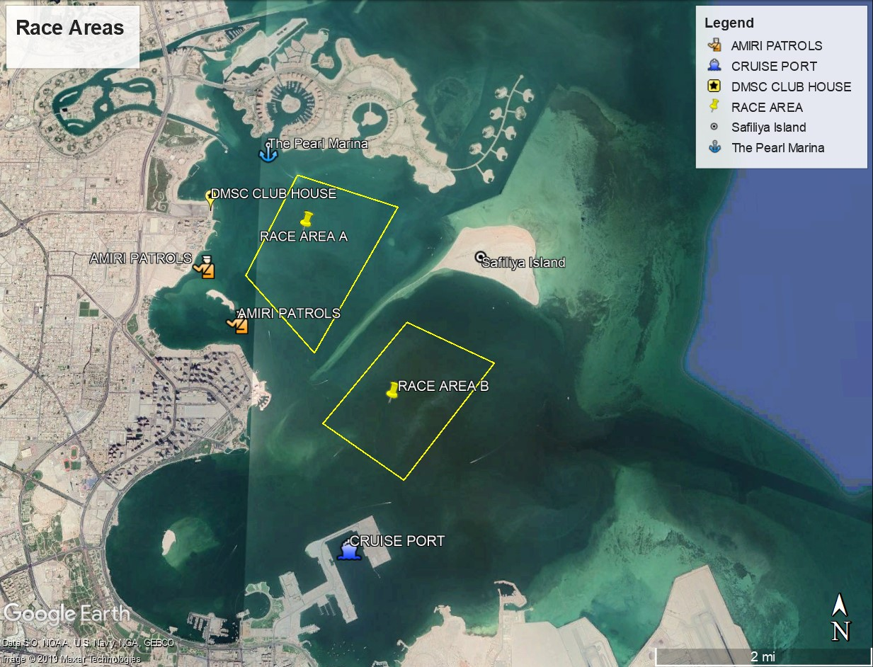
Attachment B – Course
Optimist Class

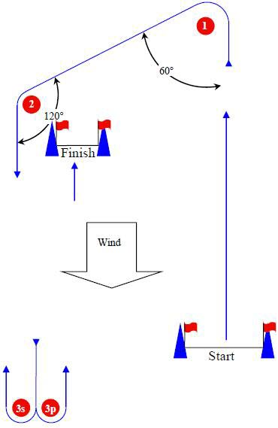

Start – 1 – 2 – 3s/3p - Finish
Attachment C – Support Boats Regulations
1. General
1.1 These Support Boat Regulations (SBR) shall apply from 00:00 on 27th of December 2019 until 23:59 on 1st of January 2020.
1.2 For the purposes of these regulations, a support boat includes any boat that is under the control or direction of a person who is or may provide physical or advisory support to an athlete, including the gathering of data that may be used at a later time.
1.3 The Organizing Authority may inspect boats at any time to ensure that they comply with these regulations, and the person responsible for the boat shall facilitate such inspection.
1.4 An alleged breach of any of these regulations may be referred to the International Jury for a hearing. As a result of the hearing, the International Jury may instruct the Organizing Authority to withdraw accreditation and access rights from the driver or person in charge, with or without the option of substitution, either for a specified period or for the remainder of the competition. Note also, action may be taken under RRS 69.
1.5 The Organizing Authority may change these regulations at any time. Any changes will be posted on the official notice board and circulated to team leaders.
1.6 The Organizing Authority may, at its discretion, refuse to register support boats not deemed to be suitable.
1.7 Support boats and designated drivers shall be registered at the regatta office either before leaving the venue by water for the first time or by 18:00 on the day before the first race of the event that it is supporting, whichever is earlier.
1.7.1 Each boat shall be insured with valid third-party liability insurance with coverage taking into account the value of the boats. The Organizing Authority is not responsible for verifying the status or validity of certificates.
1.7.2 Only an accredited person may be a designated driver.
1.7.3 The person registering the support boat shall confirm that:
a) a valid insurance certificate showing proof of third-party liability coverage as required by 1.7.1 has been obtained;
b) each designated driver has a motorboat driving license recognized by a national authority appropriate to that boat; and
c) anyone who will be using a radio has an appropriate radio operation license recognized by a national authority.
1.8 Support boats shall display a numbered flag provided by the Organizing Authority.

2. Sailing venue
2.1 Support boats shall use the designated slipway/area for launching. Once launched, trailers shall be moved immediately to the trailer park or as otherwise directed by the Organizing Authority.
2.2 Only registered support boats will be allowed into the sailing venue.
2.3 When not in use, support boats shall be appropriately berthed at the sailing venue in the allocated areas for support boats for the entire time that these Support Boat Regulations apply.
2.4 Support boats shall not use the dinghy launching slipways or keelboat pontoons for any purpose whatsoever, including mooring, launching and retrieval, and loading and unloading of equipment.

3. Safety
3.1 Support boats shall carry on board:
a) life jackets / buoyancy aid for all passengers and the driver
b) first-aid kit;
c) VHF radio;
d) device for making a sound signal;
e) compass;
f) adequate anchor and tackle for conditions and depth;
g) tow rope (minimum 15m long and 10mm thick);
h) operational engine kill cord (also known as a safety lanyard or automatic engine immobilizer);
i) hand pump or bailer
j) knife; and
k) any additional safety equipment required by local maritime law.
3.2 It is recommended that life jackets be worn at all times when afloat. When flag Y is displayed on the Signal Boat or ashore, Rule 40 applies also for coach boats.
3.3 It is strongly recommended that the kill cord is used at all times when the engine is running.
3.4 The maximum plated / certified passenger limits for the boat shall never be exceeded.
3.5 Team leaders are responsible for overseeing the safe operations of their support boats on the water, including knowledge of who is afloat and ensuring their safe return to the venue.
3.6 At all times, the registered driver(s) of a support boat shall comply with directions given by a race official. In particular, this includes assisting in rescue operations when requested to do so.
3.7 When the race committee displays flag V with repetitive sounds all registered support boats shall comply with any instruction given by the race committee or the Organizing Authority as assistance / rescue boats.
3.8 Support boats shall comply with local harbour and marina regulations, including speed limits.

4. General restrictions
4.1 The registered driver(s) of a support boat will be responsible for the control of the boat at all times and will be held responsible for any inappropriate behaviour, dangerous actions or improper practices, or actions affecting the fairness or safety of competition.
4.2 Support boats shall not leave any device, piece of equipment, buoy, marker or similar item permanently in the water. Temporary use of floating objects is allowed for current measurement. These objects shall be removed as soon as the measurement has been taken.
4.3 Support boats should take particular care to minimize their wash when transiting the course areas.

5. Racing area restrictions
5.1 Support boats shall stay outside areas where boats are racing from the time of the preparatory signal for the first fleet to start until all boats have finished or the race committee signals a postponement, general recall or abandonment.
5.2 During any starting sequence, support boats shall stay at least 50 meters to leeward of the starting line and its extensions.
5.3 Support Boats shall not be positioned:
5.3.1 Closer than 50 meters of any boat racing.
5.3.2 Within 50 meters of the starting line and marks.
5.3.3 Between any boat racing and the next mark of the course.
5.3.4 Inside the course. 5.3.5 Within 50 meters of any mark of the course while boats are in the vicinity of that mark.
5.3.6 Within 50 meters of the finishing line and marks while boats are finishing.
5.4 In addition, support boats that are motoring above 5 knots shall remain at least 150 meters from any boat racing.
5.5 When a race committee or jury member instructs a support boat to move further from the course area, the support boat shall do so immediately.
Attachment D – Handling the Boats

- GENERAL
1.1 While all reasonable care is taken to equalize the boats, variations will not be grounds for redress. This changes RRS 62.
1.2 Competitors shall report to the Race Office, at first reasonable opportunity after returning to shore, of any equipment damage or malfunction.
2. PROHIBITED ITEMS AND ACTION
Except in an emergency or in order to prevent damage or injury, or when directed by an umpire otherwise, the following is prohibited:
- Any additions, omissions or alternations to the equipment supplied.
- The use of any equipment for a purpose other than that intended or specifically permitted.
- The replacement of any equipment without the permission of the race committee.
- Sailing the boat in a manner that it is reasonable to predict that significant further damage would result.
- Moving equipment from its normal storage position except when being used.
- Boarding a boat without prior permission.
- Marking directly on the hull or deck with permanent ink.
3 MANDATORY ITEMS AND ACTIONS
  - The following is mandatory:
- The completion of a written damage report before leaving a boat and submitting it to the RC, even if no damage or loss is recorded. Reports shall include any evidence of matters which could cause damage or disadvantage to the boat in future matches.
- At the end of each sailing day:
- Folding, bagging and placement of the sails as directed.
- Leaving the boat in the same state of cleanliness as when first boarded.
3.2 At the end of the final day for a particular boat, cleaning the boat removing all trash and removing all tape and marks.
3.3 Any request to alter, in any way, the equipment on a boat shall be in writing and to permit a yes/no answer.

Attachment E – Standard Penalties
3. CODE OF CONDUCT
Not avoiding the area where boats are racing and any official boats – SI 3.3 | Three points scoring penalty in her closest sailed race.
Not avoiding the area where boats are racing and any official boats on a Course Area to which boats are not assigned - SI 3.4 | Three points scoring penalty in her closest sailed race.
6. SIGNALS MADE ASHORE
Leaving when flag D is not displayed ashore – SI 6.3 | One point scoring penalty in her first race of the day.
20. SAFETY REGULATIONS
Not Sign Out - SI 20.1 | One point scoring penalty in her first race of the day
Not Sign In - SI 20.1 | One point scoring penalty in her last race of the day
Not notifying the race office when not leaving the shore for the day's races – SI 20.2 | One point scoring penalty in her closest sailed race.
Not notifying the race office when retiring from a race – SI 20.3 | One point scoring penalty in her closest sailed race.

