RS Feva Eastern Championships 2023

hosted by
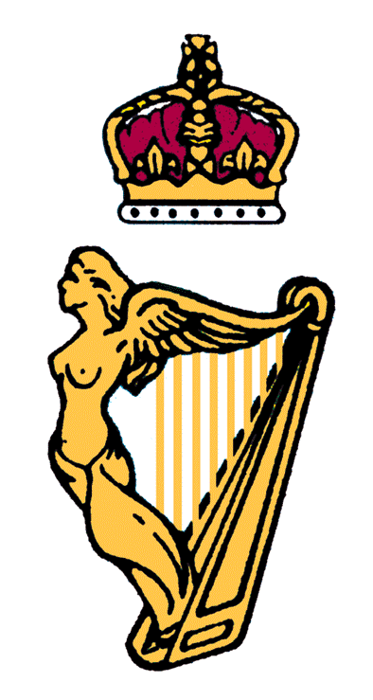
ROYAL IRISH YACHT CLUB

Saturday 6th and Sunday 7th May 2023

Change to Sailing Instructions No.2

6.1 Schedule
Sunday 7th May Time of First warning Signal

Change 11:25 to 10:55

