RYA 1985/4
Definitions, Finish
Rule 28.2, Sailing the Course
Rule A5, Scores Determined by the Race Committee
Appendix J, 2.1(5), Notice of Race and Sailing
Instructions: Sailing Instructions Contents
A race committee is not entitled to score a boat DNF because it believes she did not correctly sail the course; instead it must protest her under rule 28.
When a race committee intends a mark to be looped, the mark must be identified as a rounding mark. When the sailing instructions do not do so, or when they are

ambiguous, a boat may elect not to round a mark when she can still leave it on the required side and in the correct order.
SUMMARY OF THE FACTS

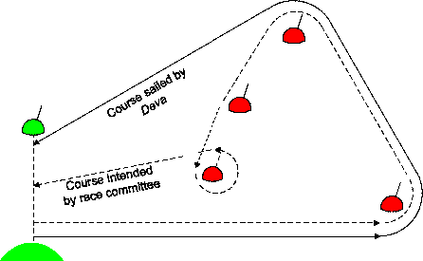
Starting and finishing
line
D
C
B
A
The course set by the race committee was A – B – C –
D - finish, all marks to port.
The race committee’s intention was that D was to be looped, but Deva sailed directly from mark B to the finishing line. In doing so she left marks C and D to port. The sailing instructions did not identify D or any mark as a rounding mark. The race committee scored Deva DNF, as she had not rounded D, which it intended to be the last mark, Deva sought redress. The protest committee refused redress on the grounds that Deva had not sailed the course, and referred its decision to the RYA.
DECISION
The decision of the protest committee is reversed. Deva
is to be reinstated.
Deva finished, as defined, because she crossed the finishing line from the course side. The race committee acted improperly in scoring her DNF (see rule A5) and the protest committee should have re-instated her in her finishing position.
The only method of validly seeking to deprive Deva of her finishing place would have been for her to be protested under rule 28.2. However, any such protest should not have succeeded in this case.
When a race committee intends that a mark is to be looped, so that a boat continuing from that mark will cross her own track, the sailing instructions must either clearly say that the mark is a rounding mark, or must state how a mark shown on a course board is to be identified as a rounding mark.
When a mark is not properly identified as a rounding mark, a boat is entitled to sail a course such that the string representing her track, when drawn taut, does not touch the mark, provided that she leaves it on the correct side and in the correct sequence. The identification of a mark as a rounding mark must be unambiguous. For instance, to state that a mark is to be left to port (or starboard) gives a boat the option not to round it.
Request for Redress by Deva, Island SC

