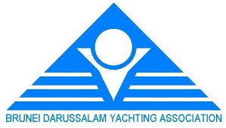
Amendment No 3
- After starting, Windsurfing target time to pass Mark DM1 is to be changed from 10 minutes to 15 minutes
- SI 15 is therefore changed as follows:
15 TIME LIMITS AND TARGET TIMES
15.1
TRAPEZOID COURSE RACES |  |  |  | MARATHON RACE See Addendum C
Class | Mark 1 | Finish | Time Limit after 1st boat | FINISH | Time Limit after 1st boat
Optimist | 15mins | 60mins | 15 mins | 2 Hrs | 30 mins
Laser 4.7 | 15mins | 60mins | 15 mins | 2 Hrs | 30 mins
Laser Std and Radial | 15mins | 60mins | 15 mins | 2 Hrs | 30 mins
Windsurfing | 15mins | 40mins | 10mins | 2 Hrs | 30 mins

If no boat has passed Mark 1 within the Mark 1 time limit the race will be abandoned. Failure to meet the target time will not be grounds for redress. This changes RRS 62.1(a). See Addendum C for Marathon special time limits.

Jury Chairman
Inaugural BDYA Sailing Championship 2019
Leonard Chin IJ (MAS)
22Sep2019

