sailing instructions had not clearly explained the position of the starting area, and that, in bad visibility, it had been difficult to find, resulting in her starting 13 minutes late, which significantly affected her score. Her request was heard, decided and refused by one person, the race officer who alone formed both the race committee and protest committee. Akela appealed.
DECISION
Akela’s appeal is upheld, and she is to be granted
redress.
It is clear that the facts are as asserted by Akela, and that she was without fault. Rule J2.2(21) required the location of the starting area to be stated in the sailing instructions, if applicable. The sailing instruction was at best ambiguous, and Akela was prejudiced by it.
With regard to the constitution of the protest committee, it is undesirable for a member of the race committee to be a member of the protest committee when a request for redress is made. Furthermore, while a protest committee can consist of one person, it is preferable for a protest committee to consist of at least three disinterested people.
Request for Redress by Akela, Chanonry SC
RYA 1984/14
Rule 63.6, Hearings: Taking Evidence and Finding
Facts
Appendix M, 3.2, Recommendations for Protest
Committees: Taking the Evidence
A party to the hearing, not the protest committee, is responsible for calling that party’s witnesses.
SUMMARY OF THE FACTS
After disqualification for breaking a rule of Part 2, Loujaine appealed on the grounds that the hearing had been incorrectly conducted, one of her witnesses not having been heard. The protest committee, commenting on the appeal, said that the appellant’s representative was given full opportunity to call any witness, and that it considered all evidence that was given.
DECISION
Loujaine’s appeal is dismissed.
The RYA is satisfied that the hearing was properly conducted. It is clear from rule 63.6, as amplified in Appendix M, section 3.2, 4th bullet point, that the responsibility for calling a witness lies with the party wishing that witness’s evidence to be heard, not with the protest committee. Having not called her own witness, the appellant cannot claim that her evidence was not allowed to be given.
Loujaine v Passion, Royal Naval & Royal Albert YC
RYA 1985/3
Rule 62.1(a), Redress
Redress is not to be granted when, despite a boat’s score being made significantly worse by an action of the race committee, that action was not improper because there was no other action the race committee could have taken.
SUMMARY OF THE FACTS
Several boats were running on starboard tack towards a mark situated about 30 feet (9 m) from the shore. The Lollipop, the leeward boat, was nearest the bank. The windward boats hailed for room at the mark, those to leeward replied that they could not give room. As the boats tried to squeeze through the gap between the mark and the bank, a number of collisions occurred and The Lollipop was pushed onto the bank. She was unable to extricate herself for about three minutes, during which time the other boats had sailed into a big lead over her.

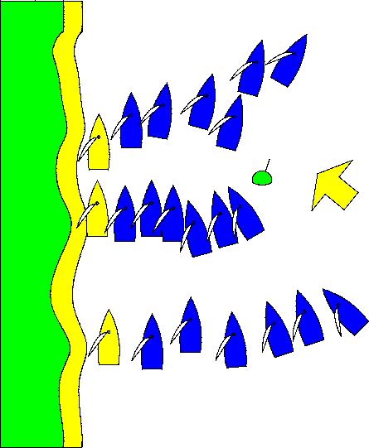
Position 3
Wind
Position 2
Position 1
The Lollipop requested redress under rule 62.1(a) on the grounds that her score in the race had been made significantly worse by the mark being laid too close to the bank. The protest committee refused redress and she appealed.
DECISION
The Lollipop’s appeal is dismissed.
The situation cannot be interpreted as an improper action of the race committee. Situations such as the one that arose in this case are undesirable, but it was not practical in these waters for the mark to be laid sufficiently far enough from the obstruction that a large number of boats could round abreast.
Request for Redress by The Lollipop, Avon SC
RYA 1985/4
Definitions, Finish
Rule 28.2, Sailing the Course
Rule A5, Scores Determined by the Race Committee
Appendix J, 2.1(5), Notice of Race and Sailing
Instructions: Sailing Instructions Contents
A race committee is not entitled to score a boat DNF because it believes she did not correctly sail the course; instead it must protest her under rule 28.
When a race committee intends a mark to be looped, the mark must be identified as a rounding mark. When the sailing instructions do not do so, or when they are

68

ambiguous, a boat may elect not to round a mark when she can still leave it on the required side and in the correct order.
SUMMARY OF THE FACTS

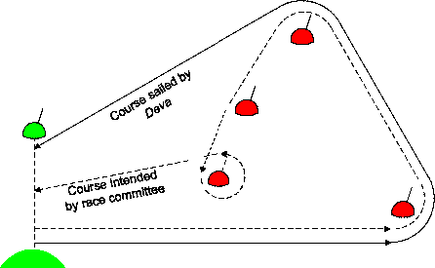
Starting and finishing
line
D
C
B
A
The course set by the race committee was A – B – C –
D - finish, all marks to port.
The race committee’s intention was that D was to be looped, but Deva sailed directly from mark B to the finishing line. In doing so she left marks C and D to port. The sailing instructions did not identify D or any mark as a rounding mark. The race committee scored Deva DNF, as she had not rounded D, which it intended to be the last mark, Deva sought redress. The protest committee refused redress on the grounds that Deva had not sailed the course, and referred its decision to the RYA.
DECISION
The decision of the protest committee is reversed. Deva
is to be reinstated.
Deva finished, as defined, because she crossed the finishing line from the course side. The race committee acted improperly in scoring her DNF (see rule A5) and the protest committee should have re-instated her in her finishing position.
The only method of validly seeking to deprive Deva of her finishing place would have been for her to be protested under rule 28.2. However, any such protest should not have succeeded in this case.
When a race committee intends that a mark is to be looped, so that a boat continuing from that mark will cross her own track, the sailing instructions must either clearly say that the mark is a rounding mark, or must state how a mark shown on a course board is to be identified as a rounding mark.
When a mark is not properly identified as a rounding mark, a boat is entitled to sail a course such that the string representing her track, when drawn taut, does not touch the mark, provided that she leaves it on the correct side and in the correct sequence. The identification of a mark as a rounding mark must be unambiguous. For instance, to state that a mark is to be left to port (or starboard) gives a boat the option not to round it.
Request for Redress by Deva, Island SC
RYA 1986/1
Definitions, Keep Clear
Rule 10, On Opposite Tacks
When a port-tack boat is required to keep clear of a starboard-tack boat, she must act clearly and early enough to ensure that other boat is in no doubt that the port-tack boat will fulfil her obligation.
SUMMARY OF THE FACTS
It was a dark and stormy night with a force 7-8 wind. Two close-hauled boats, S (an Enterprise) and P (a GP14), approached each other. At about six hull lengths, S hailed ‘Starboard’. This was clearly heard by P's helmsman and crew.
When the gap between the two boats had closed to less than two hull lengths, P with jib and main eased, started to take avoiding action that would have taken her astern of S. Almost simultaneously, S tacked and a collision occurred. The Racing Rules of Sailing were in force, not the IRPCAS or government rules, and S protested P under rule 10. The protest committee penalized P for failing to take avoiding action early enough, considering the conditions. P appealed, maintaining that she would have passed safely astern of S, of whose presence she had been fully aware, had not S tacked and prevented her from so doing.
DECISION
P’s appeal is dismissed.
When one boat is required to keep clear of another, she must act to do so early enough to ensure that the right-of-way boat has no need to take avoiding action. In the prevailing conditions, P failed to observe this principle and therefore did not keep clear.
E1087 v GP 12547, West Lancashire YC
RYA 1986/3
Definitions, Keep Clear
Rule 11, On the Same Tack, Overlapped
Rule 14, Avoiding Contact
A keep-clear boat cannot be said to have done so when, although there was no contact, there is firm evidence that contact would have occurred had not the right-of-way boat altered course to comply with rule 14.
SUMMARY OF THE FACTS

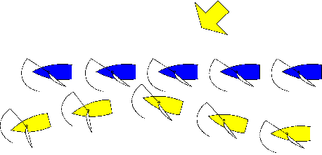
Wind
W5 W4 W3 W2 W1
L4 L3
L5
L2
L1
On a broad spinnaker reach, wind force 2-3, W, clear astern, became overlapped to windward of L, which luffed to a converging course and then, when near W, bore away. W did not change course, and there was no contact.
The protest committee found that L bore away to avoid damage, but dismissed the protest, stating: ‘L has not

69

