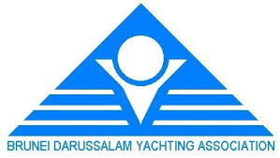
Amendment No 2
1.The class flag for Windsurfing is changed from Code Flag “W” to Code Flag “Q.”
2. Laser 4.7 shall start with Laser Radials and Laser Standards.
SI 6 is therefore amended to read as follows:
6 CLASS FLAGS
Class flags:
START SEQUENCE | CLASS | CLASS FLAG
1 | Windsurfing
2 | Laser Standard / Radial/4.7
3 | Optimist

Jury Chairman
Inaugural BDYA Sailing Championship 2019
Leonard Chin IJ (MAS)

