30NOV PROTEST PHOTO EVIDENCE
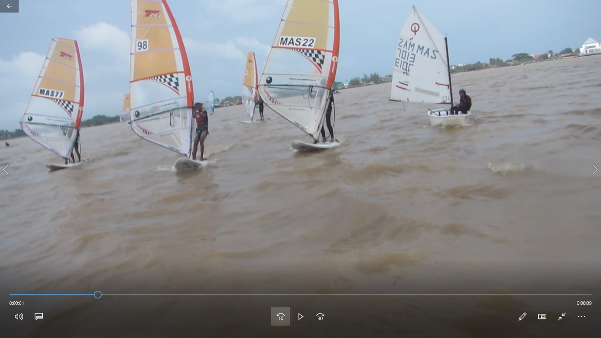
1 PROTEST NO 3: MAS7013 DSQ in Race 6 for interfering with Bic Techno Start in Race 6
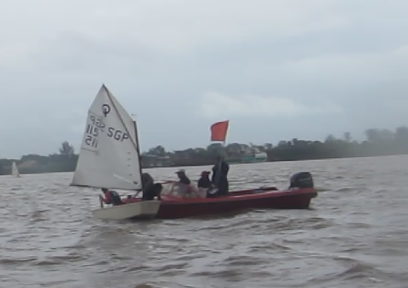
2PROTEST NO 5: SGP115 DSQ in Race 6 for breaking RRS31 when colliding with the Pin End Vessel and not exonerating with one turn penalty. Above picturescreen grabbed from video.

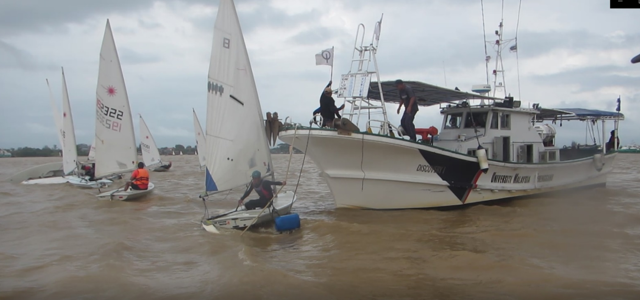
3 PROTEST NO 4: Laser Radial 8 DSQ in Race 6 for colliding with the Race Committee Start Vessel (Mast also in contact with bow anchor) breaking RRS31 and failing to exonerate with a one turn penalty. Above picture screen grab from video.
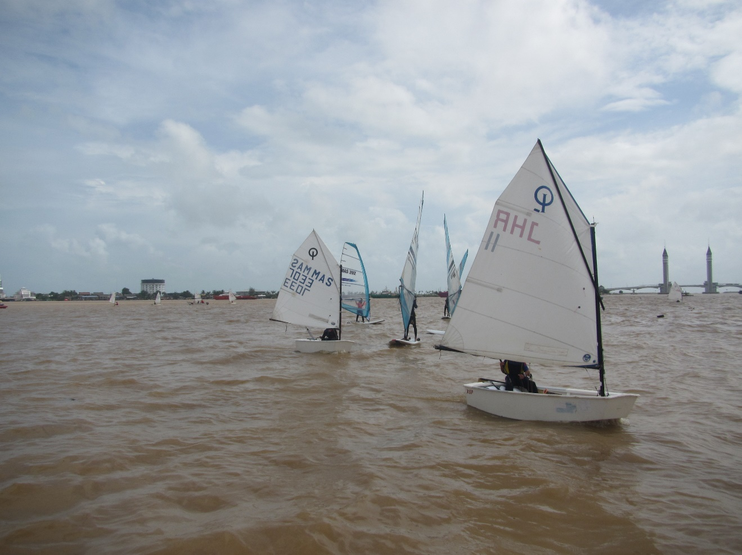
4 PROTEST NO 2: MAS 7033 and JHR11 interfering with RS One start in Race 4
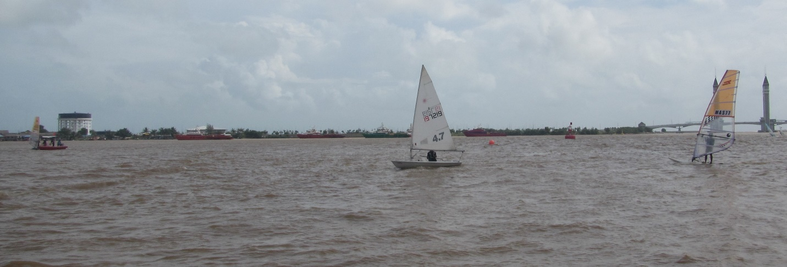
5 PROTEST NO 2 : Laser Radial 197219 interfering with Bic Techno start at the Prep signal.

