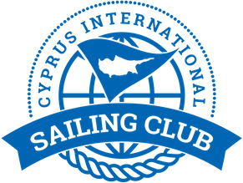

Notice to Competitors # 1

Please note that the draw for the allocation of boats will be carried out during the skippers meeting of day1 on the 31/1/2020

Yiannis Papazoglou
IRO

27/1/2020 , 18 : 40

