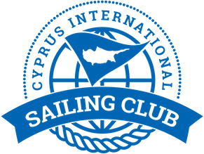

Yacht and Team for Cyprus Fareast 28R Winter Series

Yacht name | Yacht Sail | Yacht Number
Alfa | CYP 1 | 1
Bravo | CYP 2 | 2
Delta | CYP 3 | 3
Charlie | CYP 4 | 4
Echo | CYP 5 | 5
Foxtrot | CYP 6 | 6

Teams, skippers, yachts

Team name | Skippers’ name | Contact email | Yacht number
Planing 2 | Jakob Enigl | luis.gazzari@icloud.com
Adios | Ozcan Hulki | hulki@mentor.com.tr
Masha&Medvedi | Maria Pakhtusova | Bona-fides@bk.ru
J-Mania | Sukru Sanus | Christoskifidis@gmail.com
MIR | Igor Matvienko | imsailinginfo@gmail.com
Fortunato team | Maksim Grishchev | maksimgrischev@gmail.com

