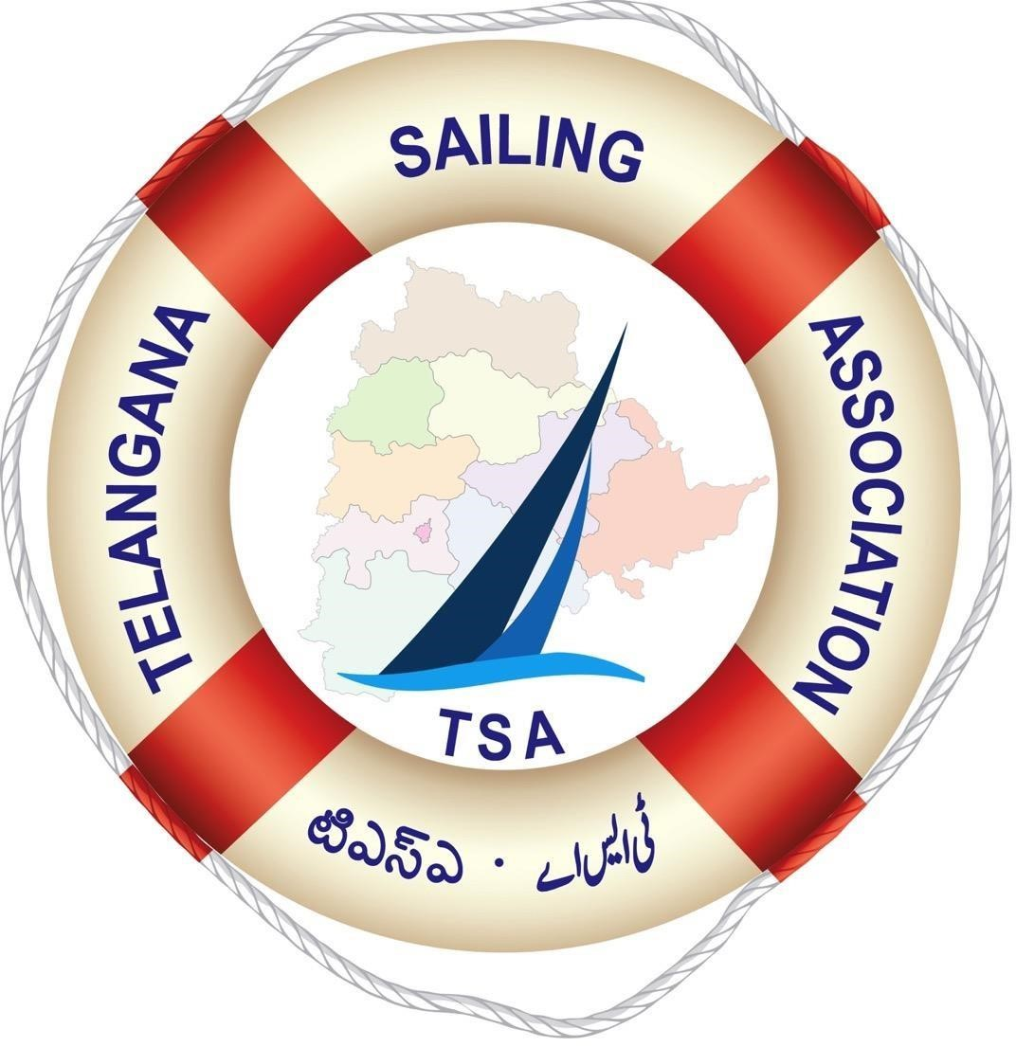

TELANGANA STATE REGATTA
OPTIMIST AND LASER 4.7 CLASSES
01-11 OCT 2020

NOTICE OF RACE
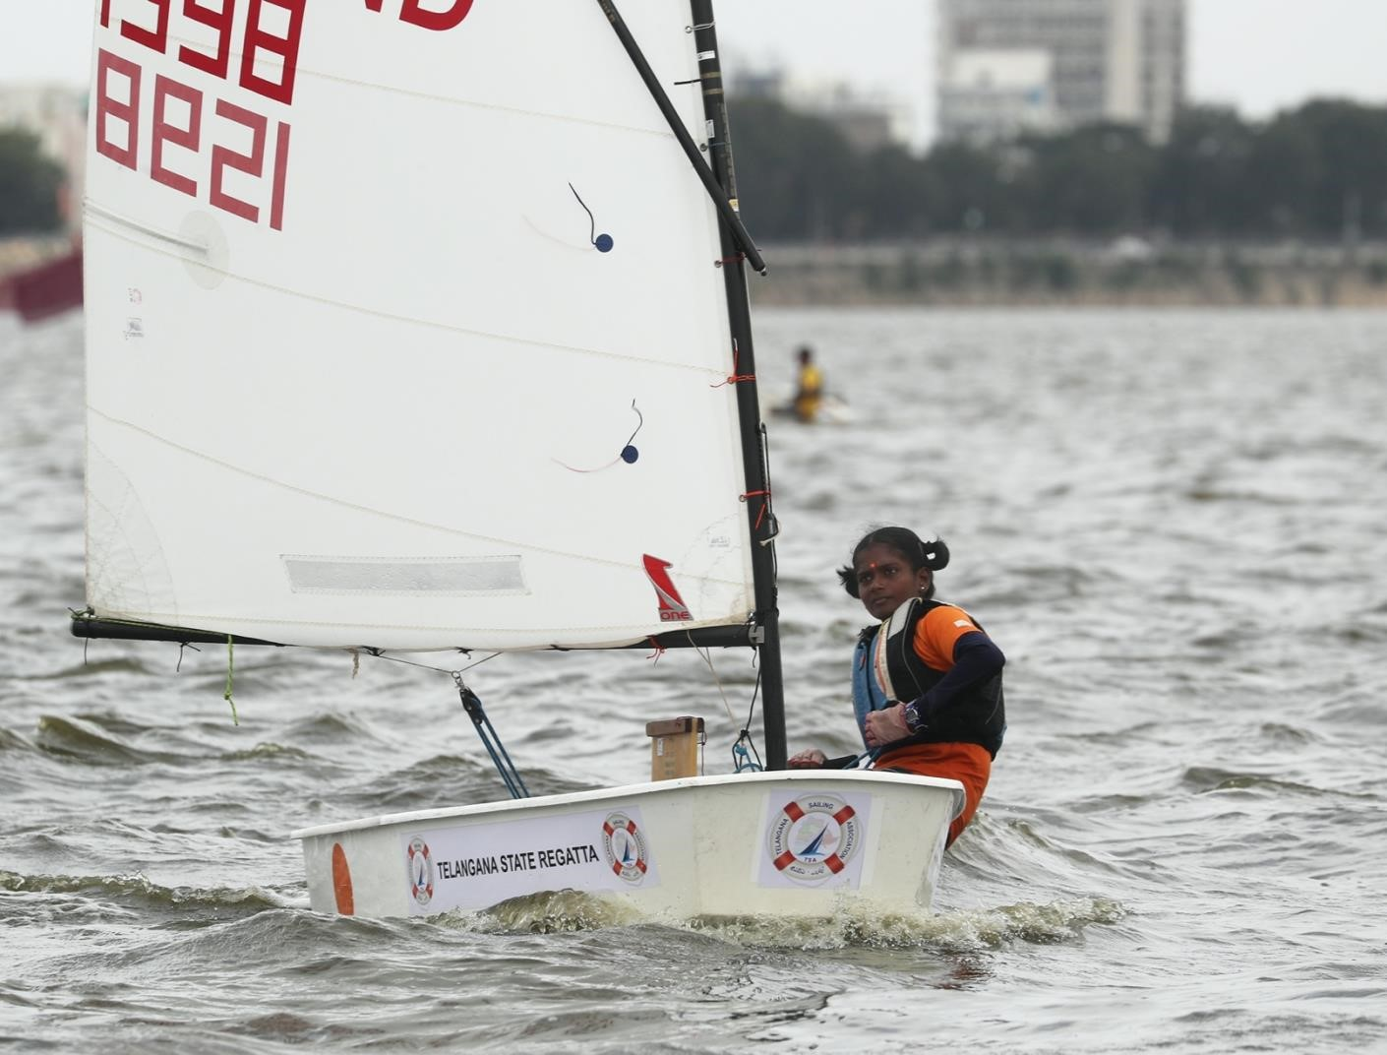

EVENT & VENUE:

1.1 The shore venue is THE YACHT CLUB OF HYDERABAD
1.2 The Regatta will consist of Optimist Class Fleet Racing and Laser 4.7 Class. The Optimist Class will sail the IODA Main Fleet (A) Green Fleet will be for lesser-experienced sailors (B) and the Light Fleet will be sailed using Half Rig Sails for beginners (C).

- ORGANISING AUTHORITY & HOST CLUB:

  - The Telangana State Regatta will be organized by Telangana Sailing Association 2.2 The event will be hosted under the burgee of The Yacht Club of Hyderabad
- RULES:

The Championship will be governed by:

  - The Rules as defined in the Racing Rules of Sailing (RRS) 2021-2024

  - RRS Appendix P, Special Procedures for Rule 42 will apply.

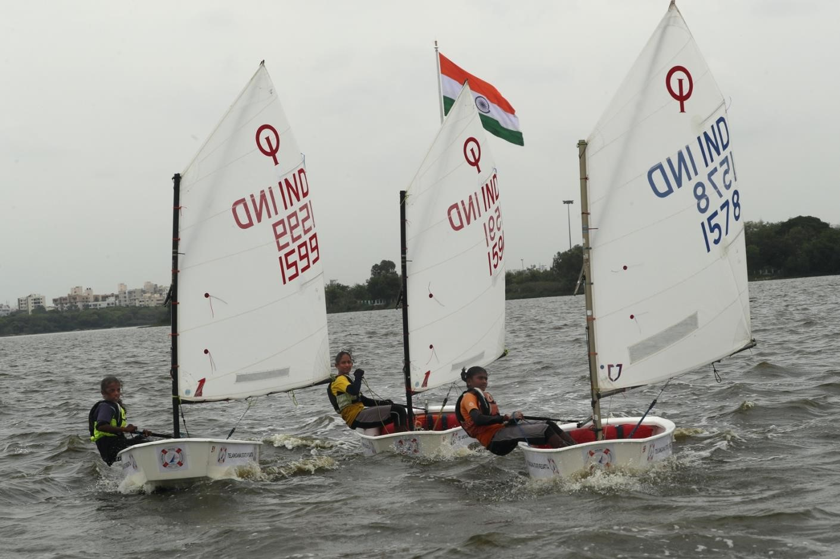

- ADVERTISING:

  - The Event is designated as Category C. All competitors will be required to display advertising of the event sponsors on each side of the hull.
  - Boats carrying sponsor logos from previous championships will need to remove all such insignia prior to measurements. Boats carrying messages of sponsors not authorized by the organizers will be penalized 3 points per race subject to the decision of the Organizers. Boats shall not be permitted the right to protest breaches of any rules regarding advertising (amends RRS 60.1). If these rules are broken then World Sailing Regulation 20.9.2 applies [DP]

  - Media Images and Sound
The OA shall have the right to use any images and sound recorded during before or after the event across classes and championships and regattas free of any charge and the Yacht Club of Hyderabad will own all copyrights to all footage and photographs produced at the event and is free to publish. No club, boat owner, city or participant can film/record the proceedings for commercial purposes or public broadcast without the prior permission of the OA in writing.
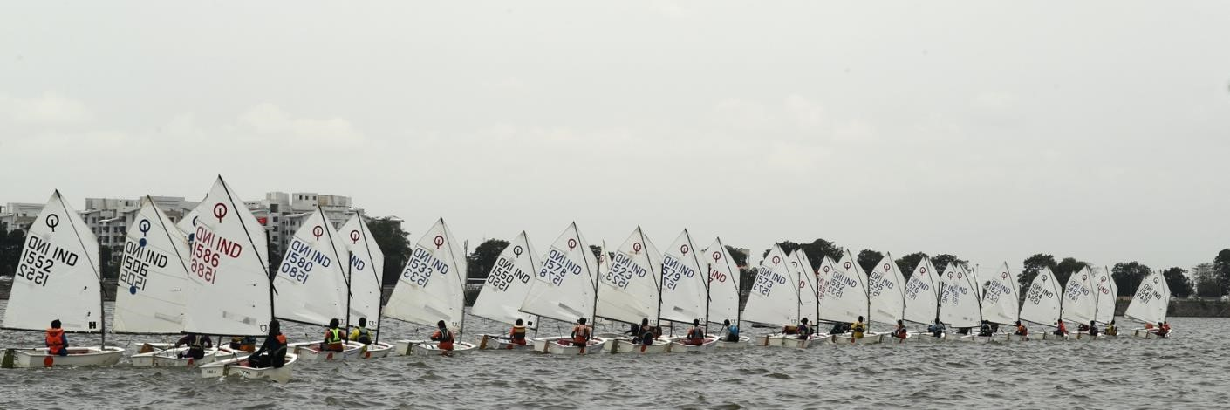

- ELIGIBILITY & ENTRY:
  - For the Optimist Class Competitors must be born on or after 1st January, 2005.

For Laser 4.7 Class the sailor must under 18 years (The max age the competitor becomes in the year of the championship)

Valid, parent attested Proof of Age is to be provided at the time of Registration for all age restricted classes.

Eligible competitors may enter by completing the attached form and sending it together with the entry fees payable by Cheque/DD favoring The Telangana Sailing Association. At the venue and only cash will be accepted.

  - Late entries will be accepted on payment of additional Late Fee of Rs.1500/-.
Last date of entry will be 23rd September 2020; however, the clubs who wish to make the payment upon arrival in Hyderabad may confirm entries with all details by email to the Organizing Secretary The Yacht Club of Hyderabad and they will not face any levy of late fee provided all entries committed pay.
  - All Entry forms, Indemnity Bonds and enclosures must be sent to
The Organizing Secretary,
Telangana Open Regatta
C/o The Yacht Club of Hyderabad
1&2 Vahini Nagar,
Near 194 Gunrock Enclave
Sikh Road
Secunderabad 500009

Contact Ms.Surekha Dathrak : 8143966389
Entry and Charter Fees (in INR)

Entry Fee Rs.6500./- Late Fee Rs.1500 Training Camp Rs.10,000
Charter Fee for Optimists Rs.10,000/- without sails and lines Charter Fee for Fully Rigged Optimists : Rs18,000/

Payments in the name of :

Telangana Sailing Association ICICI Bank Account no.068101001180 IFS Code : ICIC0000681 Diamond Point Branch Plot No.23, Tarbund Cantonment Secunderabad - 500 008

Few Charter boats will be available in the Green Fleet.

All sailors and staff and accompanying persons including coaches and escorts and parents will need to have a Covid Negative certificate within 96 hours of the start date.

All entries will need to comply will all the Covid regulations in force in keeping with World Sailing and YAI standard protocols.

- CONDITIONS OF ENTRY:

Competitors must be capable of swimming at least 50 meters without buoyancy aids. Satisfaction of this clause is assumed by virtue of participation and the responsibility of compliance of this clause is the responsibility of the participant and the respective club’s signatory and that of the parent/guardian.

- TRAINING, REGISTRATION & MEASUREMENT:
Sept 29-30 Arrival and Registration with parents
Oct 1-8 Full day Training and Preliminaries
Oct 9 & 10 10 AM to 3:30 PM
Sailors participating in overseas events may register online provided the boats and sails are measured by the last date and time of registration.

For Optimists SAIL REGISTRATION CERTIFICATES AND BOAT MEASUREMENT CERTIFICATES ARE COMPULSORY TO BE DISPLAYED TO THE MEASURERS
Boats and Sails measured are eligible for the Monsoon Regatta to be sailed thereafter.

- SCHEDULE OF RACES

Date | Time | Activity
Oct 1 – 5 | Full Day | Training
Oct 6 | 1000 | Registration &  Measurement
Oct 6-8 | Full Day | Preliminaries
Oct 9-10 | 0830 | Racing
Oct 11 | 0830 | Spare Day Racing
 | 1730 | Awards

No Warning Signal will be made after 1600 Hrs. on 11 Oct. Sailors may book departure on 11 evening as weather and logistic conditions may warrant an additional day of racing. The Awards will be at 1730 or earlier on 11 Oct in case the Spare Day is utilized.
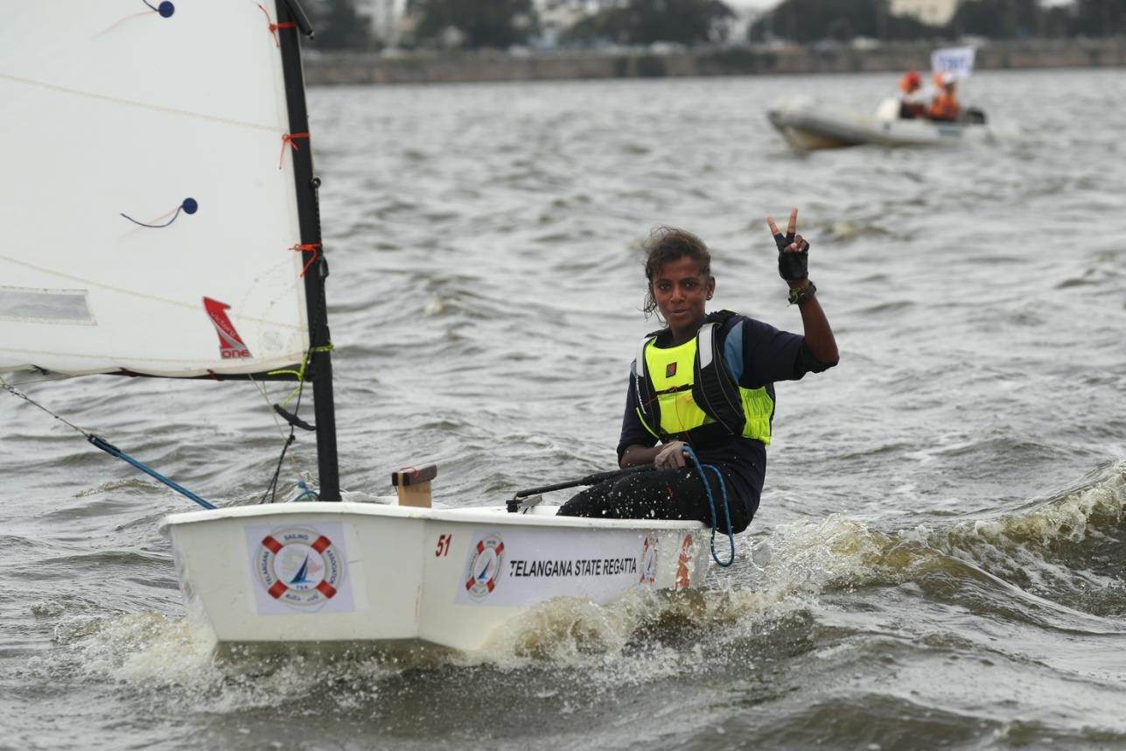

SAILING INSTRUCTIONS:

The sailing instructions, will be on our website and at the Venue hard copies will be handed out at registration. www.theyachtclub.in

- COURSE
The Courses are as shown in Annexure 1 and could be modified in the sailing instructions.

- SCORING The Low point scoring system Appendix, A will apply

- PRIZES AND AWARDS

Laser Class 4.7
Telangana Open Junior Champion (Under 18) Gold Silver and Bronze

Telangana State Junior Champion (For those domiciled in Telangana State under 18) Gold Silver and Bronze

Gold Silver and Bronze Both the above will have a Girls Category too provided there are more than 3 sailors entered.
 Eligibility for the State Championships will need an Aadhar Card as proof of domicile status (
 All age restricted Classes need a Birth Certificate to be eligible for registration

OPTIMIST CLASS

Telangana Open Sub Junior Champion
Telangana State Sub Junior Champion (For those domiciled in Telangana State) Both the above will have a Girls Category too provided there are more than 3 girl sailors The Optimists will receive medals for the top 3 positions in the Open and Girls categories.
Additional prizes may be awarded at the discretion of the OA.

- INTERNATIONAL JURY:

An International Jury has been appointed by the Organizing Authority.

- SAFETY:

  - In the Optimist Classes. each competitor shall carry an 8 Meter tow rope, whistle attached to his/her clothing, a secured paddle with a surface of not less than .25 sq meters.
  - Competitors shall sign out/sign in, in the register kept with the Beach Master before launching and on coming ashore. This is a mandatory safety requirement. All boats will be at the designated Boat Park.
  - Personal Buoyancy

All competitors shall bring their own adequate personal buoyancy which must fastened at all times while afloat. Wet/ dry suits do not constitute adequate personal buoyancy.
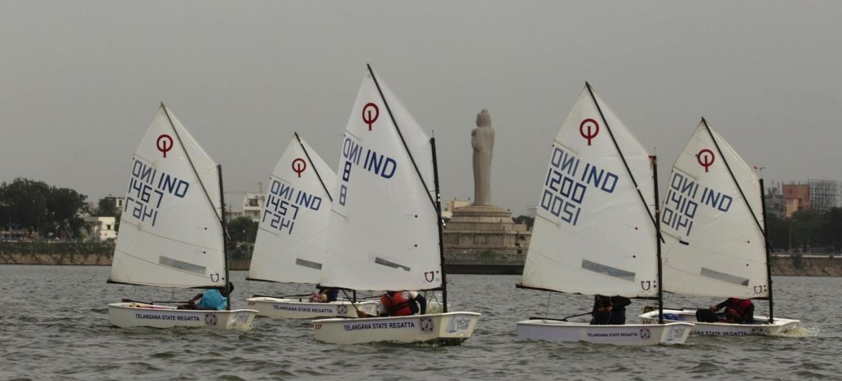

- SUPPORT BOATS:

Support Boats will be marked with large white flag (S) clearly identifying the Club(s) it belongs to. Support Boats interfering with the conduct of the racing (and the boats they are supporting) in any manner whatsoever will be barred from subsequent races by the
Organizers and be subjected to a Protest hearing. Support boats are not allowed in the racing area after the warning signal and during racing. Flags may be available at a nominal price.
- RADIO COMMUNICATION:

Unless in an emergency a boat racing shall neither make radio, transmission nor receive radio transmission not available to all boats.
This restriction also applies to mobile phones or any other form of communication device.
- ENTRY DISCLAIMER OF LIABILITY and INSURANCE:

Competitors participate in the regatta entirely at their own risk. See rule 4 Decision to race. The organizing authority will not accept any liability for material damage or personal injury or death sustained in conjunction with, prior to, during, or after the regatta.

- ACCOMODATION AND BOARDING

A reduced rate announcement regarding accommodation at the Marriott Hotel for the Optimist IODA Fleet will be announced a month prior to the regatta.

Contact Telanganasailing@gmail.com Email: secretary@theyachtclub.in
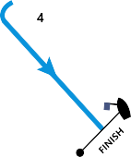

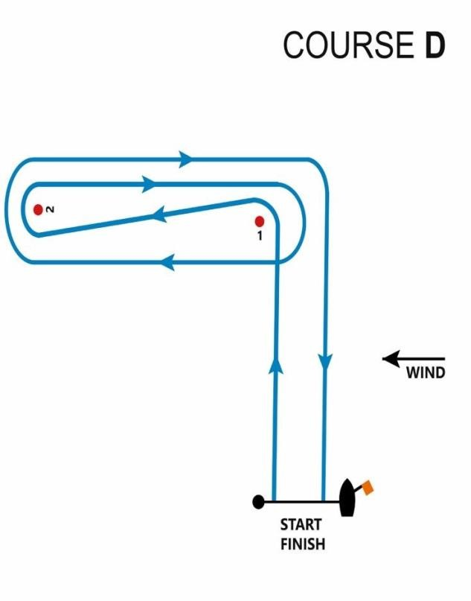

ANNEXURE 1 ENTRY FORM
I, (Male/Female)

born on (DD/MM/YY ) Member of

wish to participate in the TELANGANA OPEN REGATTA, Optimist/ Laser Class Fleet Racing
Sail No.: Boat Identification No.: Blood Group:
Furthermore, I agree to be bound by the current ISAF Racing Rules of Sailing, the Notice of Race and all other rules that govern the Event and their amendments thereof, with which I will make myself fully acquainted. I acknowledge that Rule 4 - “Decision to Race,” places me solely responsible for deciding whether or not to start or to continue racing. I further acknowledge and agree that in consideration of the Notice of Race clause ‘Entry Disclaimer’, that
subject to my entry into this Event being accepted (without any obligation on your part to accept it ), my participation is entirely at my own risk ."
I confirm that I can swim unaided, without external buoyancy for 50 meters.

I further confirm that we have been explained the above in a language of our understanding and shall abide by the English version.

Signature of Competitor & Date

Email Id: Mobile No of competitor:

Address of Parent:

<Affix Passport size photograph>
HERE

Signature of Parent/Legal Guardian Name:

Relationship (In case of minor less than 18 years):

Email Id: Mobile No.:

Designated Team Manager Name: Mobile No:
NAME OF OFFICIAL SIGNATURE & SEAL DESIGNATION: DATE:
Non-refundable entry fee enclosed for Amount: _

Cheque/DD No.: Dtd: Drawn on: (Bank)
Payable at: _.
PARENTAL CONSENT FORM (To be signed by Parent of minor)

I FATHER / MOTHER of

(Competitor) confirm that he / she
will be participating in the Telangana Open Regatta at my risk and the Yacht Club of Hyderabad or any of the organizers or their associates or its successors or assigns shall not in any way be held liable or responsible for any accident, mishap or untoward incident on land, water or on board any boat/yacht resulting in loss or damage to life or property, including death either before during or after the championships. We further confirm that we are aware of all Covid 19 related consequences and would still like to have my ward participate.
I also confirm that I have read the contents of the Notice of Race and also fully understand the risks to life and property in Water Sports and Sailing in specific.
I hereby hold harmless and fully indemnified The Yacht Club of Hyderabad and the
Telangana Sailing Association and any of its associates co-organizers, clubs and Member National Authorities and Class Associations, their successors and assigns from any and all kinds of losses, damages, claims, costs, expenses, charges, penalties, duties or the like whatsoever incurred or suffered by us while participating in any capacity whatsoever in the Regatta.
I confirm that the competitor can swim un-aided, without external buoyancy for 50 meters. We further confirm that we have been explained the above in a language of our understanding and shall abide by the English version.

I hereby authorize who will be accompanying
him/her to make all decisions with regard to my ward, the competitor as I am unable to attend the Regatta personally.
Thanking You.
Yours faithfully,

Name: Father Mother SIGNATURE OF
GUARDIAN

Date:
Place:
Relationship to competitor:
Email Id: Mobile No.:
Enclosures

- BIRTH CERTIFICATE COPY attested by the Parent
- ONE PASSPORT SIZE PHOTOGRAPH
- Letter of Consent by parents signed and sealed by the club Commodore authorizing the Guardian to represent the parent(s)

