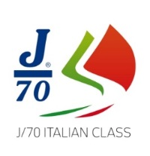 ITALIAN J/70 CUP 2019

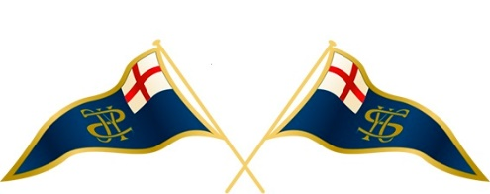

YACHT CLUB SANREMO

Compagnia della Vela

October 17
After the race
BEER & PASTA PARTY
At Yacht Club Sanremo

October 18
After the race
7.30 PM
COCKTAIL
at Royal Hotel

October 19
After the race
BEER & PASTA PARTY
At Yacht Club Sanremo

October 20
After the race
PRIZE GIVING

