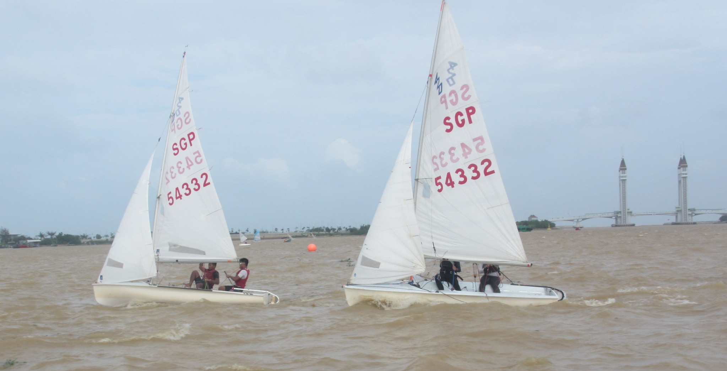
The Twin Tower bridge and the Twin 420s

