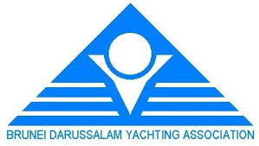
Protest Committee
The Protest committee is made up of the following judges:
- Leonard Chin IJ MAS
- Michael Tan CJ BRU
- Hamdan Yahya NJ MAS
- Sybrand Ijkema CJ NED

Conflict of Interest:
- Hamdan Yahya will recuse himself from a hearing if it involves any sailor from Sarawak Sailing Association.
- Michael Tan will recuse himself from any hearing if it involves his grandson Jeremiah.

Jury Chairman
Inaugural BDYA Sailing Championship 2019
Leonard Chin IJ (MAS)

