30th ATHENS INTERNATIONAL SAILING WEEK 2021
OPEN GREEK CHAMPIONSHIP FOR OLYMPIC & PARASAILING CLASSES
AND GREEK NATIONAL TEAM QUALIFICATIONS
INTERNATIONAL CLASSES: OPTIMIST, LASER 4.7, TECHNO 293 & 293PLUS, 420, LIGHTNING, FINN & WASZP

Athens International Sailing Center
Delta Marina, Kallithea

4 – 14 November 2021
SAILING INSTRUCTIONS (SIs)

The notation ‘[NP]’ in a rule of the sailing instructions (SIs) means that a boat may not protest another boat for breaking that rule. This changes RRS 60.1(a).

1 RULES
1.1 The event will be governed by the rules as defined in the Racing Rules of Sailing (RRS) 2021-2024.
1.1.1 The class rules.
1.1.2 No National Prescriptions will apply.
1.1.3 RRS Appendix P, Special Procedures for Rule 42, will apply.
1.1.4 RRS Appendix B, for the IQFoil class, will apply.
1.1.5 For the medal race, World Sailing Addendum Q, Umpired Fleet Racing, available on the World Sailing website (http://www.sailing.org), will apply and changes a number of racing rules. The current version of Addendum Q will be posted on the official notice board.
1.1.6 For the Greek Championship, the HSF 2021 racing program will apply.
1.7 [DP] Rule 40.1 applies at all times while afloat, except briefly while changing or adjusting clothing or personal equipment.
1.8 In all rules governing this event:
Both ‘athlete’ and ‘competitor’ mean a person competing or intending to compete in the event.
1.9 [SP] denotes a rule for which a standard penalty may be applied by the race committee or the technical committee without a hearing or a discretionary penalty applied by the protest committee with a hearing. This changes RRS 63.1 και A5
1.10 If there is a conflict between languages, the English text will take precedence.

2 CHANGES TO SAILING INSTRUCTIONS
2.1 Any change to the sailing instructions will be posted before 0900 on the day it will take effect, except that any change to the schedule of races will be posted by 2000 on the day before it will take effect.

3 COMMUNICATIONS WITH COMPETITORS
3.1 Notices to competitors will be posted on the official notice board located at:
- For the International Classes [https://www.racingrulesofsailing.org/events/2843]
- For the Olympic Classes [https://www.racingrulesofsailing.org/events/2842].
3.2 The race office is located at
Event / Class | Race Office Contact Details
Optimist  49er, 49er FX  470  Nacra17 | N.C. of Palaio Faliro  (+30) 210-9814835  info@nopf.gr
ILCA 6  ILCA 7  Lightning | N.A.C. of Voula  (+30) 210-8991189  info@naov.gr
420  WASZP | N.C. Tzitzifies Kallithea  (+30) 210-4131819  (+30) 210-4810390  info@notk.gr
ILCA 4 | N.C. of Kalamaki  (+30) 210-9829878  nokalamakiou@gmail.com
Techno 293 & 293 Plus  IQFoil | N.C.K of Vouliagmeni  (+30) 210-9671142  nokb@otenet.gr
Finn  2.4mR  Hansa 2.3  Hansa 303 | Y.C. of Greece  (+30) 210-4220506  sailing@ycg.gr

3.3 On the water, the race committee intends to monitor and communicate with competitors on VHF radio channel
Event / Class | Radio Channel
Optimist  49er, 49er FX  470  Nacra17 | VHF 72
ILCA 6  ILCA 7  Lightning | VHF 71
420  WASZP | VHF 68
ILCA 4 | VHF 69
Techno 293 & 293 Plus  IQFoil | VHF 74
Finn  2.4mR  Hansa 2.3 / Hansa 303 | VHF 68
3.4 [DP] While racing, except in an emergency, a boat shall not make voice or data transmissions and shall not receive voice or data communication that is not available to all boats.

4 CODE OF CONDUCT
4.1 [DP] Competitors and support persons shall comply with reasonable requests from race officials.
4.2 [DP] Competitors and support persons shall handle any equipment by the organizing authority with care, seamanship, in accordance with any instructions for its use and without interfering with its functionality.

5 SIGNALS MADE ASHORE
5.1 Signals ashore will be displayed on the flagpole located near to the boat park in each venue
5.2 When flag AP is displayed ashore, ‘1 minute’ is replaced with ‘not less than <30> minutes’ in Race Signals AP.
5.3 [DP] Flag D with one sound means ‘Boats shall not leave the harbour until this signal is made. The warning signal will not be made before the scheduled time or less than <30> minutes after flag D is displayed.’

6 SCHEDULE OF RACES
6.1
Part 1 – Optimist, ILCA 4, 420, Techno 293 & 293 Plus, WASZP, Lightning
Sunday, 31/10/2021 | 23:59 | End of Registration
Thursday, 4/11/2021 | 09:00 – 16:00 | Inspections
Friday, 5/11/2021 | 12:00 | First Warning Signal
Saturday, 6/11/2021 | TBA | Races
Sunday, 7/11/2021 | TBA  TBA | Races  Prize Giving

Part 2 – Olympic Classes
Sunday, 31/10/2021 | 23:59 | End of Registration
Monday, 8/11/2021 | 09:00 – 18:00 | Inspections
Tuesday, 9/11/2021 | 12:00 | First Warning Signal
Wednesday, 10/11/2021 | TBA | Races
Thursday, 11/11/2021 | TBA | Races
Friday, 12/11/2021 | TBA | Races
Saturday, 13/11/2021 | TBA | Races
Sunday, 7/11/2021 | TBA  TBA  TBA | Medal Races  Races  Prize Giving

Part 2 – Finn, 2.4mR, Hansa 2.3, Hansa 303
Sunday, 31/10/2021 | 23:59 | End of Registration
Monday, 8/11/2021 | 09:00 – 18:00 | Inspections
Tuesday, 9/11/2021 | 12:00 | First Warning Signal
Wednesday, 10/11/2021 | TBA | Races
Thursday, 11/11/2021 | TBA | Races
Sunday, 7/11/2021 | TBA | Prize Giving

6.2 No more than four (4) races will be sailed in any scheduled day in each class, except WASZP where no more than five (5) races will be sailed in any scheduled day.
6.4 To alert boats that a race or sequence of races will begin soon, the orange starting line flag will be displayed with one sound at least five minutes before a warning signal is made.
6.5 On the last scheduled day of racing no warning signal will be made after 17:00.

7 CLASS FLAGS
7.1 The class flags are:
Event | Class Insignia | Background
Optimist Boys  Optimist Girls |  | White  Yellow
ILCA 4 Boys  ILCA 4 Girls |  | White  Light Blue
420 |  | White
Waszp |  | White
Lightning |  | White
Techno 293 |  | White
Techno 293 Plus |  | Green
IQ Foil |  | White
470 |  | Light Blue
49er |  | White
Nacra |  | White
ILCA 6 |  | Light Blue
ILCA 7 |  | White
Finn |  | White
2.4mR |  | White
Hansa |  | White

8 RACING AREA
8.1 SI Addendum <A.> shows the location of the racing area(s).

9 COURSES
9.1 The diagram(s) in SI Addendum <B> show(s) the course(s), including the approximate angles between legs, the order in which marks are to be passed, and the side on which each mark is to be left.
9.2 No later than the warning signal, the race committee signal vessel will display the approximate compass bearing of the first leg.

10 MARKS
10.1 Mark(s) are
Event | Marks | New Marks
Optimist | Yellow
ILCA 4 | Yellow | Orange
420 | Yellow | Orange
Waszp | Orange | Yellow
Lightning | Red | Yellow
Techno 293 | Yellow | Orange
Techno 293 Plus | Yellow | Orange
IQ Foil | Yellow | Orange
470 | Yellow | Orange
49er | Yellow | Orange
Nacra | Yellow | Orange
ILCA 6 | Red | Yellow
ILCA 7 | Red | Yellow
Finn | Green | Red
2.4mR | Green | Red
Hansa | Green | Red

10.2 The following marks are rounding marks: <See Addendum B>.

11. FORMAT OF RACING
11.1 For the Olympic classes events (except IQ Foil) with twenty (20) or more participants:
11.1.1 The format consists of a qualification series (10 races) and a medal race.
11.1.2 A medal race will be scheduled if 4 or more qualification series races are completed.
11.1.3 The ten boats ranked highest in the qualification series will be assigned to compete in the medal race.
11.1.4 The rest of the fleet will not race.
11.2 For the Olympic classes events (except IQ Foil) with less than twenty (20) participants, the format consists of a single series (11 races).
11.3 For the international and Paralympic classes events (except WASZP), the format consists of a single series (9 races).
11.4 For the IQ Foil events, the format consists of a single series (15 races). Only the following format will be included: Course Windward/Leeward.
11.5 For the WASZP events, the format consists of a single series (15 races).
11.6 For the Optimist and the ILCA 4 classes, Boys and Girls will race separately. The boats will be divided in 2 or more fleets depending on the total number of boats. The boats will be divided into fleets at the end of each day as follows:
11.6.1 Boats will be assigned to fleets of, as nearly as possible, equal size.
11.6.2 Initial assignments will be made by the race committee and will be posted on the official notice board until 20:00 on the day before the first scheduled race. For the purposes of scoring, scores for RRS A 5.2 (DNF, DSQ, BFD, etc.) will be calculated based on the number of boats assigned to the bigger fleet.
11.6.3 If at the end of each racing day, all fleets have completed the same number of races, the race committee will assign new fleets based on the results. The assignments will be as following:
1st | Group A
2nd | Group B
3rd | Group B
4th | Group A
5th | Group A
6th | Group B
7th | Group B
Etc. | Etc.
11.6.4 If at the end of each racing day, fleets have not completed the same number of races, the race committee will assign new fleets as described in 11.6.3, but as follows:
The series scores for reassignment will be calculated for those races, numbered in order of completion, completed by all fleets. For the fleets that have completed more races, the most recent races will not be taken in consideration.
11.6.5 Fleet assignments will be based on the ranking available at 21:00 that day regardless of protests or requests for redress not yet decided.

12. THE START
12.1 The starting line will be between staffs displaying orange flags on the starting marks.
12.2 Boats whose warning signal has not been made shall avoid the starting area during the starting sequence for other races.
12.3 A boat that does not start within <5> minutes after her starting signal will be scored Did Not Start without a hearing. This changes RRS A5.1 and A5.2.
12.4 For the IQ Foil, all races will be started by using the following signals: This changes RRS Appendix B rules 26.1.

Minutes before starting signal | Visual Signal | Sound Signal | Meaning
3 | Class Flag | One | Warning Signal
2 | U or Black Flag | One | Preparatory Signal
1 | U or Black Flag removed | One long | One Minute
0 | Class Flag removed | One | Starting Signal
13. CHANGE OF THE NEXT LEG OF THE COURSE
13.1 To change the next leg of the course, the race committee will lay a new mark (or move the finishing line) and remove the original mark as soon as practicable. When in a subsequent change a new mark is replaced, it will be replaced by an original mark.

14. THE FINISH
14.1 The finishing line is between staffs displaying blue flags on the finishing marks.

15. PENALTY SYSTEM
15.1 For the classes 49er, 49er FX, Nacra 17 and WASZP, RRS 44.1 and P2.1 are changed so that the Two-Turns Penalty is replaced by the One-Turn Penalty.
15.2 Part 1 – International Classes
A Protest Committee shall be appointed in accordance with RRS 91(a).
15.3 Part 2 – Olympic Classes (National Championships)
An International Jury shall be appointed in accordance with RRS 91(b). The decisions of the International Jury will be final as provided in RRS 70.5.

16. TIME LIMITS [AND TARGET TIMES]
16.1 The Mark 1 Time Limit, Race Time Limit (see RRS 35), and the Finishing Window are shown in the table below.
Event | Mark 1 Time Limit | Race Time Limit | Finishing Window
Optimist | 25 | 70 | 15
ILCA 4 | 25 | 70 | 15
420 | 20 | 70 | 15
Waszp | 10 | 40 | 10
Lightning | 25 | 70 | 15
Techno 293 | 15 | 60 | 10
Techno 293 Plus | 15 | 60 | 10
IQ Foil |  | 25 | 10
470 | 20 | 70 | 15
49er | 15 | 40 | 10
Nacra | 15 | 40 | 10
ILCA 6 | 20 | 70 | 15
ILCA 7 | 20 | 70 | 15
Finn | 20 | 70 | 15
2.4mR | 10 | 30 | 10
Hansa | 10 | 30 | 10

16.2 If no boat has passed the first mark within the Mark 1 Time Limit, the race will be abandoned.
16.3 Boats failing to finish within the Finishing Window will be scored DNF without a hearing. This changes RRS 35, A5.1, A5.2.
16.4 Failure to meet the Target Time will not be grounds for redress. This changes RRS 62.1(a).
17. HEARING REQUESTS
17.1 For each class, the protest time limit is <60> minutes after the last boat in that class finishes the last race of the day or the race committee signals no more racing today, whichever is later. The time will be posted on the official notice board.
17.2 Hearing request forms are available from the race office on each venue or on-line at
International Classes - https://www.racingrulesofsailing.org/events/2843
Olympic Classes, Finn, 2.4mR, Hansa - https://www.racingrulesofsailing.org/events/2842
17.3 Notices will be posted no later than 30 minutes after the protest time limit to inform competitors of hearings in which they are parties or named as witnesses. Hearings will be held in the protest room, located at
Venue | Hearing Room
ILCA 6 / ILCA 7 / Lightning / Techno 293 / Techno 293 plus / IQ foil | N.A.C. of Voula
Optimist / 49er / 420 / 470 / Nacra 17 / ILCA 4 / Waszp | Hellenic Sailing Federation (HSF)
Finn / 2.4mR / Hansa | Y.C. of Greece
beginning at the time posted on the official notice board.
17.4 A list of boats that have been penalized for breaking RRS 42 under Appendix P will be posted.
17.5 Decisions of the International Jury will be final as provided in RRS 70.5. If Appendix N1.4(b) applies, the time limit for request for a full panel hearing by a full International Jury is 15 minutes after the parties have been informed of the decision.

18. SCORING
18.1 If less than 4 races have been completed, a boat’s series score will be the total of her race scores. When 4 or more races have been completed, a boat’s series score will be the total of her race scores excluding her worst score. However, the score from any medal race will not be excluded. This changes RRS A2.1.
18.2 For the Medal race RRS A5.1 is changed so that scores are based on the number of boats assigned into that race, and RRS A4 is changed so that points are doubled.
18.3 Each class event is valid if at least four (4) races are completed.
18.4 To request correction of an alleged error in the posted races or series results, a boat shall complete a scoring enquiry form available either at the race office of each venue or online at:
International Classes - https://www.racingrulesofsailing.org/events/2843
Olympic Classes, Finn, 2.4mR, Hansa - https://www.racingrulesofsailing.org/events/2842

19. SAFETY REGULATIONS
19.1 [DP] A boat that retires from a race shall notify the race committee at the first reasonable opportunity. Promptly after returning to shore, the boat shall complete a retirement declaration form, which is available either at the race office of each venue or online at:
International Classes - https://www.racingrulesofsailing.org/events/2843
Olympic Classes, Finn, 2.4mR, Hansa - https://www.racingrulesofsailing.org/events/2842

20. REPLACEMENT OF CREW OR EQUIPMENT
20.1 [DP] Substitution of competitors is not allowed without prior written approval of the race committee.
20.2 [DP] Substitution of damaged or lost equipment is not allowed unless authorized in writing by the race committee. Requests for substitution shall be made to the committee at the first reasonable opportunity, which may be after the race.
20.3 Requests forms will be available either at the race office of each venue or online at:
International Classes - https://www.racingrulesofsailing.org/events/2843
Olympic Classes, Finn, 2.4mR, Hansa - https://www.racingrulesofsailing.org/events/2842

21. EQUIPMENT AND MEASUREMENT CHECKS
21.1 A boat or equipment may be inspected at any time for compliance with the class rules, notice of race and sailing instructions.
21.2 [DP] When instructed by a race official on the water, a boat shall proceed to a designated area for inspection.

22. OFFICIAL VESSELS
22.1 Official vessels will be identified as follows:
Official Vessel | Flag Identification
Race Committee | White flag with ‘RC’
Protest Committee | White flag with ‘JURY’, ‘J’ or ‘IJ’
Media | Any flag with ‘PRESS’, ‘MEDIA’ or ‘TV’
Safety | Any flag with ‘RESCUE’

23. [DP] SUPPORT TEAMS
23.1 Support Boat’s location while afloat:
23.1.1 From the time of the warning signal for the first fleet to start, until all boats in all fleets are no longer racing, support boats shall stay outside areas where boats are or will be racing and shall not be closer than 100m to any boat racing.
23.1.2 When in the starting area, support boats shall remain in the waiting area from the first warning signal of a race, until the last fleet of that race has started. However, they may abandon the waiting area temporarily to serve their competitors after a fleet has started, been postponed, or abandoned, until the warning signal of the next fleet to start is made. Note that the limitations in SI 24.1.1 always apply.
23.1.3 When a race committee or jury member indicates a support boat to move further from the course area, the mentioned boat shall do so immediately.
23.2 Team leaders, coaches and other support persons shall wear Personal Floatation Devices at all times other than for brief periods while adding or removing clothing. With the motor running they are required to wear the Quick Stop / Kill Cord.
23.3 Support persons in the race course area, shall be able to communicate with the Race Committee via VHF Radio during racing. The radio channel for each course is mentioned in SI 3.3.
23.4 For the Olympic events only: Support person vessels shall clearly be marked with the three-letter national code of their World Sailing member national authority at all times while afloat.

24. TRASH DISPOSAL
24.1 Trash may be placed aboard official or support person vessels.

25. PRIZES
25.1 Prizes will be awarded to the best three (3) boats of each class event.

26. RISK STATEMENT
26.1 RRS 3 states: ‘The responsibility for a boat’s decision to participate in a race or to continue to race is hers alone.’ By participating in this event each competitor agrees and acknowledges that sailing is a potentially dangerous activity with inherent risks. These risks include strong winds and rough seas, sudden changes in weather, failure of equipment, boat handling errors, poor seamanship by other boats, loss of balance on an unstable platform and fatigue resulting in increased risk of injury. Inherent in the sport of sailing is the risk of permanent, catastrophic injury or death by drowning, trauma, hypothermia or other causes.

27. INSURANCE
27.1 Every participating boat must be insured with a valid third-party liability insurance, that is suitable for the racing area, with a minimum coverage of 540,000 euro per incident, or the equivalent.
27.2 The support boats must be insured with a valid third-party liability insurance with the minimum cover of Greek Law. Regardless, it is the responsibility of the support persons in charge of the boats registered, to hold adequate insurance cover for Tort Liability and Third-Party Insurance (Property and Persons).
27.3 A copy of the insurance coverage must be delivered with the registration.
27.4 The organizing authority is not responsible for verifying the status or validity of those insurance certificates.

SI ADDENDUM A
COURSE AREAS
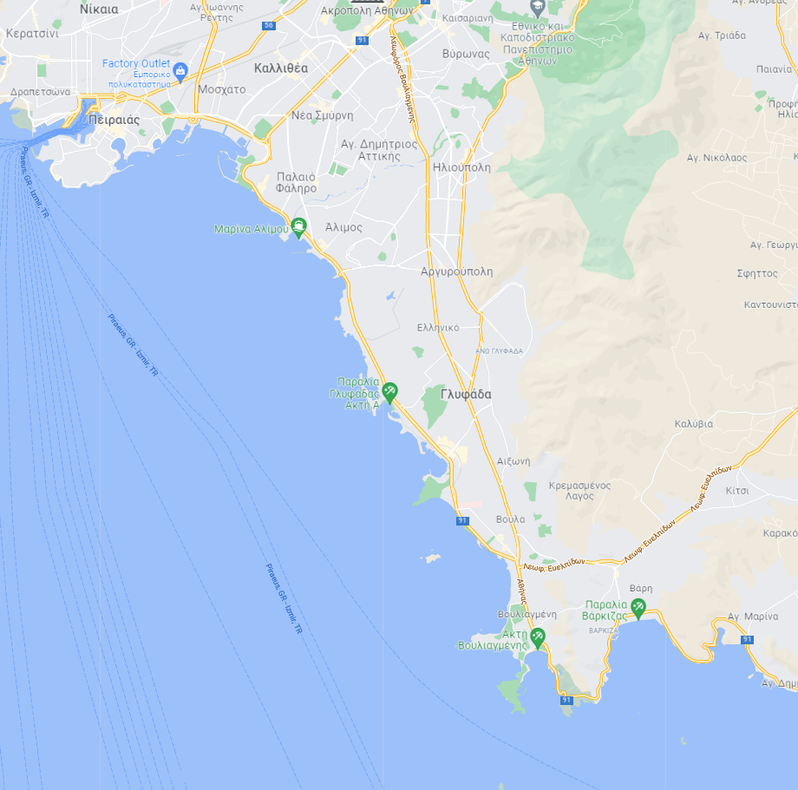

Finn, 2.4mR,Hansa
YCG Club
NOTK Club

ILCA 4
NOK Club

ILCA 6 ILCA 7 Lightning
NAOV Club

Optimist 49er, 470 Nacra
NOPF Club

Techno iQFOil
NOKV Club

420 WASZP
ADDENDUM B
RACE COURSES

Trapezoid Outer: Trapezoid Inner:
O1: S-1-2-3-2-3-F I1: S-1-4-1-2-3-F
O2: S-1-2-3-2-3-2-3-F I2: S-1-4-1-4-1-2-3-F

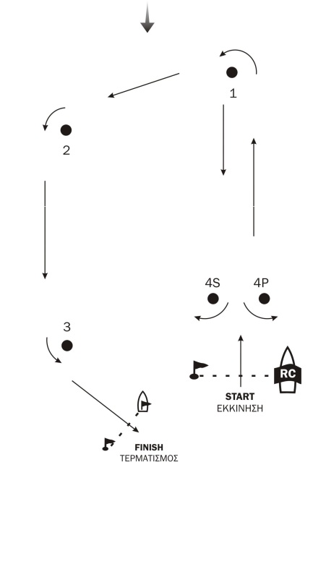
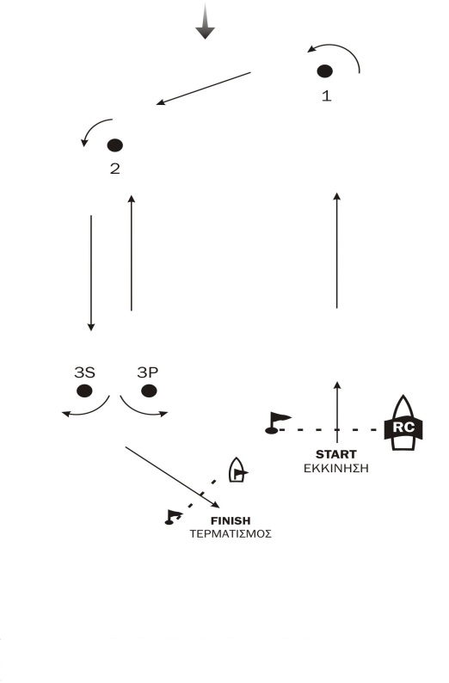

Trapezoid Outer: Marks 1-2-3s/3p will be rounding marks
Trapezoid Inner: Marks 1-2-3-4s/4p will be rounding marks

OPTIMIST COURSE:
IODA

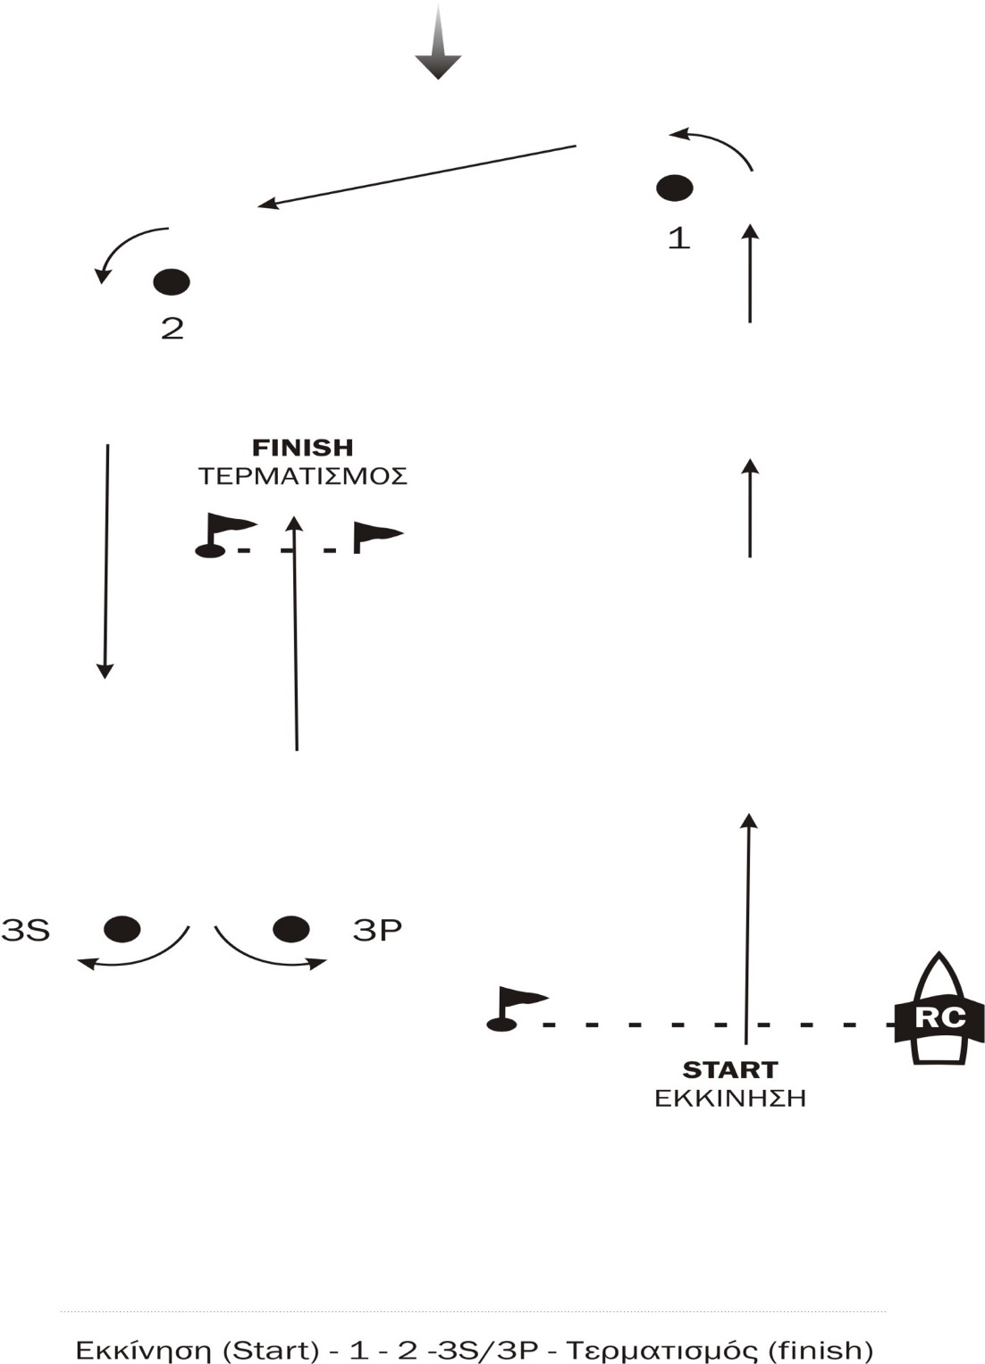

Marks 1-2-3s/3p will be rounding marks

COURSE: WINDWARD/LEEWARD
Signal. Mark Rounding Order
L1. Start – 1 – 4s/4p – 1 – 4p - Finish
L2. Start – 1 – 4s/4p – 1 – 4s/4p – 1 – 4p - Finish

1

1

FINISH

4

START

Marks 1-4s/4p will be rounding marks

