Brief Guide on how to use the RRoS.org

RacingRulesofSailing.org (RRoS.org) is an online protest management system.
Competitors can fill and submit requests electronically using the RRoS.org jury management system. Note that you do not need to be signed in or register to RRoS.org to submit a request.
There are various ways to submit requests to RRoS.org
- Using the QR Codes provided by the OA
- Visit www.racingrulesofsailing.org on your web browser
- Using the application for Android or iOS. (Not always working properly)

In any case it is the competitor’s responsibility to ensure that his/her request has been filled out correctly.

- How to submit a request through the web browser:
- On the main page scroll down and find the relevant event on the list of events.
- Open the event and press the + button (see image below)
The following actions are permitted:
- Submit a hearing request (protest, request for redress, request for reopening….)
- Submit a question to the jury
- Submit a crew or equipment substitution
- Submit a scoring inquiry
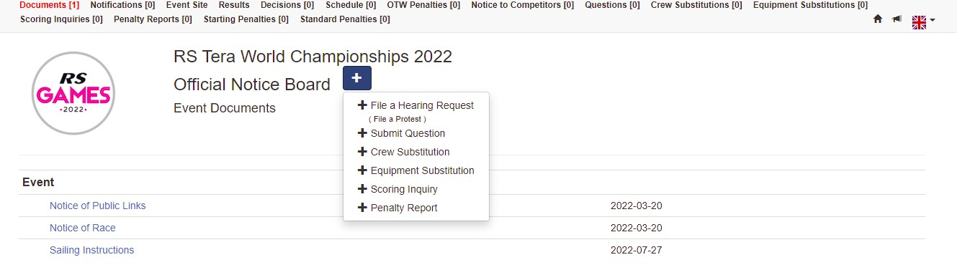
- Submit a penalty report.

- Fill in as appropriate your request form.
- Remember to monitor and review your request on RRoS.org.

- Other Functions on RRoS.org:
On the top of the page, you can find:
- a menu, if you are using a laptop
- the RRoS logo, if you are using a mobile
The following functions are available:
- Documents that govern the event
- Notifications
- Hearing Decision
- Hearing Schedule
- On the water penalties
- Notices to competitors
- Questions to the various committees (Also the answers are shown)
- Crew & Equipment substitutions (Also the answers are shown)
- Scoring Inquiries (Also the answers of the committee are shown)
- Penalty reports
- Starting penalties
- Standard penalties

For a more detailed guide please visit:
https://www.racingrulesofsailing.org/pages/help/new_protest

