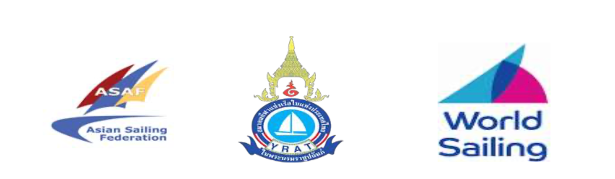

Asian Sailing Championships & Asian Continental Olympic Qualifier for Paris 2024 Olympic Games

Notice of Race

Amendment Number 1

Add the following to the last sentence.

4.4 “unless approved by ASAF/OA

Captain Arshad
Technical Delegate

