

REGATANA NAVOSILA / SAILING INSTRACTION
OLIMPIC REGATA 2022
23. – 24. 4. 2022
IZOLA – SLOVENIJA

OPTIMIST
Organizator prireditve je Jadralni klub Olimpic Izola v sodelovanju z Jadralno zvezo Slovenije.
The Organizing Authority of the event is Sailing Club Olimpic Izola in cooperation with Slovenian Sailing Federation.

JADRALNA NAVODILA  1. PRAVILA  1.1. Olimpic regata bo poteka po pravilih, kot so definirana v Jadralnih regatnih pravilih (RRS).  1.2. RRS 40.1 velja ves čas na vodi.  1.3. V primeru kakršne koli pomenske razlike med tem Regatnim razpisom in Regatnimi navodili, bodo odločilna Regatna navodila. To spremeni RRS 63.7  1.4 Če so med jeziki pomenske razlike, bo odločilno angleško besedilo.  1.5. COVID- 19 INFORMACIJE  Regata bo potekala skladno s pogoji, ki v razmerah  COVID-19 veljajo v Republiki Sloveniji.  2. REGATNA NAVODILA IN OBVESTILA  2.1. Regatna navodila bodo na voljo od petka 23. aprila 2021 v regatni pisarni ter na spletni strani prireditve.  https://www.jk-olimpic.si  2.2. Obvestila tekmovalcem bodo objavljena na oglasni deski, ki se bo nahajala na internetni strani https://www.jk-olimpic.si  2.3. Vse spremembe regatnih navodil bodo objavljene pred 9:30 uro dneva, ko začno veljati, razen sprememb v razporedu plovov, ki bodo objavljene dan prej, preden začnejo veljati, do 20:00.  3. RAZPORED  3.1. Datum Ura Opis Št. plovov  22. apr 18:00-20.00 Registracija  23. apr 08.00-09.00 Registracija  23. apr 09:30 Sestanek trenerjev  23. apr 11:00 Tekmovanje 3  24. apr 11:00 Tekmovanje 3  24. apr po končani regati Podelitev nagrad  3.2. Dnevno so lahko izpeljani največ 4 plovi.  3.3. Opozorilni signal za prvi plov bo vsak dan ob 11:00.  3.4. Na zadnji tekmovalni dan ne bo opozorilnega signala po 16:00 uri.  4. SIGNALI NA OBALI  4.1 Signali na obali bodo izobešeni na jamboru privezanega plovila regatnega odbora v Marini Izola.  4.2 Kadar je zastava kodeks izobešena na kopnem, se "1 minuta" v regatnem signalu Kodeks zamenja z "ne manj kot 30 minut".  5. ZASTAVAE RAZREDA  Zastava razreda bo – Znak ratreda  6. REGATNO POLJE  Regatno polje bo v Izolskem zalivu.  7. PROGA  7.1. Skica v prilogi Ia. in Ib. prikazuje progo s približnimi koti med stranicami, zaporedje v katerem je treba iti mimo oznak in stran na kateri je treba pustiti posamezno oznako.  7.2. V primeru postavitve le ene oznake vrat, morajo jadrnice le to pustiti levo.  8. OZNAKE  6.1 Vse oznake bodo napihnjene boje rdeče barve,  6.2 Štartni oznaki bosta signalni čoln regatnega odbora na desni in čoln regatnega odbora ali rdeča boja na levi strani.  6.3 Ciljna oznaka bo čoln regatnega odbora in napihnjena boja modre barve na levi strani.  9. ŠTART  9.1 Štartna linija bo med drogom z oranžno zastavo na štartni oznaki na desnem koncu in štartno oznako na levem koncu.  9.2 Jadrnice se morajo pred svojim opozorilnim signalom izogibati štartnemu območju med štartnimi procedurami drugih razredov.  9.3 Jadrnica, ki štarta več kot 4 minute po njenem štartnem signalu, bo točkovana kot ‘Ni štartala’ (DNS) brez zaslišanja. To spremeni pravilo A4.  10. CILJ  Ciljna linija bo med drogom z modro zastavo na ciljni oznaki na desnem koncu in ciljno oznako na levem koncu.  11. SISTEM KAZNOVANJA  Uporabljen bo dodatek P.  12 PREDPISANI ČASI IN CILJNI ČASI TRAJANJA  12.1 Časovne omejitve za zmagovalca plova ne bo. RO bo progo postavil tako, da bo vožnja trajala približno 45 minut. Neizpolnjevanje časa trajanja ni osnova za nadomestilo. To spremeni pravilo 62.1(a).  12.2 Jadrnice, ki ne končajo plova v 20 minutah za prvo jadrnico, ki prejadra progo in konča, bodo točkovane kot ‘Ni končala’ (DNF) brez zaslišanja. To spremeni pravila 35, A4 in A5.  13. PROTESTI IN ZAHTEVKI ZA NADOMESTILO  13.1 Protestni obrazci so na voljo v regatni pisarni. Protesti in zahtevki za nadomestilo ali ponovno odprtje zaslišanja morajo biti oddani v regatni pisarni znotraj predpisanega časa za oddajo protestov.  13.2 Čas za oddajo protestov je 60 minut po končanju zadnje jadrnice v zadnjem plovu dneva.  13.3 Obvestila bodo objavljena ne kasneje kot 30 minut po izteku časa za oddajo protestov, da bodo tekmovalci obveščeni o zaslišanjih v katerih so sami stranke ali so navedeni kot priče. Zaslišanja bodo v protestni sobi zraven regatne pisarne, začetek ob objavljenem času.  13.4 Obvestila o protestih s strani regatnega odbora ali protestnega odbora bodo objavljena za obveščanje jadrnic skladno s pravilom 61.1(b).  13.5 Objavljen bo seznam jadrnic, po navodilu 12, ki so bile kaznovane za prekršitev pravila 42.  13.6 Kršitev navodil 10.2, 16, 19, 20 niso podlaga za protest jadrnice. To spremeni pravilo 60.1(a). Kazni za te kršitve so lahko milejše od diskvalifikacije, če protestni odbor tako odloči. Okrajšava za diskrecijsko kazen po tem navodilu bo DPI (diskrecijska kazen dana).  13.7 Zadnji tekmovalni dan regate se mora zahtevek za ponovitev zaslišanja oddati  (a) v času za oddajo protestov, če je bila stranka, ki zahteva ponovitev, obveščena o odločitvi že prejšnji dan;  (b) najkasneje 30 minut po tem, ko je bila stranka, ki zahteva ponovitev, ta dan obveščena o odločitvi. To spremeni pravilo 66.  13.8 Zadnji tekmovalni dan regate se mora zahtevek za nadomestilo, ki je posledica odločitve protestnega odbora oddati ne kasneje kot 30 minut po objavi odločitve. To spremeni pravilo 62.2.  14 VARNOSTNI UKREPI  Jadrnica, ki je odstopila od plova, mora o tem čimprej obvestiti regatni odbor.  REGATNI ODBOR | SAILING INSTRUCTIONS  1. RULES  1.1. Olimpic Regatta will be governed by the rules as defined in The Racing Rules of Sailing (RRS).  1.2. RRS 40.1 shall apply at all times whilst afloat.  1.3. If there is any conflict between this Notice of Race and the Sailing Instructions, the Sailing Instructions will take precedence. This changes RRS 63.7  1.4. If there is a conflict between languages, the English text takes precedence.  1.5. COVID-19 INFORMATIONS  Regatta will be organised with compliance with regulations governing COVID-19 in Republic of Slovenia  2. SAILING INSTRUCTIONS AND NOTICES COMPETITORS  2.1. The Sailing instructions (SI) will be available after Friday, 22 April 2022 in the Race Office and on the event website.  https://www.jk-olimpic.si  2.2. Notices to competitors will be posted on line board at the web site https://www.jk-olimpic.si  2.3. Any change to the sailing instructions will be posted before 9:30 on the day it will take effect, except that any change to the schedule of races will be posted by 20:00 on the day before it will take effect.  3. SCHEDULE  3.1. Date Time Description Races  22. apr 18:00-20.00 Registration  23. apr 08.00-09.00 Registration  23. apr 09:30 Coach Meeting  23. apr 11:00 Racing 3  24. apr 11:00 Racing 3  24. apr after the races Prize giving ceremony  3.2. No more than 4 races may be sailed each day.  3.3. The scheduled time for the warning signal for the first race each day is 11:00.  3.4. On the last scheduled day of racing no warning signal will be made after 16:00.  4. SIGNALS MADE ASHORE  4.1 Signals made ashore will be displayed on the flag pole.  4.2 When flag AP is displayed ashore, "1 minute" is replaced with "not less than 30 minutes" in the race signal AP.  5. CLAS FLAG  6. RACING AREA  Racing area will be located in Izola bay.  7. THE COURSE  7.1. The diagram in Attachment I. shows the course, including the approximate angles between legs, the order in which marks are to be passed, and the side on which each mark is to be left.  7.2. If only one gate mark is set, boats shall leave the single mark to port  8. MARKS  6.1 All the marks will be inflatable red coloured buoy  6.2 The starting marks will be the race committee signal vessel on starboard end and race committee vessel or red coloured buoy at the port end.  6.3 The finishing marks will be race committee boat at the starboard end and inflatable blue coloured buoy at the port  9. THE START  9.1 The starting line will be between a staff displaying an orange flag on the starting mark at the starboard end and the port-end starting mark.  9.2 Boats whose warning signal has not been made shall avoid the starting area during the starting sequence for other races.  9.3 A boat starting later than 4 minutes after her starting signal will be scored Did Not Start (DNS) without a hearing. This changes rule A4.  10. THE FINISH  The finishing line will be between a staff displaying an blue flag on the finishing mark at the starboard end and the port-end finishing mark.  11. PENALTY SYSTEM  Appendix P will apply.  12 TIME LIMITS AND TARGET TIMES  12.1 There will be no time limit for the race winner. The RC will set the sailing course so that it will last about 45 minutes. Failure to meet the target time will not be grounds for redress. This changes rule 62.1(a).  12.2 Boats failing to finish within 20 minutes after the first boat sails the course and finishes will be scored Did Not Finish without a hearing. This changes rules 35, A4 and A5.  13. PROTESTS AND REQUESTS FOR REDRESS  13.1 Protest forms are available at race office. Protests and requests for redress or reopening shall be delivered there within the appropriate time limit.  13.2 The protest time limit is 60 minutes after the last boat has finished the last race of the day.  13.3 Notices will be posted no later than 30 minutes after the protest time limit to inform competitors of hearings in which they are parties or named as witnesses. Hearings will be held in the protest room near race office, at the time posted.  13.4 Notices of protests by the race committee or protest committee will be posted to inform boats under rule 61.1(b).  13.5 A list of boats that, under instruction 12, have been penalized for breaking rule 42 will be posted.  13.6 Breaches of instructions 10.2, 16, 19, 20 will not be grounds for a protest by a boat. This changes rule 60.1(a). Penalties for these breaches may be less than disqualification if the protest committee so decides. The scoring abbreviation for a discretionary penalty imposed under this instruction will be DPI.  13.7 On the last scheduled day of racing a request for reopening a hearing shall be delivered:  (a) within the protest time limit if the requesting party was informed of the decision on the previous day;  (b) no later than 30 minutes after the requesting party was informed of the decision on that day. This changes rule 66.  13.8 On the last scheduled day of racing a request for redress based on a protest committee decision shall be delivered no later than 30 minutes after the decision was posted. This changes rule 62.2.  14 SAFETY REGULATIONS  A boat that retires from a race shall notify the race committee as soon as possible.  RACE COMMITTEE
  Class flag will be – Class sign

Priloga 1a. / Attachment 1a. - Proga - Course

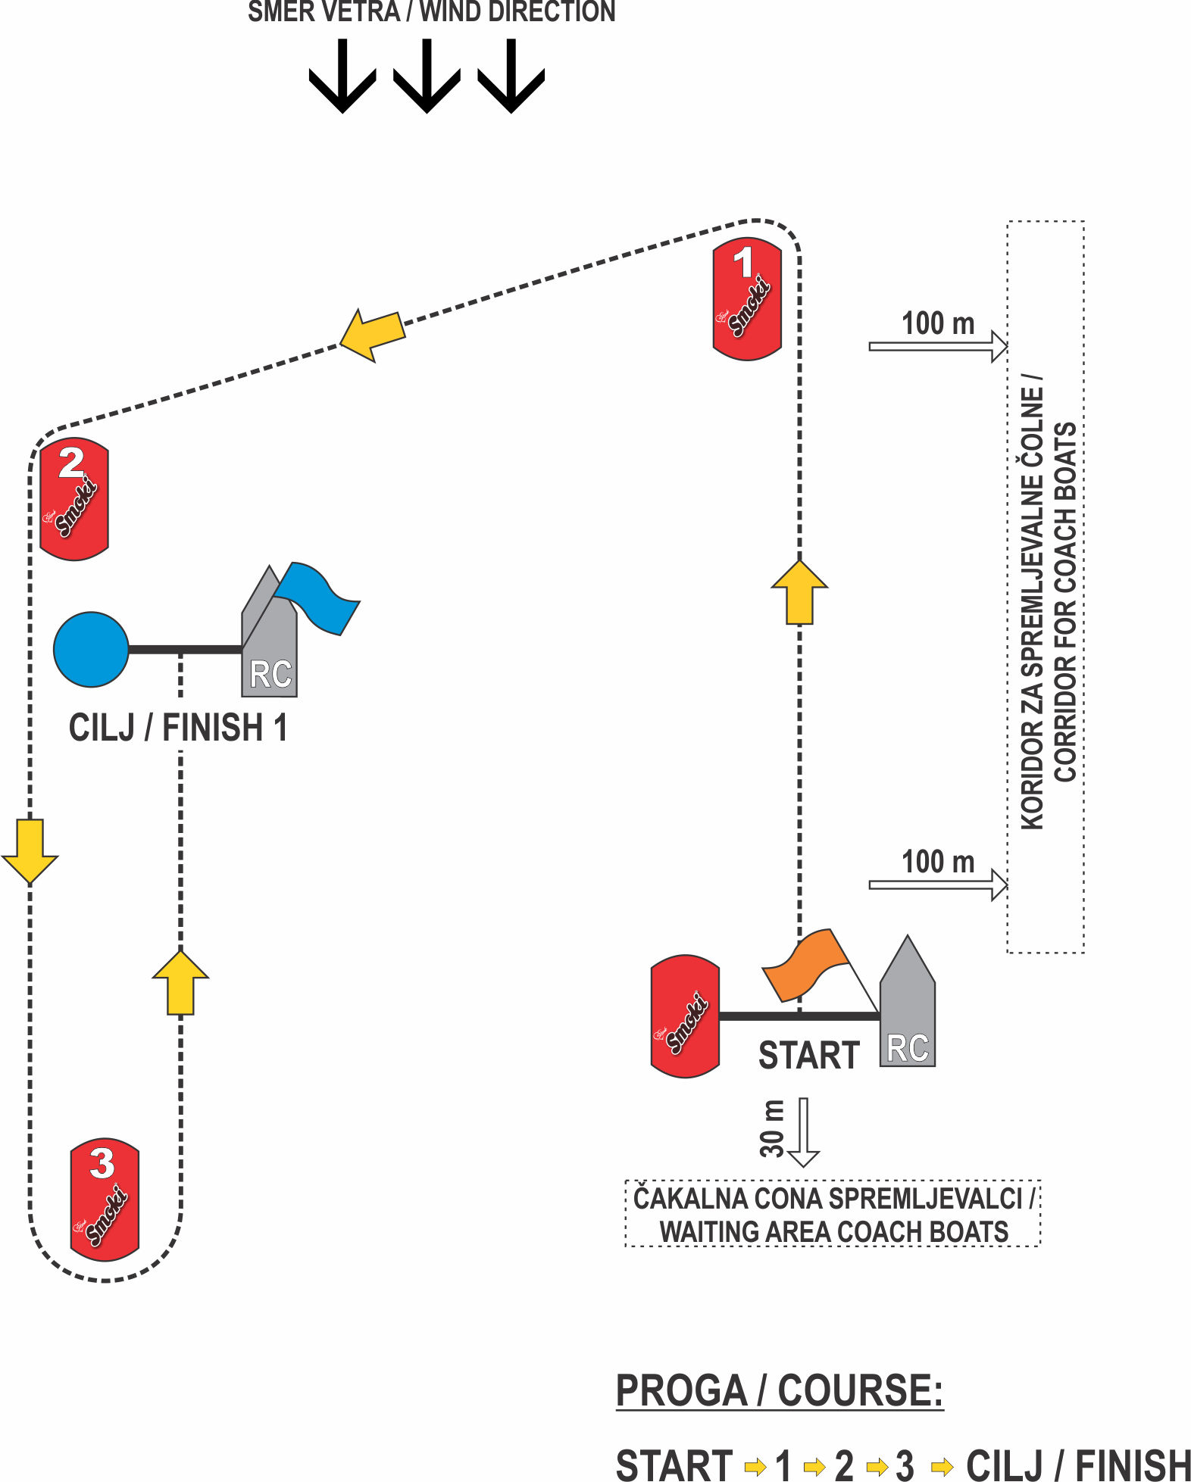

Priloga 1b. / Attachment 1b. - Proga – Course



