WEST MERSEA YACHT CLUB  
&   
DABCHICKS SAILING CLUB



***May Regatta Amendments***

**SPONSORED BY***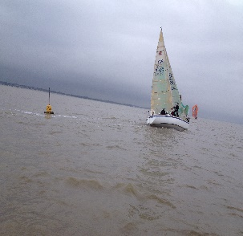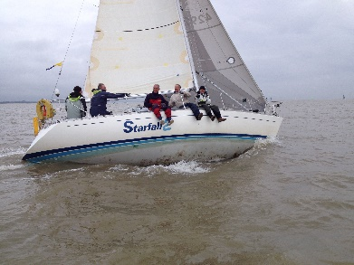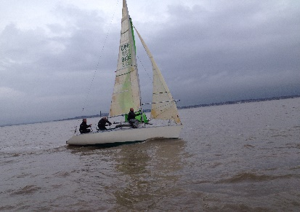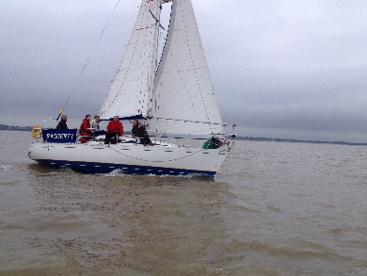*

***Entry for all events below are at*** [***https://www.merseasailing.com/event/mini-regatta-one***](https://www.merseasailing.com/event/mini-regatta-one)

***The NOR/SI’s for the following events are amended for the Long-Distance Race (11th May 2024) as follows.***

**SI 9.0 COURSES**

SI 9.1 is amended as follows  
The course to be sailed will be announced by the Committee Vessel on Channel 77 and may use Navigation marks further to seaward.

**SI 16 TIME LIMITS**

16.1 Time limit first boat to finish 3.5 hrs.

16.2 Finish window after first boat finishes 90mins

16.3 All boats finishing after the Finish Window closes will be scored TLE without a hearing. This changes RRS35.

***The NOR/SI’s for the following events are amended for the Ancient Mariners Race*** ***(12th May 2024) as follows.***

**NOR 4.** **ENTRIES & ELIGIBILITY**

4.5 This race is open to boats crewed by helms aged 60 and above.

4.6 Entries should be made Online through this link Entry.

4.7 No crew member may be less than 50.

4.8 Competitors in this race must denote their intention to race and state the number of people and their date of birth on board their boat by completing the Entry form which will be on the [website](http://westmerseayc.clubmin.website/event/ancient-mariners) from 1st July 2022

4.9 Where more than three boats declare they are White sail then their handicap will be adjusted by a further 20 points.

**SI 16.**  **TIME LIMITS**

16.1 Time limit first boat to finish 2.0 hrs.

16.2 Finish window after first boat finishes 60mins

16.3 All boats finishing after the Finish Window closes will be scored TLE without a hearing. This changes RRS35.

**SI 18. SCORING**

18.7 The boats will be scored using local handicap modified as follows;

18.7.1 A boat with the crew's average age of 60 will sail off its LH number.

18.7.2 5 points will be deducted from the LH number for each year of average age below 60,

18.7.3 5 points added to the LH number for each year of average age above 60.

***The NOR/SI’s for the following events are amended for the Wallet Cup Race (12th May 2024) as follows.***

**NOR 6. CREW LIMITATIONS**

* 1. This race is open to boats crewed by one, two, three or four people, including the helmsman.
  2. Competitors in this race must denote their intention to race and state the number of people on board their boat by completing the entry form online.

**SI 16 TIME LIMITS**

16.1 Time limit first boat to finish 2.5 hrs.

16.2 Finish window after first boat finishes 60mins

16.3 All boats finishing after the Finish Window closes will be scored TLE without a hearing. This changes RRS35.

**SI 18 SCORING**

* 1. Before the TCF (Time Correction Factor) is applied to the elapsed time of boats which have completed the course, the following adjustments will be made to the elapsed time of those boats:

Boats sailing single handed – 10% of the elapsed time will be deducted.

Boats sailing with 3 people on board – 10% of the elapsed time will be added.

Boats sailing with 4 people on board – 20% of the elapsed time will be added.

(NB Boats sailing double handed will have no adjustment made to their elapsed time)