Track System

QR code for Tracking System:

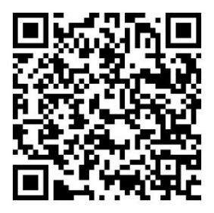

Link for Tracking System:

https://www.saill.cn/sailingrule-web/event?matchCd=sc899246303c484
6ff9d8ea70ff00733d2

