EVENTI - SOCIAL EVENTS

Venerdì - Friday
At 11.00 skipper meeting

dopo le regate – after races
“SUNSET PARTY”
(at the harbour of Castelletto)

kindly offered by
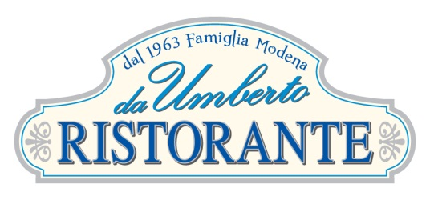

Sabato e Domenica – Saturday & Sunday
dopo le regate – after races

BUFFET AT THE SAILING CLUB

