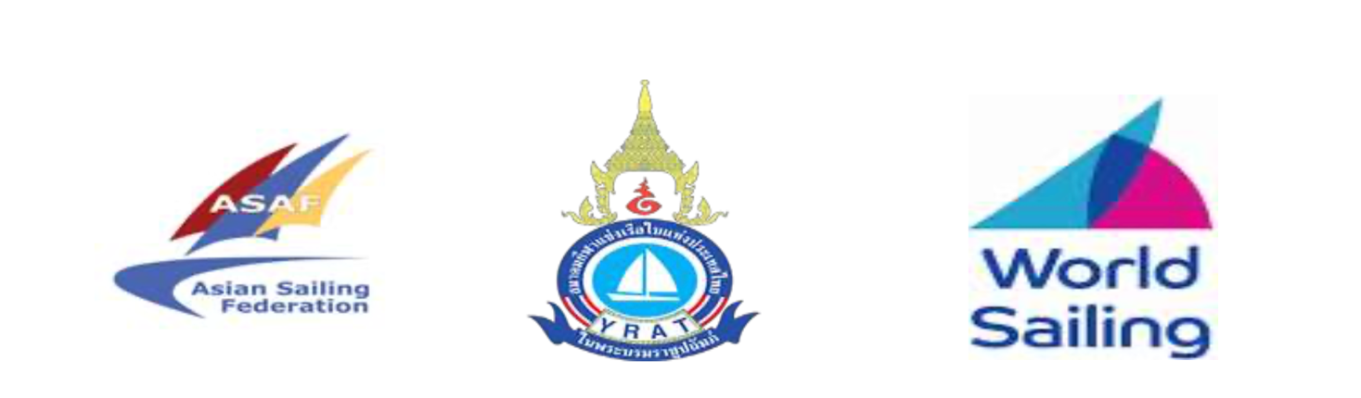

Asian Sailing Championships & Asian Continental Olympic Qualifier for Paris 2024 Olympic Games

Notice of Race

Amendment Number 2

Delete 8.4

Add 8.4
There will be a Team Leaders meeting at 08:30 at the Club House on the 2nd floor.

Captain Arshad
Technical Delegate

