BODRUM CHAMBER OF SHIPPING COUNTRY CUP
( DTO COUNTRY CUP )
SAILING INSTRUCTIONS

1. VENUE AND DATE
The event will take place in Bodrum on 16 March 2024. Depending on the wind conditions the schedule of Team Racing may be changed provided to competitors are notified according to SI 3

2. ELIGIBILITY
2.1. The regatta will be open to all Countries who will participate in the XI. BIOR.
2.2. According to the results of the races on 14 and 15 March 2024, the best male and female sailor of each country will participate in Country Cup.
3. RULES
3.1. The regatta will be governed by the rules as defined in The Racing Rules of Sailing.
3.2. The races will be umpired. A simplified Umpired Fleet Racing Sailing Instruction will be posted.
4. NOTICES TO COMPETITORS
4.1 All details about the Country Cup will be in the team racing instructions posted on the ONB https://www.racingrulesofsailing.org/documents/7587/event?name=superpar-bior-2024
4.2 There will be a short Country Cup Briefing at 09:00 on 16th March 2024 at the beach
4.3 The competitors should have red flag or red ribbons in order to protest. This changes Rule 61.1(a) (2).
5. PENALTIES
5.1 When a boat is protested for a breach of a rule of Part 2, rule 31 and rule 42 will immediately take a one turn penalty. If an umpire penalizes, by displaying red flag the penalty will be two turns.
6. SCORING
6.1. The Low Point scoring system of Appendix A shall apply. A boat’s series score will be the total of her race scores. No score will be excluded.
7. ENTRIES
The list of the competitors will be posted on the official notice board after the end of races on March 15, 2024.
8. THE COURSE
8.1. The course is shown below;
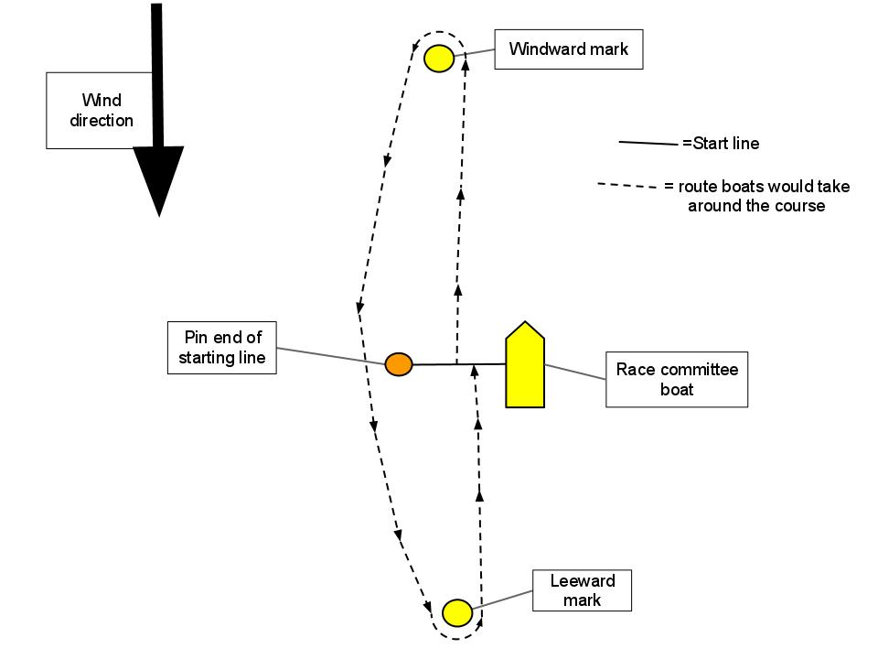
8.2.When the boats sailing downwind:
{i) the starting line ranks as an obstruction and shall not be crossed;
(ii) the start pin-end mark shall be left to port
9. Class flag
9.1 The Class Flag will be International Optimist Class Flag.
10. marks
10.1 Windward and leeward marks will be yellow and conic type.
10.2. Starting and finishing marks will be a yellow mark and a race committee boat.
11. START
11.1. The starting line will be between a staff displaying an orange flag on the race committee boat and a yellow colour mark.
11.2. When an individual recall is made, flag X will be displayed for up to 2 minutes. This changes rule 29.1.
11.3. The start will be as follows
SIGNAL | MIN. BEFORE STARTING SIGNAL | SOUND SIGNAL | VISUAL SIGNAL
Warning | 3 | One | Class Flag
Preparatory | 2 | One | “U” flag displayed
One-minute | 1 | One | “U” flag removed
Starting | 0 | One | Class flag removed
12. FINISH
12.1. The finishing line will be between a staff displaying an Blue flag on the race committee boat and a yellow colour mark.

13. MEASUREMENT CHECK
Measurement checks may be carried out before or after racing.
14. INTERNATIONAL JURY
An International Jury will be appointed according to Appendix N. The right to appeal will be denied (RRS 70.5).
15. RIGHT TO USE NAME AND LIKENESS
In participating in Country Cup any competitor automatically grants to the Organizing Authority and the sponsors of the Country Cup the right in perpetuity, to make, use and show, from time to time and at their discretion, any motion pictures and live, taped or film television and other reproductions of him/her during the period of the competition for the Country Cup in which the competitor participates and in all material related to the Country Cup without compensation.
16. SCHEDULE OF THE EVENT
16.1. Three (3) races are scheduled on 16 March 2024.
16.2. The time of the first warning signal will be after completed team racing. The time will be announce after completed team racing asap.
17. PRIZES
17.1 Prizes will be awarded to the countries. Not to the competitors.
17.2 Every country may be awarded only one prize.
17.3 Prizes will be Cups and will be given to the first three places.

RACE COMMITTEE

