SAILING INSTRUCTIONS

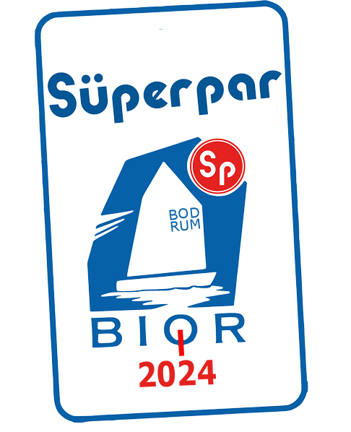

ORGANISING AUTHORITY
The XII. Superpar Bodrum International Optimist Regatta is organized by the B.B. Bodrum Sailing Club in conjunction with the Turkish Sailing Federation (TSF).

SAILING INSTRUCTIONS

1 RULES
1.1 The Championship will be governed by the ‘rules’ as defined in The Racing Rules of Sailing (RRS).
1.2 No national authority prescriptions will apply.
1.3 The first three sentences of RRS 61.1(a) are changed to ‘A boat intending to protest shall inform the other boat at the first reasonable opportunity. When her protest will c3oncern an incident in the racing area that she was involved in or saw she shall hail ‘Protest’. She shall inform the Race Committee at the finishing line immediately after finishing of the boat/s being protested, or as soon as practicable after she retires in accordance with SI 16.1.
1.4 RRS 40 applies at all times while boats are afloat on the water.
1.5 In all rules governing this championship, both “athlete” and “competitor” mean a person
competing in the event. The term “support person” means a person as defined in RRS.
1.6 In all rules governing this championship:
[SP] denotes a rule for which a standard penalty may be applied by the Race Committee or Technical Committee without a hearing or a discretionary penalty applied by the International Jury with a hearing. This changes RRS 63.1, A5.1 and A5.2;
[NP] denotes a rule that shall not be grounds for protests by a boat and for which the international jury may refuse to hold a hearing. This changes RRS 60.1(a)
1.7 (DP) Competitors and support persons shall comply with any reasonable request from an event official. Failure to comply may be misconduct.
1.8 English is the Official Language of the Championship. If there is a conflict between languages, the English text will take precedence.

2 COMMUNICATION WITH COMPETITORS
Notices to competitors will be posted on the online official notice board (Racing Rule of Sailing: on https://www.racingrulesofsailing.org/documents/7587/event?name=superpar-bior-2024 At the same time, all notices (Organization Committee, Race Committee and Jury) will share on whatsapp group which is created by organization committee. Failure to share on whatsapp group on time will not be grounds for Request for redress (this changes RRS 62.1(a)

3 CHANGES TO SAILING INSTRUCTIONS
Any change to the sailing instructions will be posted before 09:00 on the day it will take effect, except that any change to the schedule of races will be posted by 20:00 on the day before it will take effect.

4 SIGNALS MADE ASHORE
4.1 Signals made ashore will be displayed from the official flag pole located in front of the secretary
4.2 (NP)(DP) Flag D displayed with one sound means: ‘the warning signal will be made not less than 30 minutes after flag D is displayed.’ Boats shall not leave their berthing places until this signal is made.

5. FORMAT OF RACING
5.1 The format of the regatta will consist of a Qualifying Series followed by a Final Series.
5.2 Qualifying Series
5.2.1 The qualifying series will take place on the first 2 racing days.
5.2.2 If 4 races for all fleets of the qualifying series have not been completed by the end of the second racing day, the qualifying series will continue on subsequent fleet racing days until the end of the racing day in which a minimum of four qualifying races are completed.
5.2.3 For qualifying series;
Senior (born 2009 – 2012) and Juniors (born 2013 and later); boats will be assigned to Yellow, Blue, Green and Pink. As nearly as possible, equal size.
5.2.4 Initial assignments will be made by the race committee. For the initial assignment to fleets, boats will be sorted by alphabetical order of national letters and then by numerical order of sail number. Boats in the sorted list will be allocated to fleets according to the pattern shown in the table in instruction 5.2.6.
5.2.5 The initial assignment will be done on March 13 upon completion of the registration.
5.2.6 (NP) Boats will be reassigned to fleets after each day of racing. However boats will only be reassigned after the first day if all fleets have completed one race. If all fleets have completed the same number of races, boats will be reassigned on the basis of their ranks in the series. If all fleets have not completed the same number of races, the series scores for reassignment will be calculated for those races numbered in order of completion, completed by all fleets. Reassignments will be made as follows:

Rank in series | Fleet Assignment
First | Yellow
Second | Blue
Third | Green
Fourth | Pink
Fifth | Pink
Sixth | Green
Seventh | Blue
Eighth | Yellow
And so on | ...........

5.2.7 Assignments will be based on the ranking available at 21.00 that day regardless of protests or requests for redress not yet decided.
5.3 Final Series;
5.3.1 The final series will take place on days 3 and 4 of racing. Depending on the wind conditions the schedule of Final Races may be changed provided to competitors are notified according to SI 3
5.3.2 A final series will be scheduled if 4 or more qualifying series races have been completed for all fleets.
5.3.3 Boats will be assigned to the Gold, Silver, Bronze and Emerald Fleets on the basis of their ranking in the qualifying series. Gold, Silver, Bronze and Emerald Fleets will have as near as possible the same number as competitors. Boats with the best ranking in the qualifying series ranks will race all final series races in the Gold Fleet (Yellow), Silver (Blue), Bronze (Green), Emerald ( Pink )
5.3.4 Any recalculation of the final series ranking after the boats have been assigned to final fleets will not effect the assignments except that a redress decision may promote a boat to a higher fleet.

5.4 Fleet Assignments:
5.4.1 Qualifying Series: For the initial assignment, boats will be sorted by alphabetical order of national letters and then by numerical order of sail number. Fleet assignments will be based on the ranking available at 21:00 that day regardless of protest or request for redress not yet decided.
5.4.2 Final Series: Fleet assignments will be based on the ranking of the qualifying series.
5.5 Only in the qualifying series, if all fleets have not completed the same number of races by the end of a day, the fleets with fewer races will continue racing the following day until all fleets have completed the same number of races. All boats will thereafter race in the new fleets.
5.6 (NP)(DP) Boats shall display a coloured ribbon corresponding to the colour of her fleet, permanently fixed during the day’s races and free to fly from the top of the sprit. The ribbons will be provided by the Race Office.

Country Cup; According to the results of the fleet races in the first two days, the best female and male athletes of each country will be eligible to participate in the SUPERPAR BIOR 2024 Country Cup. All details regarding the Country Cup will be posted on the ONB and on the web site https://www.racingrulesofsailing.org/documents/7587/event?name=superpar-bior-2024 Depending on the wind conditions the schedule of Country Cup may be changed provided to competitors are notified according to SI 3

6. SCHEDULE OF RACES
6.1. Schedule
DATE | TIME | ACTION
13 March 2024 Wed. | 10.00-17.00  13.00  14.00  18.00 | Registration  Team Leaders’ meeting  Practice race  Opening Ceremony
14 March 2024 Thu. | 09.30  11.00 | Coaches meeting  Races
15 March 2024 Fri. | 09.30  11.00 | Coaches meeting  Races
16 March 2024 Sat. | 09.00  10.00 | Coaches meeting  Country Cup / Fleet Races
17 March 2024 Sun. | 09.30  11.00  15.30  18.00 | Coaches meeting  Races  The last warning signal  Prize giving ceremony

  - 12 races are scheduled with a maximum of 3 races per day.
  - Coaches meeting will take place in the Cafe at the beach.
  - To alert boats that a race or sequence of races will begin soon, the orange flag defining the starboard end of the starting line will be displayed with one sound at least five minutes before a warning signal is displayed.
  - On the last day of racing, no warning signal will be made after 15.30 hours.
  - For the practice race on March 13, the fleets will be divided into two fleets as follows:

START | FLEETS | CLASS FLAG
1st start | Boats with an odd sail number (ending in 1, 3, 5, 7, 9) | Yellow
2nd start | Boats with an even sail number (ending in 0, 2, 4, 6, 8) | Blue

- Class flags
Class flag will be the fleet flags as follows:
The fleet flag is a flag of the colour of the corresponding fleet as per instruction 5.2.6 which means Yellow, Blue, Green and Pink
For Final series:
Gold fleet: Yellow
Silver fleet: Blue
Bronze fleet: Green
Emerald fleet: Pink

- racing area
Attachment 1 shows the location of the racing area.

- the course
  - The diagram in Attachment 2 shows the course, including the approximate angles between legs, the order in which marks are to be passed, and the side on which each mark is to be left.
  - If there is only one mark in the gate, to be left to port.

10. marks(NP)
  - Mark 1, 2, 3S and 3P will be of Yellow colour dressed with sponsor logo on white banner and conic type.
  - New marks, as provided in instruction 12, will be grey colour and conic type marks.
  - The starting marks will be race committee boats.
10.4 The finishing marks will be race committee boat and yellow colour and conic type marks.
  - Except at the gate, a race committee boat signaling a change of a leg of the course is a mark as provided in instruction 12
  - Waiting Area marks will be red colour marks.

- the start
Races will be started according to the procedure explained in the following sailing instruction.

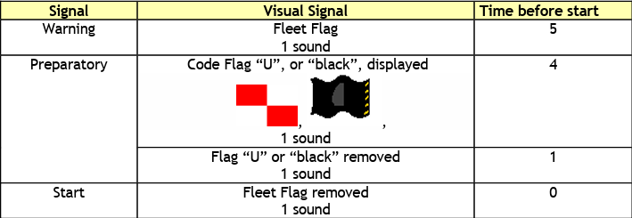

  - The starting line will be between staffs displaying orange flags on the starting marks.
11.1.1 (DP)(NP) When the warning signal for the first fleet has been made, boats from other fleets shall be in the waiting area as defined in instruction 11.3. Boats may approach the starting line after the starting signal of the previous fleet.
    - A boat starting later than 2 minutes after her starting signal will be scored Did Not Start without a hearing. This changes RRS A4 and A5.
11.2 (DP)(NP) Boats that have finished shall return directly to the waiting area or ashore, keeping well clear of all boats racing and of all boats whose warning signal has been made.
11.3 The waiting area windward boundary will be between the red marks.
11.4 The starting order of the fleets will be: Yellow, Blue, Red, Green and Pink in all qualification races and Gold, Silver, Bronze and Emerald Fleet for all final races.

- CHANGE OF THE NEXT LEG OF THE COURSE
To change the next leg of the course, the race Committee will lay a new mark, move the finishing line or move the leeward gate, When a new mark is laid, the original mark will be removed as soon as practicable.
Except at a gate, boats shall pass between the race committee boat signaling the change of course and the nearby mark, leaving the mark to port and the race committee boat to starboard. This changes RRS 28.2.

- FINISH
The finish line will be between staff displaying blue flags on the finishing boat and grey conic mark

- PENALTY SYSTEM
(NP) A boat that has taken a penalty according to RRS 44.1 shall complete a declaration form at site https://www.racingrulesofsailing.org/documents/7587/event?name=superpar-bior-2024 or at the race office within the protest time limit. If the declaration form is not filed, the boat shall be considered as not having taken the penalty
The penalty for breaches of Class Rules will be Standard Penalties (SP), which changes rule RRS 63.1 and may also be less than disqualification.
14.1 Appendix P will apply. RRS P2.3 will not apply and RRS P2.2 is changed so that it will apply to any penalty after the first one.
15 TIME LIMITS AND TARGET TIMES
15.1 Time limits and target times are as follows:

TIME LIMIT MARKS 1 TIME LIMIT TARGET TIME FINISH WINDOW
90 min 30 min 50 min 20 min

15.2 If no boat has passed Mark 1 within the Mark 1 time limit the race shall be abandoned. Failure to meet the target time will not be grounds for redress. This changes RRS 62.1(a).
15.3 Boats failing to finish within 20 minutes after the first boat sails the course and finishes will be scored Did Not Finish without a hearing. This changes RRS 35, A4, A5.1 and A5.2.

16 HEARING REQUESTS
16.1 To inform the Race Committee of the boat/s being protested, the boat intending to protest shall approach the race committee boat at the starboard end of the finishing line immediately after finishing and shall hail the protested boat’s sail number/s while sailing along her starboard side and asking confirmation.
16.2 Hearing Request forms are available at the Racing Rules of Sailing application https://www.racingrulesofsailing.org/documents/7587/event?name=superpar-bior-2024 Protests and requests for redress or reopening shall be delivered there within the appropriate time limit. If the online system is not operational, contact to the Race Office.
16.3 The protest time limit is 45 minutes after the last boat has finished the last race of the day or the Race Committee signals no more racing today, whichever is later.
16.4 Notices will be posted ONB within 30 minutes of the protest time limit to inform competitors of hearings in which they are parties or named as witnesses. Hearings will be held in Protest Hearing Room located inside the race office
16.5 Notices of protests by the race committee, technical committee or international jury will be posted to inform boats under RRS 61.1(b).
16.6 A list of boats that under instruction 14.3 have been penalized for breaking RRS 42 will be posted.
16.7 For the purpose of measurement protests as per RRS 64.3(b), the ‘authority responsible’ is the championship technical committee representative.
16.8 On the last scheduled day of the qualifying series a request for reopening a hearing shall be delivered:
16.8.1 within the protest time limit if the requesting party was informed of the decision on the previous day;
16.8.2 No later than 30 minutes after the requesting party was informed of the decision on that day. This changes RRS 66.2.
16.9 On the last scheduled day of the final series or the qualification series, a request for redress based on a protest decision shall be delivered no later than 30 minutes after the decision was posted. This changes RRS 62.2(a).
16.10 Decisions of the international jury will be final as provided in RRS 70.5. If Appendix N1.4 (b) applies, the time limit for request for a full panel hearing by a full international jury is 15 minutes after the parties have been informed of the decision.

17 SCORING
17.1 Race scores instruction 17.1.1 and 17.1.2 apply only when boats sail in separate fleets. Instruction 17.1.2 applies only to the qualifying series:
17.1.1 RRS A5.2 is changed so that the scores are based on the number of boats assigned to the largest fleet.
17.1.2 If at the end of the last day of races in the qualifying series some boats have more races scores than others, scores for the most recent races will be excluded so that all boats have the same number of race scores.
17.2 Three races are required to be completed to constitute a valid regatta.
17.3 When 4 or more races have been completed, a boat’s series score will be the total of her race scores excluding her worst score.
17.5 To request correction of an alleged error in the posted races or series results, a boat shall complete a scoring enquiry form available at the race office or on Racing Rules of Sailing application.
17.6 Once the final series has begun, gold fleet shall rank ahead of silver fleet, followed by bronze fleet. However, a boat that is scored DNE in all races shall be ranked in last place OVERALL.

18 (NP) SAFETY REGULATIONS
18.1 (NP)(DP) A boat retiring from a race shall notify a race committee or safety boat before leaving the course and shall complete the relevant form available at https://www.racingrulesofsailing.org/documents/7587/event?name=superpar-bior-2024 or at the Race Office within protest time limit.
18.2 Each day of competition the coaches or team leaders shall notify the race office before D flag is displayed, of the boats not intending to race that day.
18.3 When code flag F is displayed ashore, each coach or team leader shall sign a checklist adjacent to the race office within 60 minutes after the flag has been displayed, to indicate that all team members have returned to shore. Flag F will be displayed when the last boat has finished the last race of the day or the race is abandoned. All team members will be penalised at the discretion of the jury for each race of the day on which the coach or team leader failed to comply with this instruction. This changes RRS 63.1.
18.4 [SP] Check-Out and Check-In Procedures: The requirements of this instruction are specified for the safety of the competitors.
18.4.1 Check -Out and Check-In lists will be located in front of the race office.
18.4.2 The team leader or coach of each country/club shall individually Check-Out each competitor on their team each day before racing, beginning two hours before the scheduled first warning for the day, by signing beside their own name in the space provided on the required form and marking X beside the name of each competitor on their team that will be leaving the venue to race.
18.4.3 The team leader of each county/club shall individually Check-In each competitor on their team each day after racing immediately upon returning to shore, but no later than the protest time limit, by personally signing beside their own name in the space provided on the required form and making x beside the name of each competitor on their team that have returned to the venue after racing.
18.4.4 A standard penalty of 1 point in the first race of the day shall be imposed by the race committee without a hearing on competitors for failure to comply with instruction 18.4.2.
18.4.5 A standard penalty of 1 point in the last race of the day shall be imposed by the race committee without a hearing on competitors for failure to comply with instruction 18.4.3.
18.5 Competitors who require assistance should blow a whistle or wave the paddle or one arm. The race committee reserves the right to assist competitors who in their opinion require assistance, regardless of the wishes of the competitor. This will not be grounds for redress. This changes RRS 62.1(a).
18.6 In accordance with RRS 37 when the race committee displays flag V with repetitive sound signals and/or broadcasts “Code Flag Victor” on the designated VHF Channel 71, all officials and support boats shall comply with the instructions given by the race committee or the organizing authority as assistance / rescue boats.

19 (DP) REPLACEMENT OF EQUIPMENT
19.1 Substitution of damaged or lost equipment will not be allowed unless approved in writing by the technical committee. Requests for substitution shall be made to the technical committee at the first reasonable opportunity.
19.2 Substitution of damaged equipment may be permitted provided that the relevant form has been completed at the race office and both the damaged and the substituting equipment has been inspected by the technical committee.
19.3 If the substitution was made on the water between races, both the damaged and the substituting equipment shall be presented to the technical committee after the end of the day’s racing. The substitution is subject to the approval of the technical committee given retrospectively.

20 (DP)(NP)(SP) EQUIPMENT AND MEASUREMENT CHECKS
A boat or equipment may be inspected at any time for compliance with the Class Rules, the Notice of Race or the Sailing Instructions.

21. OFFICIAL BOATS
Official boats will be identified as follows:

BOAT | FLAG
Race committee boats | White flag with black ‘RC’ letter
Start Pin End boat | White flag with black ‘RC’ letter
Jury Boats | White flag with black ‘J’ letter
Mark Layer/Rescue Boats | White flag with black ‘RC  ’ letter
Support Boats | White sticker with blue numbers

22 SUPPORT BOATS
22.1 (NP) Team Leaders, Coaches and other support personnel shall stay outside areas where boats are or will be racing from the time the preparatory signal until all boats of all fleets in that race have finished or the race committee signals a postponement or abandonment. To observe a race, support boats may move from leeward to windward through the port side of the course keeping well clear of the exclusion boundary, approximately 100 meters from the course area. Support boats may, after the last start of a race, move between the waiting and the finishing areas through the centre channel (see drawing in Attachment 2). When a race committee or jury member indicates a support boat to move further from the course area, the mentioned boat shall do so immediately.
22.2 (DP) All boats associated with an infringing support boat may be penalised at the discretion of the jury for the race in which the support personnel failed to comply with Notice of Race and/or with this instruction. This changes RRS 64.5 (b)
22.3 (NP)(DP) Competitors shall not approach any boat other than an official boat (see instruction 21) from their first warning signal of the day until they finish their last race for the day or the race committee signals no more racing today, whichever is later.
22.4 Coaches are encouraged to carry a working VHF radio and monitor VHF Channel 71.
22.5 In accordance with RRS 37 all registered support person vessels shall act as assistance / rescue boats in case of need and shall comply with any instruction given by the Race Committee on the designated VHF Channel 73 or the Organising Authority.
22.6 Numerical stickers must be visible on the supports boats.

23 TRASH DISPOSAL
In addition to RRS 55 trash may be placed aboard support and race committee boats.

24 (NP)(DP) BERTHING
Boats shall be kept in their assigned places in the boat park.
25 PRIZES
25.1. Prizes will be awarded below;
25.1.1. First two racing day will be awarded Bodrum Chamber of Commerce Cup (BODTO CUP)
First 3 boys in overall
First 3 girls in overall
25.1.2. Country Cup will be named Bodrum Chamber of Shipping Cup (BODRUM DTO CUP)
Top 3 Countries will be awarded
25.1.3. All races completed sailors will be awarded as follows;
Top 10 in Overall
Top 3 girls
Top 5 Juniors ( Born 2013 and later )
Top 3 Junior girls ( Born 2013 and later )
Top 5 Bambinos ( Born 2015 and later )
Top 3 Bambinos girls ( Born 2015 and later )
25.2 Special prizes will be announced on the registration day (13th March 2024).

26. RISK STATEMENT
26.1. Competitors and support team participate in the regatta entirely at their own risk and responsibility and they are reminded of the provisions of RRS 3, Decision to Race. Sailing is by its nature an unpredictable sport and therefore inherently involves an element of risk. By taking part in the event, each competitor and the responsible adult agree and acknowledge that:
26.1.1. They are aware of the inherent element of risk involved in the sport and accept responsibility for the exposure of themselves and their boat to such inherent risk whilst taking part in the event;
26.1.2. They are responsible for the safety of themselves and their boat, and their other property whether afloat or ashore.
26.1.3. They accept responsibility for any injury, damage or loss to the extent caused by their own actions or omission;
26.1.4. Their boat is in good order, equipped to sail in the event, and they are fit to participate;
26.1.5. The provision of a race management team, patrol boats and other officials and volunteers by the event organizer does not relieve them of their own responsibilities;
26.1.6. The provision of patrol boat cover is limited to such assistance, particularly in extreme weather conditions, as can be practically provided in the circumstances.
26.2. The Organising Authority and all parties involved in the regatta organisation will not accept any liability for material damage or personal injury or death sustained in conjunction with or prior to, during, or after the regatta.

27 RIGHT TO USE NAMES AND LIKENESS
In participating in this championship, a competitor automatically grants to the organizing authority, sponsors of the championship the right in perpetuity to make, use and show at their discretion any motion pictures, still pictures and live, taped or filmed television and other reproductions of him or her during the championship, and of all of his or her material related to the championship, without compensation.

ATTACHMENT 1 – RACING AREA
BODRUM 37 10N, 27 26E

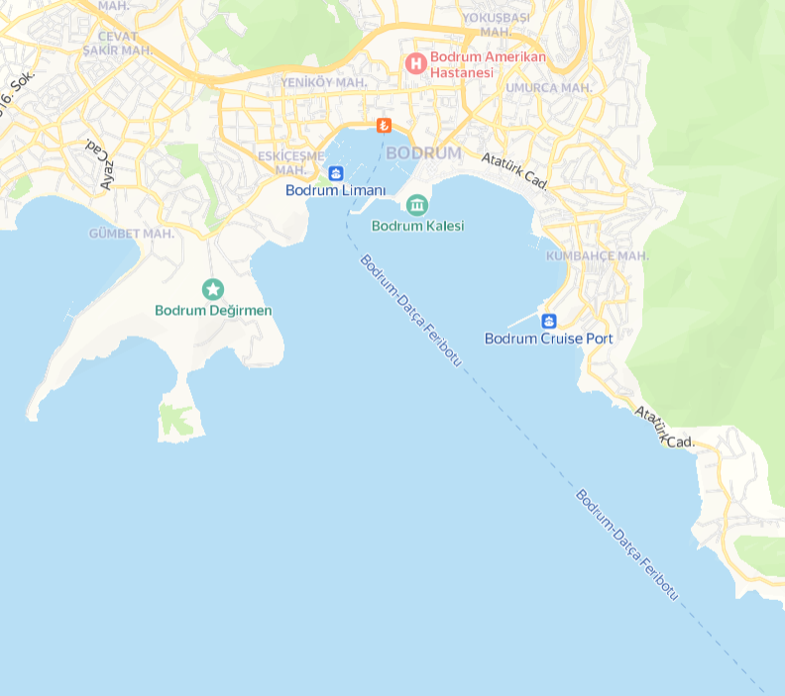
Marina
Gas Station
Racing Area
Sailing Club

ATTACHMENT 2 – THE COURSE

OPTIMIST
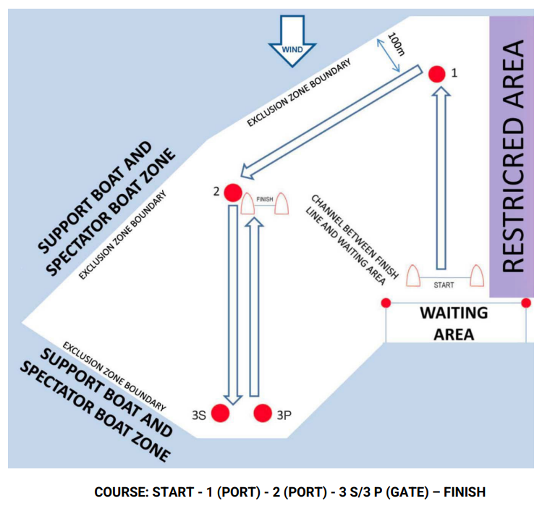

ILCA
