Transitions

# Introduction

Umpires and judges often talk about ‘transitions’, and the concept is a very useful tool in analysing and resolving When Boats Meet rules problems.

The term is not discussed in either the Judges or Umpires Manuals.

This paper will:

* explain what transitions are,
* give some examples of sequences of transitions, and
* show how transitions are used to analyse a typical rules problem.

# What is a Transition?

A transition is an event when rules, usually the Part 2 When Boats Meet rules, applicable between boats changes. Transitions can be either:

* ‘Rules only’ transitions, where the applicable rules change, but the obligations or entitlements of boats do not; or
* Transitions where obligations or entitlements, as well as applicable rules change.

Obligation or entitlement transitions may be further subdivided into:

* Right-of-way transitions (RRS 10, 11, 12, 13, and 21); and
* Room transitions (RRS 15, 16, 18, 19 and 20); and
* Other transitions (RRS 17 Proper Course, RRS 22 Capsized, Anchored or Aground; Rescuing, and RRS 23 Interfering with Another Boat).

# Examples of Transitions

## Simple Examples of Transitions

### Example

A simple example of a transition is when two boats, (B)lue and (Y)ellow are sailing downwind, overlapped on starboard tack, with Y sailing faster than B.

Consider Figure 1

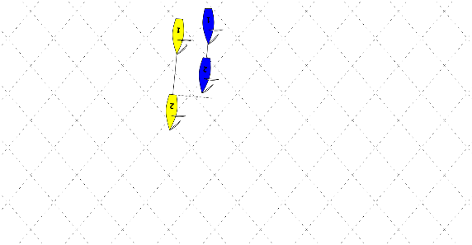

Figure 1

@1, Y overlapped to windward on the same tack is required to keep clear of B by RRS 11 *On the same tack, overlapped*.

@2, Y draws clear ahead of B and B, clear astern on the same tack, is now required to keep clear of Y by RRS 12 *On the same tack not overlapped.*

**This is a right-of-way transition.**

### Example

Continuing on from that, Y gybes from starboard onto port tack.

Consider Figure 2

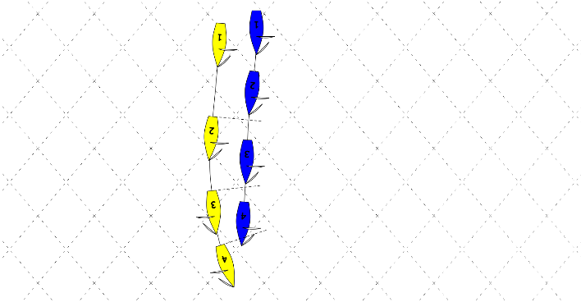

Figure 2

@ 3, Y, still clear ahead of B, but now on port tack, is required to keep clear of B on starboard tack by RRS 10 *On opposite tacks.*

**This, again, is a right-of-way transition.**

@4, Y and B are once again overlapped, but there is no change in right-of-way, *room,* or rules applicable.

### Example

Here is an example of a *room* transition with no change in right-of-way. B and Y are sailing on port tack, downwind to a mark to be rounded to port.

Consider Figure 3

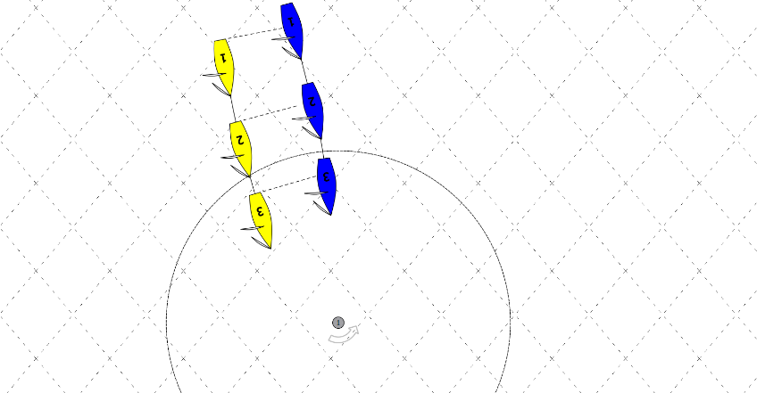

Figure 3

@1, B is overlapped to windward on the same tack as Y, and required by RRS 11 *On the same tack overlapped* to keep clear of Y.

@2, Y reaches the *zone* around the *mark,* overlapped outside B. RRS 18 *Mark-room* begins to apply, and Y is required to give B *mark-room* by the first sentence of RRS 18.2(b) *Giving mark-room.*

There is no change in right-of-way, but if B, while sailing within the *mark-room* to which she is now entitled, does not keep clear of Y, she is exonerated by RRS 43.1(b).

**This is a *room* transition.**

## More Complicated Examples

### Example

Here is a more complicated example involving both right-of-way and *room* transitions.

B and Y are sailing downwind, initially overlapped both on port tack.

Consider Figure 4

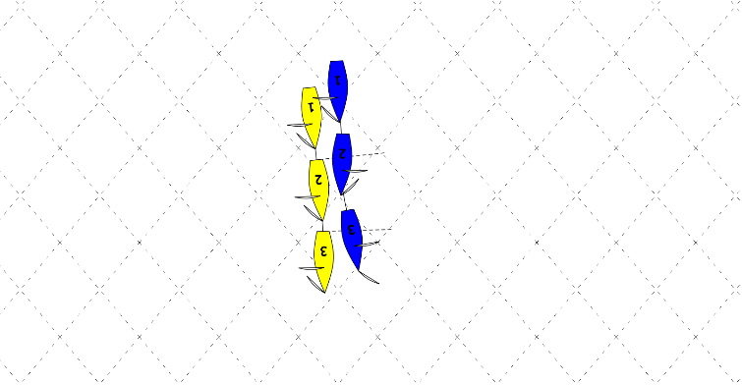

Figure 4

@1, B, overlapped to windward on the same tack, is required to keep clear of Y by RRS 11 *On the same tack, overlapped.*

@2, B gybes onto starboard without changing course. Y, on port is required to keep clear of B on starboard by RRS 10 *On opposite tacks*

**This is a right-of-way transition.**

@2 also, B, acquiring right-of-way not because of Y’s actions is initially required to give Y *room* to keep clear by RRS 15 *Acquiring right-of-way.*

**This is a *room* transition.**

@3, B changes course away from Y and gives Y *room* to keep clear.

### Example

Another example is when one of two boats, initially overlapped on starboard tack luffs and passes head to wind.

Consider Figure 5

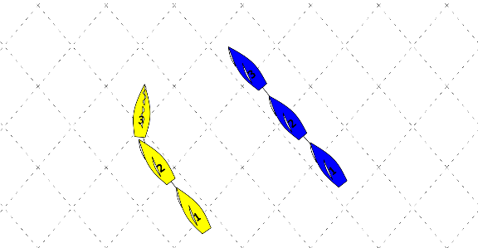

Figure 5

Initially B is required by RRS 11 *On the same tack overlapped*, to keep clear of Y.

@2 Y begins changing course. While she changing course she is required by RRS 16.1 *Changing Course* to give B room to keep clear, and given the distance apart of the boats, she does so.

**This is a room transition.**

@3, when Y passes head to wind, RRS 11 no longer applies and RRS 13 *While tacking* begins to apply, so that Y is now required to keep clear of B.

**This is a right of way transition.**

### Example

Continuing on from that, Y continues to bear away and @4 reaches her close hauled course on port tack.

Consider Figure 6.

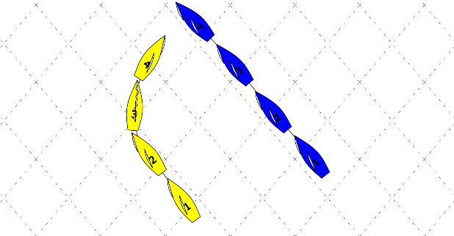

Figure 6

Now there is a further transition @4 when Y reaches her close hauled course, RRS 13 no longer applies, Y is now on port tack and still required to keep clear of B, but the obligation now arises under RRS 10 *On opposite tacks*. SL’s obligation to keep clear has not changed.

**This is a rules only transition.**

### Example

Here is a more complicated example involving both right-of-way and several *room* transitions.

B and Y are sailing downwind approaching an obstruction.

Consider Figure 7

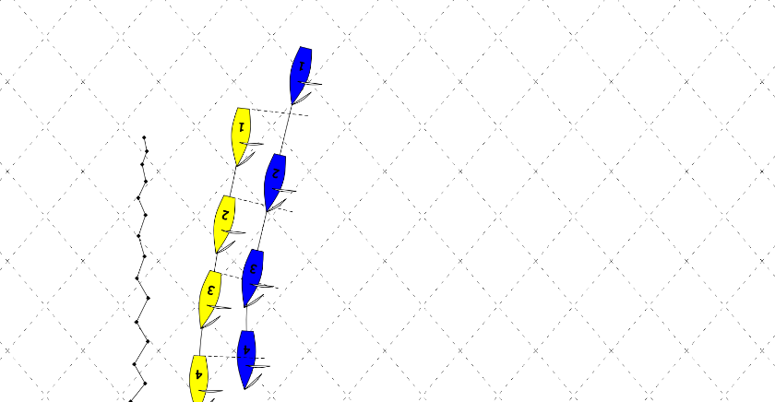

Figure 7

@1 B, initially on the same tack, clear astern, is required to keep clear of Y by RRS 12 *On the same tack not overlapped*.

@2, B becomes overlapped to leeward of Y:

* B acquires right of way, and Y, to windward on the same tack, is required to keep clear of B by RRS 11 *On the same tack, overlapped.*

**This is a right-of-way transition.**

* B, acquiring right-of-way not because of Y’s action, is required by RRS 15 *Acquiring right-of-way*, initially, to give Y *room* to keep clear, which she does and then RRS 15 ceases to apply.

**These are *room*** **transitions.**

* Boats are at the obstruction indicated by the wiggly line, so, now they are overlapped, RRS 19 *Giving room at an obstruction* requires B to give Y *room* to pass between her and the obstruction.

**This is a *room* transition.**

Between @3 and @4 B bears away and gives Y *room* to pass the obstruction.

### Example

A more complicated example of transitions, involving right-of-way, room, and rules only transitions, happens with two boats reaching, both on starboard tack initially with Y clear ahead of B when B becomes overlapped to leeward of Y.

Consider Figure 8

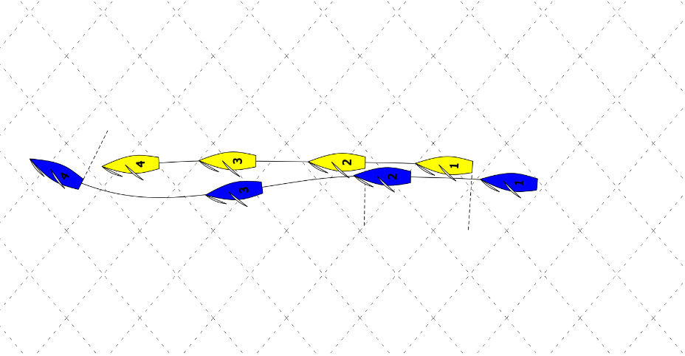

Figure 8

@1, B, clear astern, is required by RRS 12 *On the same tack, not overlapped* to keep clear of Y, on the same tack.

@2, B becomes overlapped to leeward of Y on the same tack, and:

* Y is required to keep clear of B by RRS 11 *On the same tack, overlapped*,

**This is a right-of-way transition.**

* B, acquiring right of way not because of Y’s action is required initially to give Y *room* to keep clear by RRS 15 *Acquiring right-of-way.*

**This is a *room* transition**

* B, becoming overlapped within two of her hull lengths to leeward of Y on the same tack is required to not sail above her *proper course* by RRS 17 *On the same tack Proper Course.*

**This is a transition, other than right-of-way or *room.***

@3, B has borne away and given Y *room* to *keep clear.*

B’s course after becoming overlapped was consistent with her course before becoming overlapped and with Y’s course: there is no evidence that she is sailing above her *proper course.*

@4, B has drawn clear ahead of Y, RRS 11 *On the same tack, overlapped* no longer applies, but B remains the right-of-way boat because Y is now required to keep clear by RRS 12 *On the same tack, not overlapped.*

**This is a rules only transition.**

@4, B is no longer overlapped on Y, RRS 17 *On the same tack Proper Course* ceases to apply and B is no longer required to not sail above her *proper course.*

**This is a transition when RRS 17, a limitation other than right-of-way or *room*** **ceases to apply.**

@4 B, now clear ahead and not limited by RRS 17, changes course to windward. B, a right of way boat is changing courses and is required by RRS 16.1 *Changing course* to give Y *room* to *keep clear*, and does so.

**This is a room transition**

# Using Transitions to Analyse a Rules Problem

Here is a worked example of using transitions to analyse a rules problem to identify:

* what rules were applicable, and
* whether any rules were broken

(R)ed and (G)reen are sailing on a beat to windward as shown in Figure 9.

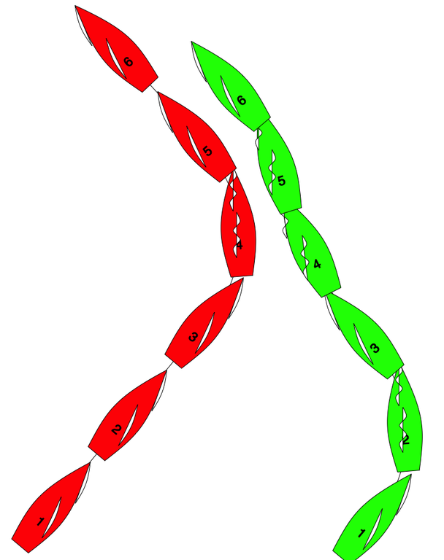

Figure 9

### Analysis

@1, both boats are on port tack, R is clear astern of G, and is required to keep clear of G by RRS 12 *On the same tack, not overlapped.*

@1.5, as G changes course to windward:

* G becomes overlapped to leeward of R and R continues to be required to keep clear of G, but now under RRS 11 *On the same tack, overlapped;* and
* G, a right-of-way boat changing course is required to give R *room* to *keep clear* by RRS 16.1 *Changing course,* and does so.

@2, G passes head to wind and is required to keep clear of R by RRS 13 *While tacking*.

@3, G reaches her close hauled course on starboard tack:

* R is required to keep clear of her by RRS 10 *On Opposite tacks*; and
* G, acquiring right-of-way not because of any action of R, is required initially to give R *room* to *keep clear* by RRS 15 *Acquiring right-of-way.*

@3+delta:

* R, acting promptly after becoming required to *keep clear*, begins changing course to windward in order to *keep clear* as required by RRS 10, *On Opposite tacks.*
* G changes course to windward in order to give R *room* to *keep clear* as required by RRS 15 *Acquiring right-of-way.*
* R and G are on a collision course so close together that there is a reasonable apprehension that if G does not change course there will be contact so R is not *keeping clear* of G and R breaks RRS 10 *On opposite tacks.*
* R is sailing within the *room* to which she is entitled and is exonerated for breaking RRS 10 by RRS 43.1(b) *Exoneration.*
* G is giving R *room* to *keep clear,* and is complying with RRS 15 *Acquiring right-of-way.*

@4, R passes head to wind and is now required to *keep clear* by RRS 13 *While tacking*, and G continues to give R *room* to *keep clear.*

@4.5, R has borne away onto a divergent course from G, there is enough space between R and G for G to change course in either direction without immediately making contact with R and R is *keeping clear* of G.

@5, R reaches her close hauled course on starboard tack, overlapped to leeward of G:

* G is required to keep clear of R by RRS 11 *On the same tack overlapped,* and
* R is required initially to give G *room* to *keep clear* by RRS 15 *Acquiring right-of-way*

Both boats comply with these rules

@5+delta R has given G *room* to *keep clear* and G has *kept clear* and RRS 15 *Acquiring right-of-way* no longer applies.

@6 G bears away onto her close hauled course and continues to keep clear of R.

### Rules Applicable

@1

* RRS 12 *On the same tack, not overlapped*

Between @1 and @2

* RRS 11 *On the same tack, overlapped* (rules only transition)
* RRS 16.1 *Changing course*

Between @2 and @3

* RRS 13 *While tacking*
* RRS 10 *On Opposite tacks*
* RRS 15 *Acquiring right-of-way*

Between @3 and @4

* RRS 10 *On Opposite tacks*
* RRS 15 *Acquiring right-of-way*
* RRS 43.1(b) *Exoneration*

Between @4 and @5

* RRS 13 *While tacking*

Between @5 and @6

* RRS 11 *On the same tack overlapped*
* RRS 15 *Acquiring right-of-way*

### Rules broken

Throughout the various changes in right-of-way and obligation to give room to keep clear no boat broke a rule.

# Conclusion

The concept of transitions is useful to analyse and resolve many rules problems.

A transition is an event when rules, usually the Part 2 When Boats Meet rules, applicable between boats changes.

This paper has provided simple and more complex examples of transitions and how they can be used to resolve rules problems.