470, 49ER AND NACRA 17 SENIOR OPEN CHAMPIONSHIP 2022
(RANKING EVENT & ASIAN GAMES SELECTION TRIAL)
19 MAY TO 24 MAY 2022

AMENDMENT NO 2 TO SAILING INSTRUCTIONS FOR iQ Foil (M & W)

For:- Para 10 COURSES

Add:- Add to Addendum C “SLALOM RACE COURSE” for iQ Foil (M) & iQ Foil (W)

MARKS
Course | Marks | Description of marks
A  (Slalom Race Course For iQ Foil) | Starting marks | Race Committee Vessel with a staff displaying an Orange Flag and a Red Ball Mark
 | Marks 1 | Orange Conical Marks
 | Mark 2 | Yellow Cylindrical Mark
 | Marks 3 | Orange Conical Marks
 | Finishing marks | Race Committee Vessel with a staff displaying a Blue Flag and a Red Ball Mark

ADD COURSE DIAGRAM TO COURSE A FOR iQ Foil (M) & (W)
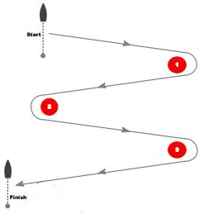

Signal | Mark Rounding Order
S | Start – 1S – 2P – 3S – Finish

Date: 23 May 2022. Srikanth Chaturvedi
Time: 09:50 hrs. PRO

