ILCA Masters Nationals

9th to 11th July 2021

Hosted by Pevensey Bay Sailing Club
Eastbourne, UK

Notice of Race.
Organising Authority: Pevensey Bay Sailing Club, & UKLA
The notation ‘(DP)’ in a rule in the NOR means that the penalty for a breach of that rule may, at the discretion of the protest committee (PC), be less than disqualification.
The notation ‘[NP}’ in a rule means that a boat may not protest another boat for breaking that rule. This changes RRS 60.1(a)

1. RULES
1.1. The event is governed by the rules as defined by The Racing Rules of Sailing.
1.2 All documents pertaining to this event are available at Events Homepage
1.3 RRS Appendix T, Arbitration, will apply.
1.4 RRS Appendix P, Special Procedures for RRS 42, will apply.
  - Boats shall comply with the Class Rules as posted on the ILCA website. [DP]
  - ILCA class rule 7 (a) is restricted as follows “only one person shall be on board whilst racing. The person shall be named on the entry form” No substitution of helm is permitted.
  - Rule 40.1 shall apply at all times on the water.
  - Protocols relating to Covid 19 may be published at any time and will state if they have a status of a rule. [DP]
2. SAILING INSTRUCTIONS
  - The Sailing Instructions will be published on the UKLA event page website Sailing Instructions by 2nd July 2021
- COMMUNICATIONS
  - The online official noticeboard is located at Official Noticeboard
  - While racing except in an emergency, a boat shall not make voice or data transmissions and shall not receive voice or data communications that is not available to all boats. [DP]
  - Hearings may be held remotely under procedures which will be set out in the sailing instructions.
  - Competitors should note that it is anticipated that all communication for this event will be online. Competitors should be aware that the club WIFI system may not be accessible, and they must have a device which can connect to the internet via an alternative means
  - A competitor Whatsapp group will be set up and advised in the sailing instructions
- ELIGIBILITY & ENTRY
4.1. The event is open to all boats which comply with the ILCA Class Rules excluding the ILCA 4
4.2 Entries will only be accepted via the event website, which can be accessed via the Events Homepage.
4.3 Entry is on line using the official on line application form located at Entry
4.4 To be considered an entry in the event, a boat shall complete all registration requirements and pay all fees.
4.5 Competitors and support persons shall have complied with and completed all UK guidelines and regulations concerning Covid 19, including but not limited to travel, quarantine, and vaccinations prior to registration.
4.6. Competitors shall be current, fully paid members of the International Laser Class Association and of a World Sailing Member National Authority may enter the Championship. Membership is through District Associations such as the UKLA.
4.7. Crew substitution of the registered sailor is not permitted.
4.8 For Master categories, the competitors age will determine in which category they are eligible.
4.9. Entry dates

Action | Date
Entry opens | 29th April 2021
Entry Closing Date | 23th June 2021
Late Entry opens | 24th June 2021
Late Entry Closing Date | 5th July 2021

4.10 Entries after the 5th July 2021 will only be accepted at the discretion of the UKLA and PBSC. Please contact: Events@laser.org.uk
4.11. All competitors shall be a minimum age of 33 at the start of the event.
4.12 In order to qualify for age category prizes they shall reach the following ages in 2021:

Age Qualification | Class
35 to compete in the Apprentice Masters | ILCA 7 or ILCA 6
45 to compete in the Masters | ILCA 7 or ILCA 6
55 to compete in the Grand Masters | ILCA 7 or ILCA 6
65 to compete in the Great Grand Masters | ILCA 7 or ILCA 6
75 to compete in the Legend category | ILCA 6

4.13 The following restrictions on the total number of boats apply
Class | Number of Boats
Overall | 120
4.14 The Organising Authority retains the sole right to limit total entry numbers during the application process.
4.15 When any limit has been reached a waiting list will be as per the Entry process. Priority will be given to those who are fully paid members as at 1st May 2021 and in the order of Entry application receipt
5. FEES
5.1 The entry fee for the event will be £91. The late entry fee will be £110. The late entry fee applies from 24 June 2021. A BBQ is planned for Saturday 10 July. Tickets may be purchased on the event website for £11 per person.
5.2 Should the event be cancelled, a refund of at least 85% of the entry fee will be made after transfer fees. This will be dependent on the expenditure committed to by and at the discretion of the Organising Authority.
5.3 If an entry is cancelled by a competitor, the entry fee will be refunded as described in the application and entry procedure

6. CREW LIMITATIONS
6.1 Please refer to NOR 1.6
7. ADVERTISING
7.1 Boats may be required to display advertising chosen and supplied by the Organising Authority [DP]

8. QUALIFYING SERIES AND FINAL SERIES
8.1 At the sole discretion of the Race committee a fleet may be divided into two fleets and sail a qualifying series of up to six races followed by a final series of two races in accordance with Sailing Instructions.
8.2 However many races are completed by the end of the second scheduled racing day the qualifying series will cease. The results at that stage will be used for the assignment of Gold and Silver fleet

9. SCHEDULE
9.1 Registration
Date | Open | Close | Location
8/7/21 | 12:00 |  | On line
9/7/21 |  | 10:00 | On Line

9.2 Equipment Inspection
See NOR 10

9.3 Number of Races

Class | Number of Races | Races per day scheduled | Races per day Maximum
ILCA 6 | 8 | 2 or 3 | 4
ILCA 7 | 8 | 2 or 3 | 4

9.4 The scheduled time of the warning signal for the first race each day is;
Date | Race | Time of first warning signal | High Water
9/7/21 | Up to 3 races | 1155 | 11:45
10/7/21 | Up to 3 races | 0955 | 12:20
11/7/21 | Up to 2 races | 0955 | 12:58

  - On the last scheduled day of racing no warning signal will be made after 1430
  - Each day succeeding races will be started as soon as practicable after the finish of the previous race

10. EQUIPMENT INSPECTION
10.1 Boats may be inspected at any time.
10.2 Boats shall also comply with RRS 78.1 [DP]

11. CLOTHING & EQUIPMENT
11.1 Wet clothing may be inspected at any time for compliance with the class rules as permitted by RRS 50.1(b)

12. VENUE
12.1 NOR Appendix one shows the plan of the event venue.
12.2 NOR Appendix one shows the Race area.
12.3 The intended racing area will be within 2NM of Pevensey Bay Sailing Club

13. COURSES
13.1 The courses to be sailed will be Inner or outer loop trapezoid with an upwind finish.
13.2 There will be a 50 minute target time for each race.

14.PENALTY SYSTEM
14.1. Appendix P, Special Procedures for RRS 42, will apply. The Sailing Instructions will state Rule P2.3 will not apply and rule P2.2 is changed so that it will apply to any penalty after the first one.
14.2 To encourage boats to take a penalty afloat, jury members may blow a whistle when they see what they believe to be a breach of a rule.
14.3 Each competitor agrees and acknowledges that they are responsible for complying with any regulations in force from time to time in respect of COVID-19 and for complying with the Organising Authority COVID-19 procedures. [DP]
14.4 Competitors and support persons shall comply with any reasonable request from an event official. Failure to comply may be misconduct. Reasonable actions by event officials to implement COVID-19 guidance protocols or legislation, even if they later prove to be unnecessary, are not improper actions or omissions. [DP]

15. SCORING
15.1. Two races are required to be completed to constitute a series.
15.2. The total score for each boat will be the sum of her scores as follows:
15.2.1 When fewer than four races have been completed, a boat's series score will be the total of her race scores.
15.2.2 When from four or more races have been completed, a boat's series score will be the total of her race scores excluding her worst score.
15.3 There will be separate rankings for each Master category as defined in 15 Prizes below. It will be by extraction for each age category from the overall position in the ILCA 7 fleet and ILCA 6 fleet unless there is more than one start in the ILCA 7 or ILCA 6 fleets when the ranking will be extracted from the overall position in the starting fleet.
15.4 A separate ranking will be extracted from each age category for the ILCA 6 women. The fleet rankings are for information only (no overall winners of the ILCA 7 or ILCA 6 fleet).
15.5 If a point scoring penalty would result in a score worse than DSQ, the penalty will be that corresponding to DSQ. The scores of other boats will not be changed.

16. SUPPORT PERSON VESSELS
16.1. There will be no support boats at this event, only safety fleet see 16.4 below.
16.2. Personal equipment such as food bags, drinks, spare parts and extra clothing may not be stored on any official boat for the duration of the event. Competitors should ensure that they carry sufficient food and water on their own boat.
16.4 If you wish to volunteer as part of the safety fleet please contact Events@laser.org.uk
16.5. Further specific safety boat instructions will be distributed prior to the event and will include details that would normally be included in the safety boat briefing. Any information necessary on the day will be communicated electronically.

17. CHARTERED OR LOANED BOATS
17.1 A limited number of charter boats are available from SailingFast. These will be allocated on a first come, first served basis. Latest date for application for a charter boat is 13 June 2021. Charter boat contact: Duncan Hepplewhite Duncan@sailingfast.co.uk
18. BERTHING AND LAUNCHING
18.1. Boats shall be kept in their assigned area during the championship from the start of their event until the completion of the final race. Social distancing regulations and guidelines shall be complied with in the dinghy park and launch areas. [DP]
18.2. Tallying is required. After entry a competitor will receive a competition number for the event. Prior to arrival all competitors shall place a label for the duration of the event on their boats trolley, with their competition number clearly displayed on that label. The competition number will be used for tallying. [DP]

19. HAUL-OUT RESTRICTIONS
NA

20. DIVING EQUIPMENT & PLASTIC POOLS
NA
21 DATA PROTECTION
21.1 The personal information you provide to the Organising Authority will be used to facilitate your participation in the event. If you have agreed to be bound by the Racing Rules of Sailing and the other rules that govern the event (the rules), the legal basis for processing that personal information is contract. If you are not bound by the rules, the legal basis for processing that personal information is legitimate interest. Your personal information will be stored and used in accordance with the Organising Authority’s privacy policy. When required by the rules, personal information may be shared with the RYA, your national authority and/or World Sailing. The results of the event and the outcome of any hearing or appeal may be published.

21.2 Competitors automatically grant to the OA, without payment, the right In perpetuity to make, use and show any motion pictures, still pictures and live, taped or filmed television of or relating to the event.

22. RISK STATEMENT
22.1 Rule 3 of the Racing Rules of Sailing states: “The responsibility for a boat’s decision to participate in a race or to continue racing is hers alone.”
22.2 Sailing is by its nature an unpredictable sport and therefore inherently involves an element of risk. By taking part in the event, each competitor agrees and acknowledges that:
22.2.1 They are aware of the inherent element of risk involved in the sport and accept responsibility for the exposure of themselves, their crew and their boat to such inherent risk whilst taking part in the event.
22.2.2 They are responsible for the safety of themselves, their crew, their boat and their other property whether afloat or ashore.
22.2.3 They accept responsibility for any injury, damage or loss to the extent caused by their own actions or omissions.
22.2.4 Their boat is in good order, equipped to sail in the event and they are fit to participate;
22.2.5 The provision of a race management team, patrol boats if any and other officials and volunteers by the event organiser does not relieve them of their own responsibilities.
22.2.6 The provision of patrol boat cover if any is limited to such assistance, particularly in extreme weather conditions, as can practically be provided in the circumstances.
22.2.7 It is their responsibility to familiarise themselves with any risks specific to this venue or this event drawn to their attention in any rules or information produced for the venue or event and to attend any competitor briefing held for the event.

23. INSURANCE
23.1 Each Participating boat shall be insured with valid third-party liability insurance with a minimum cover of £3 million per event or equivalent.

24. PRIZES
24.1 Prizes will be awarded in the following categories

ILCA 7 Apprentice Master (men only) | 35 to 44
ILCA 6 Apprentice Master (men and women) | 35 to 44
ILCA 7 Master (men only) | 45 to 54
ILCA 6 Master (men and women) | 45 to 54
ILCA 7 Grand Master (men only) | 55 to 64
ILCA 6 Grand Master (men and women) | 55 to 64
ILCA 7 Great Grand Master (men only) | >=65
ILCA 6 Great Grand Master (men and women) | 65 to 74
ILCA 6 Legend (men and women) | >=75

24.2 Details on the official prizegiving will be posted on the ONB during the event

25 RIGHTS TO USE NAMES AND LIKENESS
25.1 Competitors automatically grant to the Organising Authority without payment the right in perpetuity to make, use and show any motion pictures, still pictures and live, taped or filmed television of or relating to the event.

END OF NOTICE OF RACE

APPENDIX ONE

Location
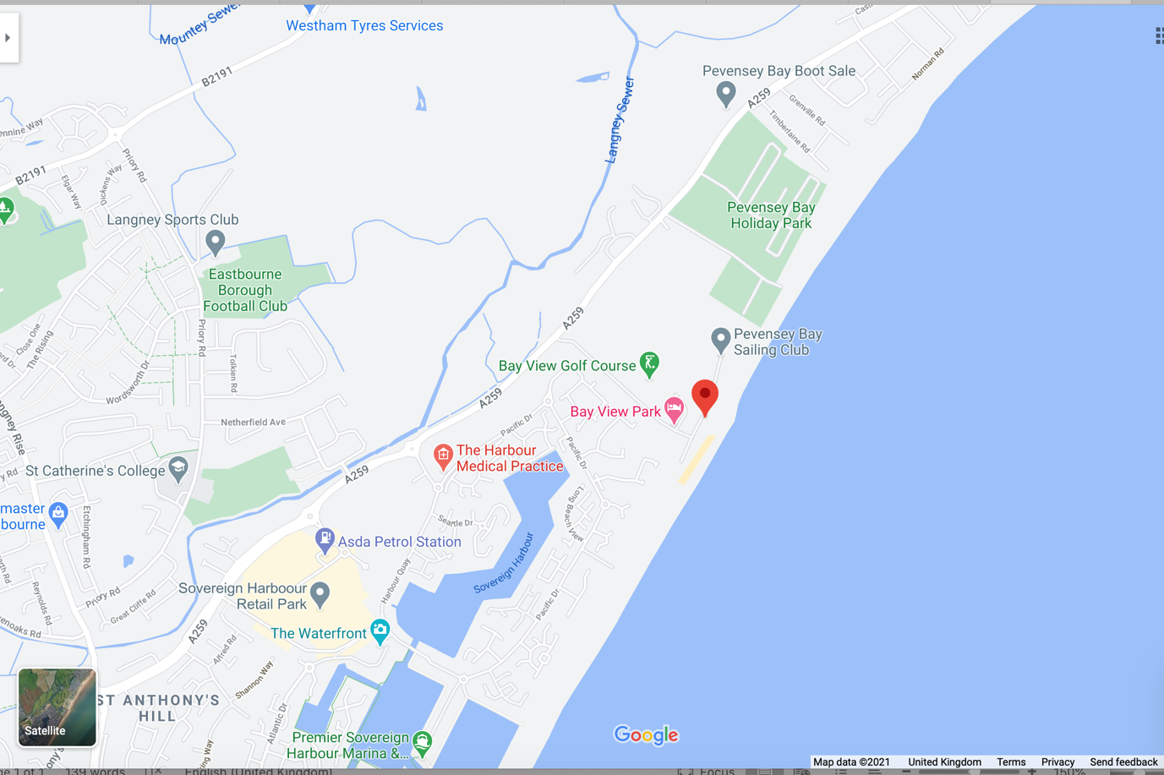

Venue Plan

Launching Area

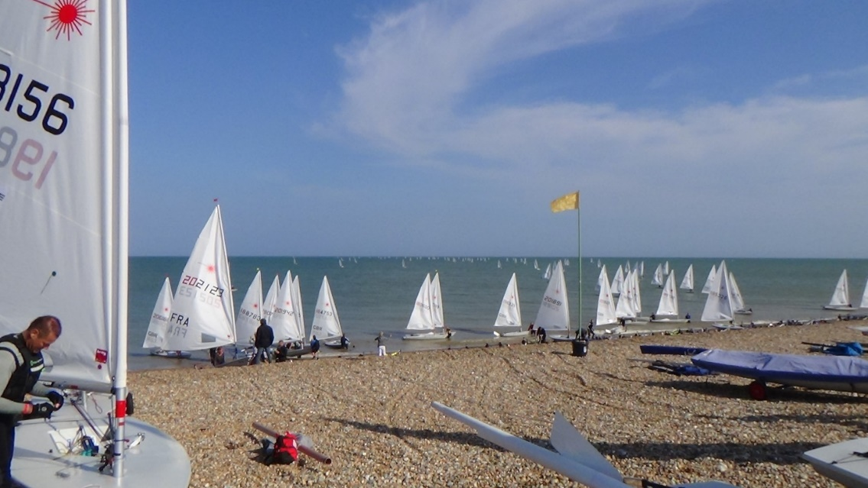

Course area

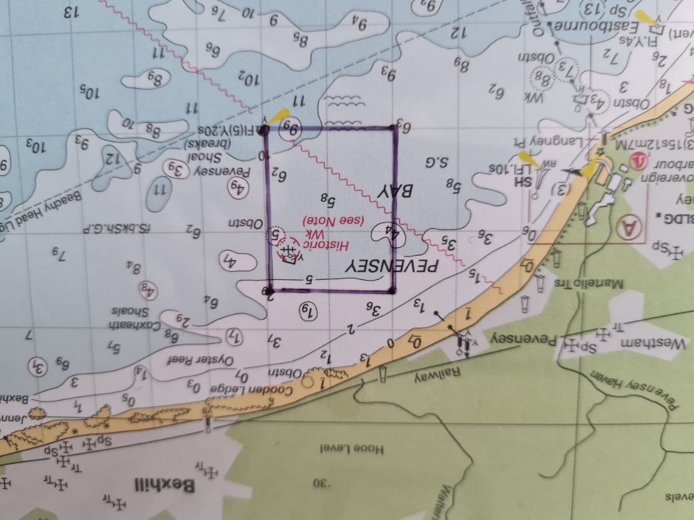

Directions
Directions to Pevensey Bay Sailing Club can be found at: https://www.pbsc.org.uk/about-us/contact-us/

FURTHER INFORMATION PBSC
We should like to express our thanks to PBSC for all their help in putting this event on, together with all the volunteers who have offered to help us. There may be significant changes in Government Covid 19 guidance, regulation and operating procedures between the issue date of this document and the event date, we will endeavour to keep competitors informed. We would, however ask that all competitors and volunteers take action to keep themselves informed of any changes in both the regulations and guidance.

Part of our operational plan is shown below
- We will, as a class, take a considerate and conservative approach to the racing and the wind strength, sea state and the ability of competitors. This may mean postponements to starts. This is to ensure that we minimise as much as we can the impact on the local community. We will however endeavour to meet the programme as laid out in the Notice of Race.
- We have to maintain control of launching/recovery and dinghy parking. There may be special requirements for launching, recovery and the hygiene of boats and equipment, it is the responsibility of every competitor to make themselves aware of those regulations and to follow them, this includes labelling with their competitor number the boat trolley if required.
- Competitors should be prepared to provide their own PPE, should Government guidelines change. This may include amongst other items, hand sanitiser and face masks. Please make yourselves aware of the current guidelines and regulations.
- Social distancing and gatherings should be in accordance with regulation, including any mitigation.
- Personal equipment such as food bags, drinks, spare parts and extra clothing will not be stored on any official boat for the duration of the event. Competitors should ensure that they carry sufficient food and water on their own boat.
- The changing facilities on site may be closed, except for the toilets.
- Should you have any questions please contact the event organiser at adrian.peckhampbsc@gmail.com and we will try to help.

UKLA: https://ilca.uk
Pevensey Bay Sailing Club: https://www.pbsc.org.uk
Pevensey Bay Sailing Club have a comprehensive list of accommodation on their website.

Camping and campervans are welcome on site for a donation of £15 Per night. There are a limited number of Campervan places available. Please email Adrian Peckham on adrian.peckhampbsc@gmail.com to reserve your campervan space.

The club will be serving food on Friday and Saturday evenings; breakfasts will be available on Saturday and Sunday mornings; afternoon tea will be available after racing on Sunday. Under the current Covid restrictions we expect to be serve this from the ground floor servery with consumption on the outside balcony – covered by a marquee and limited socially distanced tables in the clubhouse.

