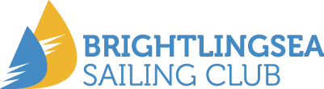

**International Fireball Class Gul UK National & Open Championship**

**International Contender Class North Sails National Championship**

**1st – 5th June 2022**

**Organised by Brightlingsea Sailing Club in conjunction with the Class Associations**

**BSC, Oyster Tank Road, Brightlingsea, Essex CO7 0BA**

Amendment to Schedule for 5/6/22

# Change to schedule

6.1 The schedule for racing is changed to the following

**Day Date Event Time**

Sunday 5th June 3 Races All Classes First start 11.00

Signed

PJ

Race Officer