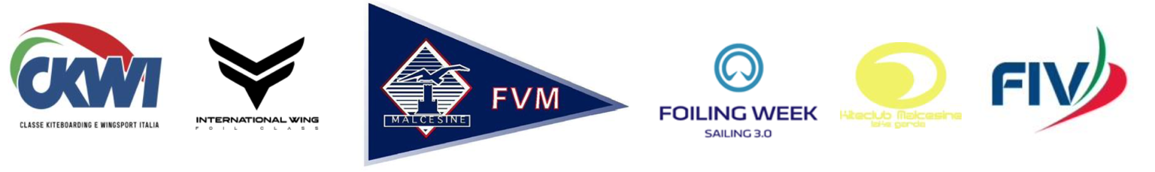

5th ACT ITALIAN WINGFOIL CHAMPIONSHIP
EURO CUP WINGFOIL CLASS
2 – 4 JULY 2021- Navene – Malcesine (VR)
RACING - AIRSTYLE

LOCAL SAILING INSTRUCTIONS (LSI)
These LSI complement the NOR/SI. If there is conflict between the NOR/SI and the LSI, the LSI take precedence.

3 RULES
NoR 3 d is deleted and replaced by:
d. Development Rule 21 05 Appendix WF Wingfoiling Racing Rules.

8 SCHEDULE
The schedule for 2 July 2021 will be:
Registration: 1000-1100
Skipper’s meeting: 1100
Races: 1200

12 COURSES
12.1 Marks: Marks 1 and 3 will be yellow inflatable cylinders
Marks 2 and 4 will be red inflatable cylinders
Start: The starting line will be between a staff displaying an orange flag and a
yellow inflatable stick
Finish: The starting line will be between a staff displaying an orange flag and a
yellow inflatable stick
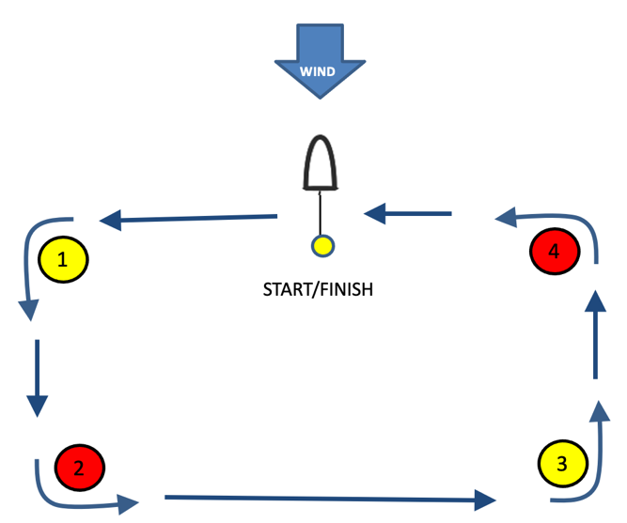
12.2 The class flag will be a yellow flag with a black wingfoil class logo
12.3 The course will be:
Start – mark 1 – mark 2 – mark 3 –
mark 4 – finish.
All marks shall be left to port.
The drawing illustrates the course,
the order and the side each mark
shall be left to.
12.4 Time limits
Start time limit: 1 minute
Target time: 7 minutes
Course time limit: 15 minutes
Finish window: 5 minutes

