INVITATION KFC-TERENGGANU MONSOON CHALLENGE
SAILING GP 2019 (27th NOV-01st Dis 2019)

The event hosted by Terengganu Sailing Association (TESA) and Terengganu Windsurfing Association (TWSA) under the auspices of the Malaysian Windsurfing Association (MWSA) and Malaysian Sailing Association (MSA).

EXPERIMENTAL SAILING INSTRUCTIONS
These Experimental Sailing Instructions have been approved by World Sailing in accordance with RRS 86.2 and Regulation 28.1.3. It applies to all relay races and all pre-race or post-race activities related to them.
- RULES
  - The relay races will be governed by the rules as defined in The Racing Rules of Sailing (RRS), and as changed by these Experimental Sailing Instructions.
  - No national prescriptions will apply.
  - Class rules regarding class association membership and its championship rules will not apply.
  - If appropriate and applicable, items of the main Sailing Instructions will apply to the relay races. If there is a conflict between a rule in the main Sailing Instructions and a rule in the Experimental Sailing Instructions, the rule in the Experimental Sailing Instructions shall take precedence. This changes RRS 63.7.
  - Courses will not be shortened. This changes RRS 32.
  - After the start of each race the course will not be changed. This changes RRS 33.
  - Add to the definition Proper Course: “A board taking a penalty or manoeuvring to take a penalty is
not sailing a proper course.”
  - If there is a conflict between languages the English text will take precedence.

NOTICES TO COMPETITORS & CHANGES TO SI
  - Notices to competitors for the relay races only, will be posted on:
    - ASHORE: on the Official Notice Board will be located beside the official flagstaff, at least 60 minutes before flag D is displayed on the official flagstaff; or
    - AFLOAT: on the Race Committee starting vessel, after flag D is displayed on the official flagstaff.

SIGNALS MADE ASHORE
  - When flag AP is displayed ashore, “1 minute” in RRS Race Signals AP is replaced with 30 minutes.
  - A board shall not launch until flag D is displayed ashore. The warning signal will be made not less than 30 minutes after flag D is displayed or not before the scheduled time, whichever is later.

FORMAT AND SCHEDULE OF RACES
  - A total of 4 relay races are scheduled out of the total 7 races for the event.
  - The schedule for the relay races will be posted no later than 30 minutes after the end of the latest protest time limit on the day before it will take effect, using knowledge of forecasted or prevailing weather conditions on-site. Schedule of races will be posted on the main official notice board.
  - Each race will consist of four laps with the following order:
Start – Lap 1 (Male) – Lap 2 (Female) – Lap 3 (Male) – Lap 4 (Female) – Finish

EVENT FLAGS
The event flag will be the class insignia.

RACING AREAS
The racing area for the relay races will be sailed waters in front of the venue.

THE COURSES
The course to be sailed will be as follows:
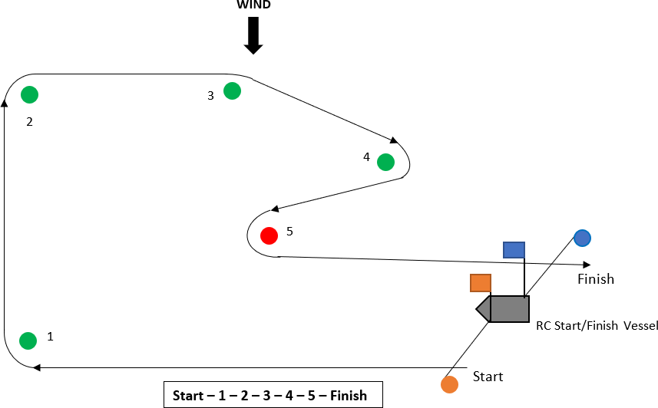

MARKS
  - Marks 1, 2, 3 and 5 will be inflatable yellow cylindrical buoys. Mark 4 will be an port hand Latrell mark.
  - The starting marks will be a Race Committee vessel and an red spherical buoy.
  - The finishing marks will be a Race Committee vessel and a white buoy with blue flag .

THE START
  - The starting line will be between a staff displaying an orange flag on the Race Committee vessel and an red spherical buoy at port end.
  - The orange starting line flag will be displayed 2 minutes before the warning signal.
  - For the first starter only (Lap 1), races will be started using RRS 26 with the warning signal 3 minutes before the starting signal and the preparatory signal 2 minutes before the starting signal. RRS 30.3 will apply.
  - For subsequent starters (Laps 2-4), before the board who is racing finishes, the other board on her team waiting to start shall not have any part of her hull, crew or equipment on the course side of the starting line or one of its extensions during the last minute before her starting signal. If she does so, she shall sail across the leeward extension (only the start pin buoy) to the pre-start side before starting. If a board breaks this rule and is identified, her team shall be disqualified (DSQ) without a hearing. This changes RRS 63.1 and A5.

THE FINISH
The finishing line will be between a staff displaying a blue flag on the Race Committee vessel and a blue teardrop buoy on windward of the Race Committee vessel.
(The finishing line will be between a red spherical buoy at the port end and a white buoy with blue flag at the starboard end)

PENALTY SYSTEM
  - Races will be umpired.
  - The first sentence of rule B4.44.1 is replaced with: ‘A board may take a 360°-Turn Penalty in accordance with rule B4.44.2 when, in an incident while racing, she may have broken one or more of the rules of Part 2, except RRS 14 when she has caused damage or injury.
  - RRS 60.1 is replaced with ‘A board may protest another board provided she complies with instruction 11.4.’
  - While racing, a board may protest another board under a rule of Part 2 (except RRS 14); however, a board may only protest under a rule of Part 2 for an incident in which she was involved. To do so she shall hail ‘Protest’ at the first reasonable opportunity.
  - A board that protests as provided in instruction 11.4 is not entitled to a hearing. Instead, a board involved in the incident may acknowledge breaking a rule by taking a 360°-Turn Penalty in accordance with rule B4.44.2. An umpire may penalise any board that broke a rule and was not exonerated, unless the board took a voluntary penalty.
  - An umpire will signal a decision as follows:
    - A green and white flag with one long sound means ‘No penalty.’
    - A red flag with one long sound means ‘A penalty is imposed or remains outstanding.’ The umpire will hail or signal to identify each such board.
    - A black flag with one long sound means ‘A board is disqualified.’ The umpire will hail or
signal to identify the board disqualified.
  - A board penalised under instruction 11.6(b) shall take a 360°-Turn Penalty in accordance with RRS B4.44.2, except when disqualified, in which case she shall promptly leave the course area.
  - If umpires decide that a board
    - gains an advantage despite taking a penalty;
    - deliberately breaks a rule;
    - commits a breach of sportsmanship; or

    - fails to take a penalty when required to do so by an umpire,
Umpires may impose her one or more additional penalties in accordance with instruction 11.6(b).
  - RRS 64.1(a) is changed so that the provision for exonerating a board may be applied by the umpires without a hearing, and it takes precedence over any conflicting instructions or rules.
  - The last sentence of RRS 28.2 is changed to ‘She may correct any errors to comply with this rule, provided she has not rounded the next mark or finished.’ A board that does not correct any such error shall be penalised instruction SI 11.6(c).

TIME LIMITS AND TARGET TIMES
  - The overall time limit for the first team to complete the relay race of four laps is 20 minutes. If this time limit is exceeded, the Race Committee may abandon the race.
  - The target time for the first team to complete the relay race is 12 minutes.

PROTESTS AND REQUESTS FOR REDRESS
A board may not request redress under RRS 62.1. The Protest Committee may consider giving redress under that rule if it believes that an error has been made. The Race Committee or umpires may request the Protest Committee to consider this. This changes RRS 60.1(b), RRS 62.1 and RRS B5.62.

SCORING
  - RRS B8 is deleted.
  - The scores from the relay races shall not be discardable.
  - The first finisher after all four laps are completed by her team, will score one point for each team- mate (i.e. male = 1 point, female = 1 point), and the team score for that race will be two points. The second finis her after all four laps are completed by her team, will score two points for each team- mate (i.e. male = 2 points, female = 2 points), and the team score for that race will be four points, and so on and so forth for the subsequent finishers.

