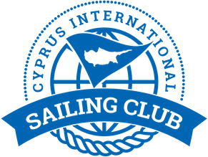

Notice to Competitors # 6
Allocation of boats for DAY 3 2/2/2020

Bow number | Team | skipper
2 | Planing 2 | Jakob Enigl
5 | J-Mania | Sukru Sanus
6 | Fortunato team | Maksim Grishchev
1 | Adios | Ozcan Hulki
3 | Masha&Medvedi | Maria Pakhtusova
4 | MIR | Igor Matvienko

Yiannis Papazoglou
IRO

31/1/2020 , 10:22

