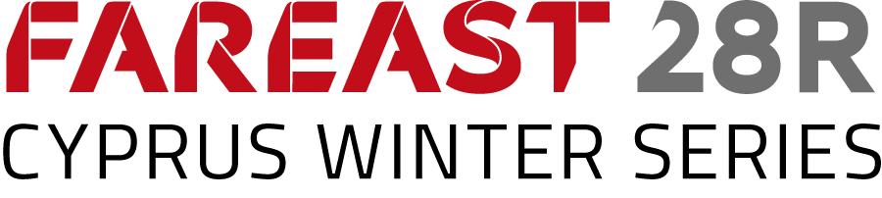

Notice to Competitors # 4

The request of the team Jmania to reopen the hearing will be examined after the protest time limit on the 1/2/20.
The member of the team who possess new evidence must present them personally to the chairman of the protest committee.

Socrates Jordanou
Chairman of the protest committee

1/2/2020 , 07:50

