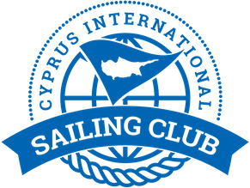

Notice to Competitors # 2
Allocation of boats for DAY 1 31/1/2020

Bow number | Team | skipper
4 | Planing 2 | Jakob Enigl
1 | J-Mania | Sukru Sanus
6 | Fortunato team | Maksim Grishchev
2 | Adios | Ozcan Hulki
5 | Masha&Medvedi | Maria Pakhtusova
3 | MIR | Igor Matvienko

Yiannis Papazoglou
IRO

31/1/2020 , 10:22

