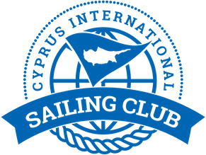

Notice to Competitors # 3
Allocation of boats for DAY 1 1/2/2020

Bow number | Team | skipper
5 | Planing 2 | Jakob Enigl
4 | J-Mania | Sukru Sanus
2 | Fortunato team | Maksim Grishchev
3 | Adios | Ozcan Hulki
6 | Masha&Medvedi | Maria Pakhtusova
1 | MIR | Igor Matvienko

Yiannis Papazoglou
IRO

31/1/2020 , 10:22

